Report by the Secretariat to the Executive Committee on Communications:
Website updates, Twitter and Website analytics

1 March 2016

Website updates
The Secretariat regularly updates the website. Since the last report the following noteworthy changes have been made to the website:
- Events calendar: Numerous events in different jurisdictions for 2016 and 2017 added. The calendar is continuously updated and we are seeking to be an key resource for DPAs and others scheduling international meetings.
- 38th Conference updates: A dedicated page is created for the 38th Conference where regular updates will be posted.
- Presentations on behalf of ExCo at International events: Presentations at Macau, December 2015, Ghana, January 2016 and Peru, February 2016 have been uploaded.
- Current working groups: A page dedicated for current working groups is under construction and will be used to provide updates on ongoing work.
- Twitter widget: A twitter widget publicise the Conference’s twitter account and gives the website a more dynamic feel. The widget will also enable visitors easily to chose to follow our Twitter account.
- Presentations to 37th Conference closed session: Further presentations by closed session speakers have been uploaded.
- News releases: The Chair’s news release to mark Data Protection Day has been uploaded.
- Annual reports: ExCo annual reports 2011–2015 are now all uploaded.
Twitter
The Secretariat launched a Twitter account on 27 January coinciding with Data Protection Day. A policy describing the Secretariat’s approach was earlier circulated to the Committee. In the last 6 weeks:
- the Twitter account has gained 62 followers
- the Secretariat has tweeted 231 times
- a list of member authorities’ twitter accounts has been created.

Website analytics
Since the last report on website analytics in December 2015 the Secretariat reports on website analytics from the period ranging 4 December 2015 – 1 March 2016.
- Continuous increase in the number of users visiting the website
- Top page views are events calendar, adopted resolutions, next conference updates
As the ‘next conference updates’ page is one of the top three page visited, the Secretariat recommends that the host of the 38th Conference collaborate with the Secretariat to continue to update and refresh that page periodically pending launch of the website for the Morocco conference.
The diagram below shows the visits from 4 December 2015 – 1 March 2016.
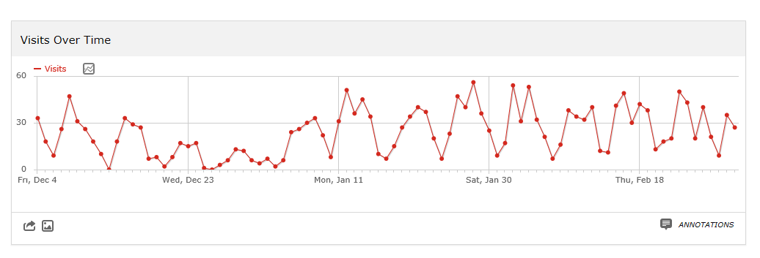
Visitor map since last conference in October 2015
