GPA Global Privacy and Data Protection Awards 2022
Entry Form
To submit an entry to the GPA Global Privacy and Data Protection Awards please complete and email this form to secretariat@globalprivacyassembly.org no later than 17 June 2022.
Note: GPA member authorities can submit as many entries as they wish, but a separate form should be used for each different entry, submitted by the deadline above.
Languages: The GPA documentation Rule 6.2 applies.
- CONTACT DETAILS FOR THIS ENTRY
Privacy/Data Protection Authority: | UK Information Commissioner’s Office
Person completing this form: | Alister | Pearson
 | First name | Last name
Job title: | Principal Policy Advisor
Email address: | Alister.Pearson@ico.org.uk  gpa@ico.org.uk

- ELIGIBILITY
By submitting this entry, I confirm that (please tick all boxes to confirm):
☒ | The Authority is a member of the Global Privacy Assembly
☒ | The initiative described in this entry was undertaken since January 2020.
☒ | I am aware that the information in the entry (other than the contact details in 1(a) above) will be publicised by the GPA Secretariat.

- CATEGORIES
Please indicate which category you wish to enter.
Please tick one; please use a separate form for each category you wish to enter:
☐ | Education and Public Awareness
☒ | Accountability
☐ | Dispute Resolution and Enforcement
☐ | Innovation
☐ | People’s Choice
- DESCRIPTION OF THE INITIATIVE

- Please provide a brief summary of the initiative (no more than 75 words)
The artificial intelligence (AI) and Data Protection Risk Toolkit helps organisations identify the risks to individual rights and freedoms where personal data is used, which can be caused by AI systems and provides practical steps to help sufficiently mitigate them.

- Please provide a full description of the initiative (no more than 350 words)
In April 2022, the ICO published its AI and Data Protection Risk Toolkit version 1.0. This version follows from successful consultation over an alpha and beta version of the toolkit. The toolkit uses the ICO’s Guidance on AI and data protection and its co-badged guidance with The Alan Turing Institute on Explaining decisions made with AI as its foundation and builds on it to provide a practical tool that organisations can use in their daily operations, which involves AI and personal data.

The risks and benefits to individuals that arise from personal data processing using AI are heavily context-dependant, and vary significantly across the diverse range of sectors, technologies and organisation types covered by data protection legislation. The ICO produced this toolkit to help organisations understand some of the AI-specific risks to individual rights and freedoms and provides practical steps to mitigate, reduce or manage them.

Organisations using AI to process personal data can use this tool as a way to assess the risks to fundamental rights and freedoms of individuals. By undertaking the practical steps suggested in line with what is expected under the legislation, these risks to fundamental rights and freedoms are reduced and compliance with data protection law becomes more likely. Documenting their assessment of the risk and the steps they take to mitigate them can help organisations demonstrate compliance with the legislation. The toolkit provides additional cells to illustrate how they could carry out an evaluation.

The toolkit has been designed to complement data protection impact assessments, providing practical guidance about how to identify and minimise the data protection risks of a project that involves AI.

- Please explain why you think the initiative deserves to be recognised by an award (no more than 200 words)
We believe the toolkit deserves to be recognised by an award for several reasons:

- It is robust. We have rigorously tested the toolkit via publishing alpha and beta versions for consultation, engaging with experts from multiple fields, including data scientists, security and compliance professionals, and testing the toolkit on live AI projects.
- It is pioneering. This is the first toolkit produced by a data protection regulator that focuses on risks to individual rights and freedoms caused by AI systems.
- It promotes responsible innovation. We recognise the power of AI and the potential benefits it can deliver for individuals and society, but we also understand the risks it can cause. This toolkit helps organisations to identify the greatest risks as well as ways to sufficiently mitigate them. By following the toolkit, organisations can realise the benefits of AI whilst minimising the risks for individuals.

- Please include a photograph or image, if you wish (This will be published with your entry on the GPA website. The image can be pasted into the box below, be sent as an attachment or a link may be provided)
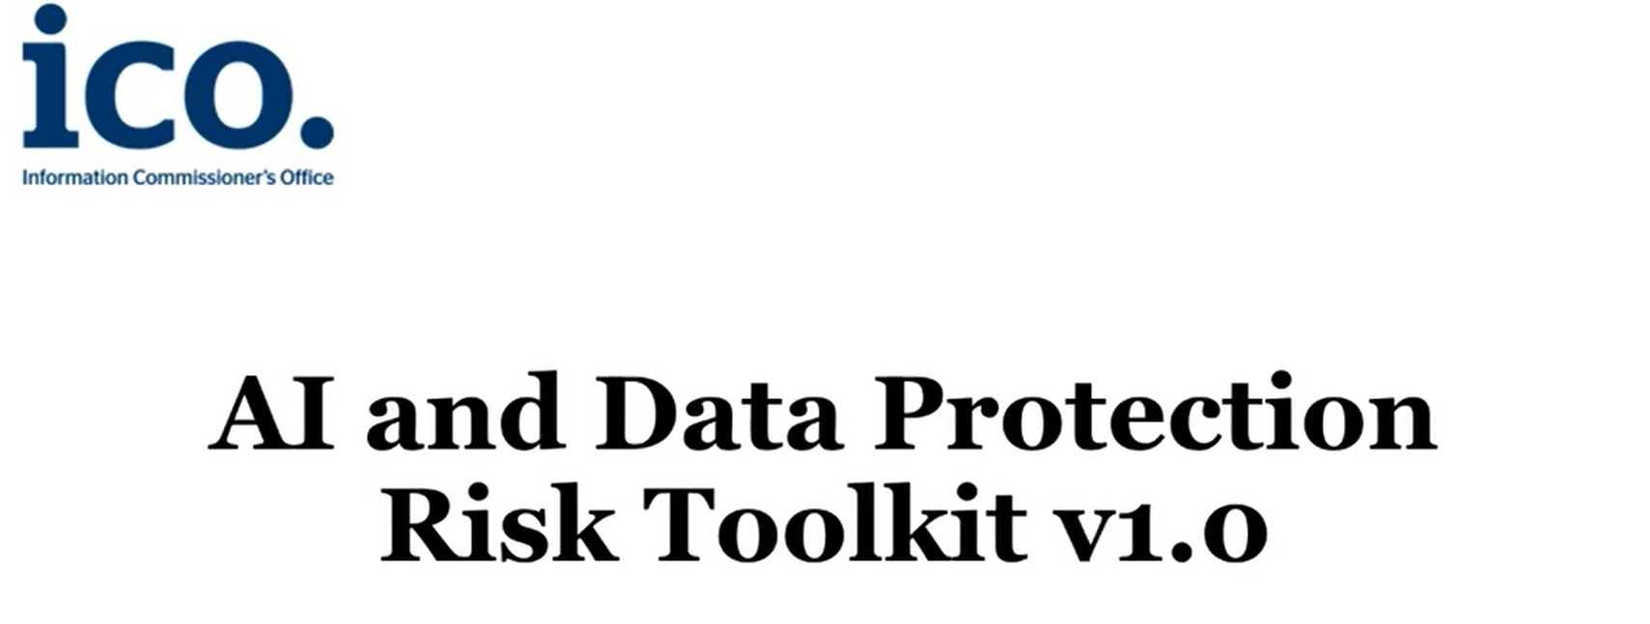

- Please provide the most relevant link on the authority’s website to the initiative, if applicable (The website content does not need to be in English)
AI and data protection risk toolkit | ICO

- Please provide any other relevant links that help explain the initiative or its impact or success (e.g. links to news reports or articles):
The ICO launches an AI and data protection risk toolkit (dacbeachcroft.com)

ICO unveils AI data protection risk toolkit | UKAuthority

GPA Rules and Procedures, Rule 6.2 ‘Assembly documents’: Without prejudice to section 4.2, Assembly documents, including accreditation and observer applications may be submitted in English or in another language. In the latter case, the documents shall be accompanied by an English version. Members with the ability and the resources to do so are encouraged to translate proposed resolutions and other Assembly documents such as the Assembly Rules and Procedures.

