GPA Global Privacy and Data Protection Awards 2022
Entry Form
To submit an entry to the GPA Global Privacy and Data Protection Awards please complete and email this form to secretariat@globalprivacyassembly.org no later than 17 June 2022.
Note: GPA member authorities can submit as many entries as they wish, but a separate form should be used for each different entry, submitted by the deadline above.
Languages: The GPA documentation Rule 6.2 applies.
- CONTACT DETAILS FOR THIS ENTRY
Privacy/Data Protection Authority: | Turkish Personal Data Protection Authority
Person completing this form: | Kumru | DÖNE
 | First name | Last name
Job title: | Personal Data Protection Expert
Email address: | kumru.done@kvkk.gov.tr

- ELIGIBILITY
By submitting this entry, I confirm that (please tick all boxes to confirm):
☒ | The Authority is a member of the Global Privacy Assembly
☒ | The initiative described in this entry was undertaken since January 2020.
☒ | I am aware that the information in the entry (other than the contact details in 1(a) above) will be publicised by the GPA Secretariat.

- CATEGORIES
Please indicate which category you wish to enter.
Please tick one; please use a separate form for each category you wish to enter:
☒ | Education and Public Awareness
☐ | Accountability
☐ | Dispute Resolution and Enforcement
☐ | Innovation
☐ | People’s Choice
- DESCRIPTION OF THE INITIATIVE

- Please provide a brief summary of the initiative (no more than 75 words)
Caricature, essay and slogan competitions have been held within the scope of the Personal Data Protection at Digital World activities. High school students participated in caricature and slogan competitions. Master or P.h.D. students participated in essay competition. The prize ceremony was organised on-line due to the Covid-19 Pandemics situation. These competitions attracted considerable attention of students and contributed to the public-awareness activities on personal data protection field.

- Please provide a full description of the initiative (no more than 350 words)
Caricature, essay and slogan competitions have been held within the scope of the Personal Data Protection at Digital World activities. High school students participated in caricature and slogan competition. Master or P.h.D. student participated in essay competition. The prize ceremony was organised on-line due to the Covid-19 Pandemics situation. These competitions attracted considerable attention of students and contributed to public-awareness activities on the data protection field. Three candidates won the prizes under each competition category. 9 students won the monetary prizes in total.

On the other hand, we published winners essay in the Turkish Journal of Privacy and Data Protection (The essay titled A Research on Personal Data Protection in Turkish Legal Literature (2000-2020) and; The essay titled Analyzing of Data Protection Impact Assessment As A Compliance Instrument In Terms of Turkish Law have won the prizes.) You can find the Journal on this page: https://dergipark.org.tr/tr/pub/kvkd

The slogans of the winners are presented below:

1. Data is personal, protection is universal
2. Do not let your secrets turn into traces
3. Your future is safe and secure if you protect your personal data

- Please explain why you think the initiative deserves to be recognised by an award (no more than 200 words)
These competitions attracted considerable attention of students and contributed to the public-awareness activities on the data protection field. These competitions have big impact on understanding of the importance of data protection issue among people ranging from high school students to P.h.D. students.

- Please include a photograph or image, if you wish (This will be published with your entry on the GPA website. The image can be pasted into the box below, be sent as an attachment or a link may be provided)
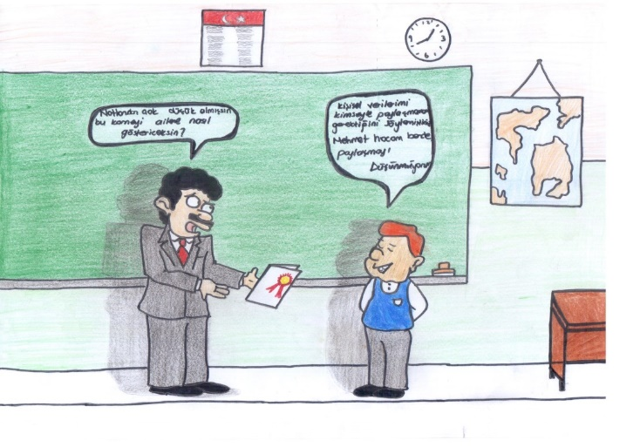

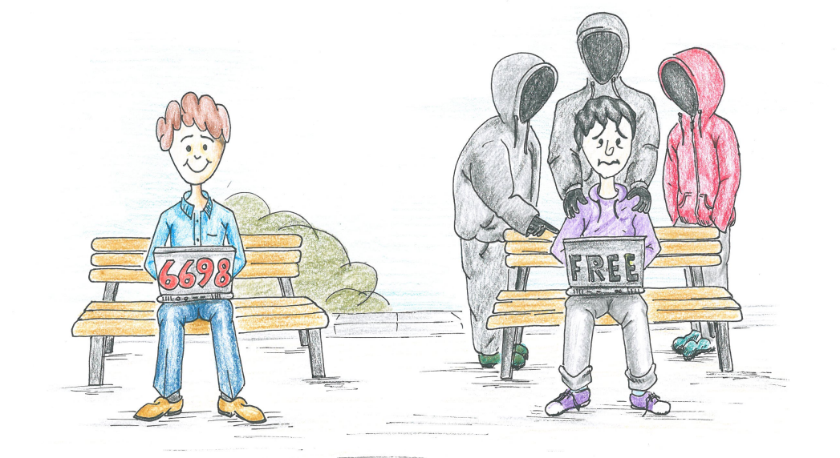

- Please provide the most relevant link on the authority’s website to the initiative, if applicable (The website content does not need to be in English)
KİŞİSEL VERİLERİ KORUMA KURUMU | KVKK | 7 Nisan Kişisel Verileri Koruma Günü Etkinliği Gerçekleştirildi

- Please provide any other relevant links that help explain the initiative or its impact or success (e.g. links to news reports or articles):

GPA Rules and Procedures, Rule 6.2 ‘Assembly documents’: Without prejudice to section 4.2, Assembly documents, including accreditation and observer applications may be submitted in English or in another language. In the latter case, the documents shall be accompanied by an English version. Members with the ability and the resources to do so are encouraged to translate proposed resolutions and other Assembly documents such as the Assembly Rules and Procedures.

