GPA Global Privacy and Data Protection Awards 2022
Entry Form
To submit an entry to the GPA Global Privacy and Data Protection Awards please complete and email this form to secretariat@globalprivacyassembly.org no later than 17 June 2022.
Note: GPA member authorities can submit as many entries as they wish, but a separate form should be used for each different entry, submitted by the deadline above.
Languages: The GPA documentation Rule 6.2 applies.
- CONTACT DETAILS FOR THIS ENTRY
Privacy/Data Protection Authority: | Information Commissioner’s Office
Person completing this form: | Michael | Murray
 | First name | Last name
Job title: | Head of Regulatory Strategy
Email address: | michael.murray@ico.org.uk / gpa@ico.org.uk

- ELIGIBILITY
By submitting this entry, I confirm that (please tick all boxes to confirm):
☒ | The Authority is a member of the Global Privacy Assembly
☒ | The initiative described in this entry was undertaken since January 2020.
☒ | I am aware that the information in the entry (other than the contact details in 1(a) above) will be publicised by the GPA Secretariat.

- CATEGORIES
Please indicate which category you wish to enter.
Please tick one; please use a separate form for each category you wish to enter:
☐ | Education and Public Awareness
☐ | Accountability
☐ | Dispute Resolution and Enforcement
☒ | Innovation
☐ | People’s Choice
- DESCRIPTION OF THE INITIATIVE

- Please provide a brief summary of the initiative (no more than 75 words)
The Children’s code (formally known as the Age Appropriate Design Code) is a code of practice that sets out how online services likely to be accessed by children (eg apps, online games, and social media) should protect them in the digital world.

To support businesses in complying with the code, the ICO has created:
- an award-winning design guidance that shows how to apply some of the standards in practice; and
- a best interests of the child guidance.

- Please provide a full description of the initiative (no more than 350 words)
The Children’s code is a data protection code of practice for online services, such as apps, online games, and web and social media sites, likely to be accessed by children under the age of 18.

To comply with the code, organisations providing online services likely to be accessed by children in the UK must take into account the best interests of the child.

The code sets out 15 standards of age appropriate design reflecting a risk-based approach. The focus is on:
- providing default settings which ensures that children have the best possible access to online services whilst minimising data collection and use, by default.
- ensuring that children who choose to change their default settings get the right information, guidance and advice before they do so, and proper protection in how their data is used afterwards.
- addressing how to design data protection safeguards into online services to ensure they are appropriate for use by, and meet the development needs of, children.

To support industry to implement the code standards, the ICO has created:
- award winning design guidance that shows how to apply some of the standards in practice, in order to create an open, transparent and safe place for children online. This guidance supports designers to put privacy by design at the core of their work.

- guidance, a self-assessment tools and a framework to help industry to apply the best interests of the child standard of the code as a primary consideration when designing and developing online services likely to be accessed by a child. This is the first time a DPA has tried to explain a complex concept in a way that industry can follow and apply. It is supported by a self-assessment risk toolkit.

- Please explain why you think the initiative deserves to be recognised by an award (no more than 200 words)
The Children’s code has already prompted changes by industry in how it protects children’s data.

We have seen large digital economy companies applying the standards of the code to reduce or prevent children’s data being used for targeted advertising. Further improvements can be seen in safe searching, the banning of direct messaging from strangers to teens, and significant improvements in transparency information that children can understand.

The Children’s code and its innovative UX design and best interest guidance shows technology companies how to design and function in a way that protects children’s rights.

It has also allowed the ICO to be a more engaged and proactive regulator, working closely with industry to guide code related improvements, and taking a more hands on approach to gathering evidence of conformance.

The Code has been an inspiration for similar child data protection initiatives in Europe and North America, which should help ensure that children everywhere are protected.

- Please include a photograph or image, if you wish (This will be published with your entry on the GPA website. The image can be pasted into the box below, be sent as an attachment or a link may be provided)
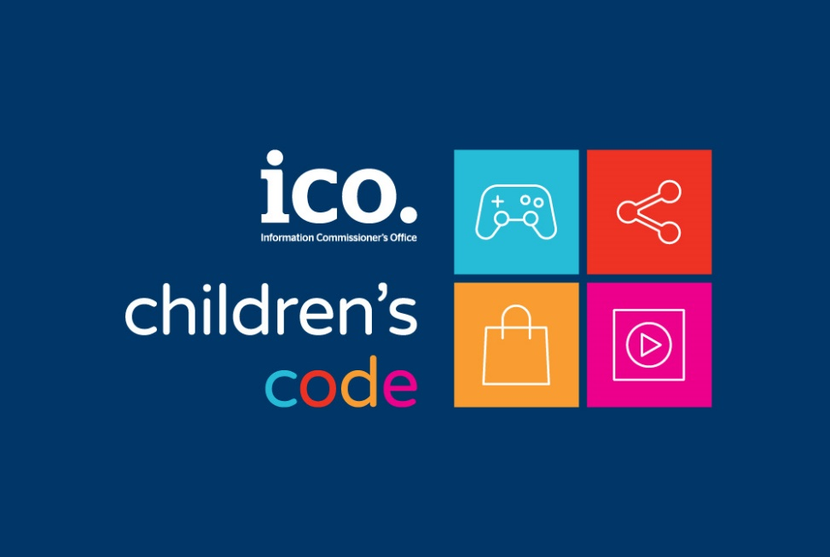

- Please provide the most relevant link on the authority’s website to the initiative, if applicable (The website content does not need to be in English)
https://ico.org.uk/for-organisations/childrens-code-hub/

- Please provide any other relevant links that help explain the initiative or its impact or success (e.g. links to news reports or articles):
https://ico.org.uk/for-organisations/guide-to-data-protection/ico-codes-of-practice/age-appropriate-design-a-code-of-practice-for-online-services/

https://global-uploads.webflow.com/5f47b99bcd1b0e76b7a78b88/627d107d47e2af70b18721fe_Fosi%20Brief_Creating%20an%20Age%20Appropriate%20Design%20Code%20in%20California_May%202022%20V2.0.pdf

https://iapp.org/news/a/reconciling-the-age-appropriate-design-code-with-coppa/
https://5rightsfoundation.com/uploads/Joint_letter_welcoming_the_Code.pdf

GPA Rules and Procedures, Rule 6.2 ‘Assembly documents’: Without prejudice to section 4.2, Assembly documents, including accreditation and observer applications may be submitted in English or in another language. In the latter case, the documents shall be accompanied by an English version. Members with the ability and the resources to do so are encouraged to translate proposed resolutions and other Assembly documents such as the Assembly Rules and Procedures.

