GPA Global Privacy and Data Protection Awards 2022
Entry Form
To submit an entry to the GPA Global Privacy and Data Protection Awards please complete and email this form to secretariat@globalprivacyassembly.org no later than 17 June 2022.
Note: GPA member authorities can submit as many entries as they wish, but a separate form should be used for each different entry, submitted by the deadline above.
Languages: The GPA documentation Rule 6.2 applies.
- CONTACT DETAILS FOR THIS ENTRY
Privacy/Data Protection Authority: | Data Protection Commission (Ireland)
Person completing this form: | Andrew | Carroll
 | First name | Last name
Job title: | Assistant Commissioner
Email address: | ATCarroll@dataprotection.ie

- ELIGIBILITY
By submitting this entry, I confirm that (please tick all boxes to confirm):
☒ | The Authority is a member of the Global Privacy Assembly
☒ | The initiative described in this entry was undertaken since January 2020.
☒ | I am aware that the information in the entry (other than the contact details in 1(a) above) will be publicised by the GPA Secretariat.

- CATEGORIES
Please indicate which category you wish to enter.
Please tick one; please use a separate form for each category you wish to enter:
☒ | Education and Public Awareness
☐ | Accountability
☐ | Dispute Resolution and Enforcement
☐ | Innovation
☐ | People’s Choice
- DESCRIPTION OF THE INITIATIVE

- Please provide a brief summary of the initiative (no more than 75 words)
In December 2021, the DPC published the final version of its comprehensive guidance on children’s data protection rights (‘the Fundamentals’) following a public consultation to give stakeholders an opportunity to review and make submissions on the draft version.

The DPC also published a report on this consultation and the submissions it received in November 2021.

Finally, the DPC published a series of guidance materials on data protection for children aged 13-18 in May 2022.

- Please provide a full description of the initiative (no more than 350 words)
The DPC has published the final version of its Fundamentals guidance for organisations that process children’s data following an extensive period of research, consultation and engagement with stakeholders. The DPC organised a public consultation in the first quarter of 2021 to give stakeholders an opportunity to comment and make submissions on the draft guidance. In total, 27 submissions were received from a range of sectors, including technology and social media companies, children’s rights charities, public sector bodies and trade associations.

In November 2021, the DPC published a report on this consultation, which gave an overview of the submissions received from participants as well as the DPC’s response. The DPC then published the final version of the Fundamentals in December 2021, which draws from the feedback from this consultation, but also from previous consultations, including with children themselves, and the DPC’s extensive research and engagement in this area. The final Fundamentals contain 14 child-specific data protection interpretative principles and recommended measures to help organisations protect children against risks to their data in both the online and offline world.

As part of this initiative, the DPC also published three short guides on data protection for children aged 13 and over on 25 May 2022. The purpose of these guides is to explain to children in language they can easily understand what data protection is and why it’s important, what their data protection rights are and how to use them, and to give children practical advice on how to keep their personal data safe in the digital environment. The names and format of these guides are as follows:
- Data protection - what's it all about? Introduces children to the idea of personal data and data protection, and why it's important for them to know about it.
- My data protection rights: Introduces children to data protection rights and how to use them.
- Top tips for keeping your data safe online: This guide has 15 useful tips to help children - and indeed everyone - keep their personal data safe when they go online.

- Please explain why you think the initiative deserves to be recognised by an award (no more than 200 words)
The DPC has produced comprehensive guidance for organisations on the processing of children’s data and the rights of children as data subjects. The Fundamentals have immediate application and now form the basis of the DPC’s approach to supervision, regulation and enforcement in the area of processing of children’s personal data. The Fundamentals are a significant contribution to public awareness and international best practice on providing the specific protection that children merit under the GDPR. This initiative also reflects the DPC’s commitment to prioritising the protection of children and other vulnerable groups as part of its 2022-2027 Regulatory Strategy.

This initiative also demonstrates the DPC’s commitment to providing children and young people with the knowledge and tools that they need to help keep their data safe in the digital environment, as demonstrated by our recently-published guidance for children aged 13 and over. The DPC consulted with child’s rights experts in the drafting of these materials to ensure the language and format was appropriate for children, and we also gave these materials a strong social media focus to ensure that they would resonate with children and reflect their day-to-day experience of data protection issues.

- Please include a photograph or image, if you wish (This will be published with your entry on the GPA website. The image can be pasted into the box below, be sent as an attachment or a link may be provided)
Image 1: Fundamentals Cover Page

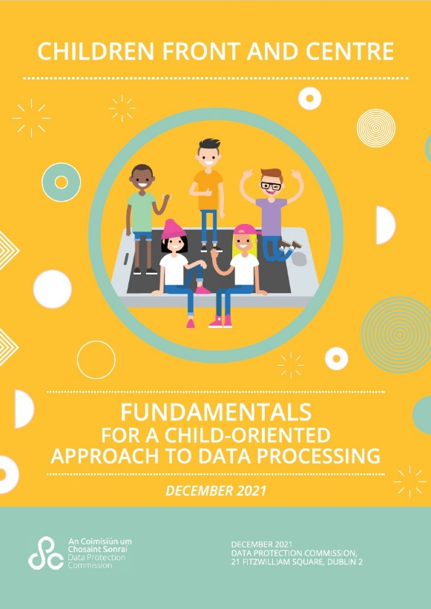

Image 2: My Data Protection Rights Cover Page

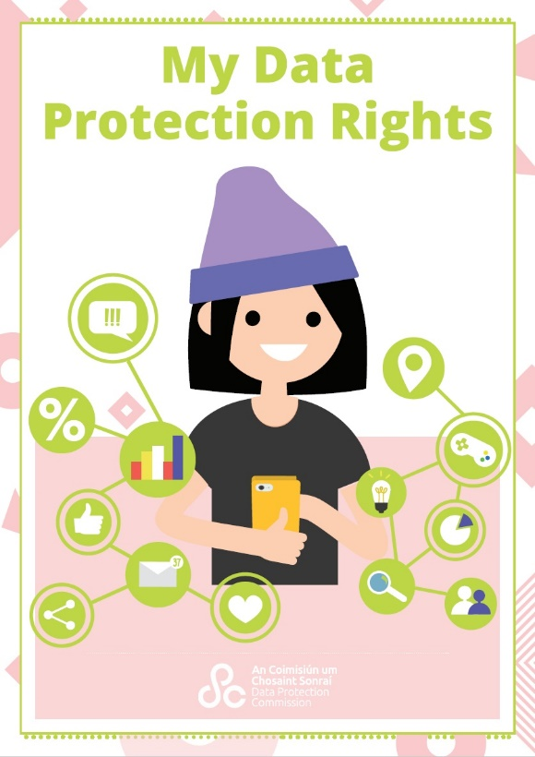

- Please provide the most relevant link on the authority’s website to the initiative, if applicable (The website content does not need to be in English)
DPC publishes final version of Children’s “Fundamentals”
https://www.dataprotection.ie/en/news-media/latest-news/dpc-publishes-final-version-childrens-fundamentals

DPC publishes guidance for children on their data protection rights:
https://www.dataprotection.ie/en/dpc-guidance/childrens-data-protection-rights

- Please provide any other relevant links that help explain the initiative or its impact or success (e.g. links to news reports or articles):
Comments on the Fundamentals from stakeholders:
- Common Sense Media (US) “The Fundamentals embody many of the principles and practices Common Sense has highlighted in debates on privacy and data protection in the U.S., and the principles and guidance in the Fundamentals will help encourage organizations to design products and services with privacy, digital well-being, and the best interests of the child in mind and from the start.”
- The Department of Education (Ireland) “The Department of Education commends the office of the Data Protection Commission in its work on developing the practical implementation of data protection rights for children”
- The National Council for Curriculum and Assessment (Ireland) “[The Fundamentals] will be an invaluable resource for all organisations who engage with children and young people”.
- The 5Rights Foundation (UK) “5Rights warmly welcomes the Fundamentals for a Child-Oriented approach to Data Processing as a significant step toward building the digital world young people deserve”
- The Age Check Certification Scheme (UK) “We welcome [the Fundamentals] and in particular its compatibility with the UK ICO’s Age Appropriate Design Code”
- Tusla (Irish agency for children and families) “Tusla welcomes the development of these “Fundamentals” and fully supports the DPC in their objective to improve standards and protections surrounding children’s personal data.”
- Webwise (Irish internet safety awareness centre) “Webwise is delighted to support the work of the Office of the Data Protection Commissioner. In particular we commend the child centred approach taken by the DPC to help protect and empower children online. The recent resources designed for young people in a clear, concise manner are an invaluable support for children, parents and educators”

Webinars / panel discussions by DPC staff on children’s privacy
- “Helping young people to better protect their privacy and safety online” Privacy Laws and Business (March 2022)
- Interview with Deputy Commissioner Anna Morgan on children’s privacy and the DPC’s Fundamentals (February 2021)

Reports / blogs on the Fundamentals
- “The Irish DPC publishes final version of its children’s fundamentals” Goodwin Law
- “GDPR and Children’s Data: What Lawyers Need to Know” Law Society of Ireland
- “DPC Publishes Guidance On Processing Children’s Personal Data” Lexology
- “Children's Privacy: New Irish Fundamentals v UK AADC” Reed Smith

GPA Rules and Procedures, Rule 6.2 ‘Assembly documents’: Without prejudice to section 4.2, Assembly documents, including accreditation and observer applications may be submitted in English or in another language. In the latter case, the documents shall be accompanied by an English version. Members with the ability and the resources to do so are encouraged to translate proposed resolutions and other Assembly documents such as the Assembly Rules and Procedures.
https://www.dataprotection.ie/sites/default/files/uploads/2021-11/Common%20Sense.pdf
https://www.dataprotection.ie/sites/default/files/uploads/2021-11/Department%20of%20Education.pdf
https://www.dataprotection.ie/sites/default/files/uploads/2021-11/National%20Council%20for%20Curriculum%20and%20Assessment.pdf
https://twitter.com/5rightsfound/status/1380695786657304579?s=27&t=ycg313K9nmPytl0KgxMeog
https://www.dataprotection.ie/sites/default/files/uploads/2021-11/Age%20Check%20Certification%20Scheme.pdf
https://www.dataprotection.ie/sites/default/files/uploads/2021-11/Tusla.pdf
https://www.privacylaws.com/events-gateway/events/youth22/
https://www.newstalk.com/podcasts/tech-talk-with-jess-kelly/exclusive-data-protection-commission-on-child-safety-online
https://www.goodwinlaw.com/publications/2022/01/the-irish-dpc-publishes-final-version-of-its-child
https://www.lawsociety.ie/News/News/Stories/gdpr-and-childrens-data-what-lawyers-need-to-know
https://www.lexology.com/library/detail.aspx?g=cc946074-c45e-47d0-9aa5-cce66afedf6b
https://viewpoints.reedsmith.com/post/102heyo/childrens-privacy-new-irish-fundamentals-v-uk-aadc

