GPA Global Privacy and Data Protection Awards 2022
Entry Form
To submit an entry to the GPA Global Privacy and Data Protection Awards please complete and email this form to secretariat@globalprivacyassembly.org no later than 17 June 2022.
Note: GPA member authorities can submit as many entries as they wish, but a separate form should be used for each different entry, submitted by the deadline above.
Languages: The GPA documentation Rule 6.2 applies.
- CONTACT DETAILS FOR THIS ENTRY
Privacy/Data Protection Authority: | The Danish Data Protection Agency
Person completing this form: | Anders | Due
 | First name | Last name
Job title: | Head of Communication
Email address: | ad@datatilsynet.dk

- ELIGIBILITY
By submitting this entry, I confirm that (please tick all boxes to confirm):
☒ | The Authority is a member of the Global Privacy Assembly
☒ | The initiative described in this entry was undertaken since January 2020.
☒ | I am aware that the information in the entry (other than the contact details in 1(a) above) will be publicised by the GPA Secretariat.

- CATEGORIES
Please indicate which category you wish to enter.
Please tick one; please use a separate form for each category you wish to enter:
☒ | Education and Public Awareness
☐ | Accountability
☐ | Dispute Resolution and Enforcement
☐ | Innovation
☐ | People’s Choice
- DESCRIPTION OF THE INITIATIVE

- Please provide a brief summary of the initiative (no more than 75 words)
A fun online learning game for children about their rights under data protection law – available for free on the Danish DPA website.

- Please provide a full description of the initiative (no more than 350 words)
On the 28th of January 2022 The Danish Data Protection Agency launched an online learning game for kids called: ”Datadysten”.

The game aims to promote awareness amongst kids of their rights to have their personal data protected under data protection law in a fun way.

The game “Datadysten” is available for free at the Danish Data Protection Agency’s official website at: https://www.datatilsynet.dk

The game includes learning material for teachers and parents who might be interested. The target group of the game is children aged 10-12, however, grown-ups have said they have also learned about data protection playing the game.

The game has been developed by a game company specialized in learning games in union with lawyers and IT specialists. Furthermore, both teachers and kids have been included in the process of the development of the game to ensure that it works well with the target group.

Finally and most important it has been received very nicely amongst kids and teachers!

- Please explain why you think the initiative deserves to be recognised by an award (no more than 200 words)
The GDPR stresses that DPAs should make a special effort to address children and help them understand their rights. This initiative aims to do this in a way that’s fun for the children and at the same time easy for teachers to incorporate in their lessons.

- Please include a photograph or image, if you wish (This will be published with your entry on the GPA website. The image can be pasted into the box below, be sent as an attachment or a link may be provided)
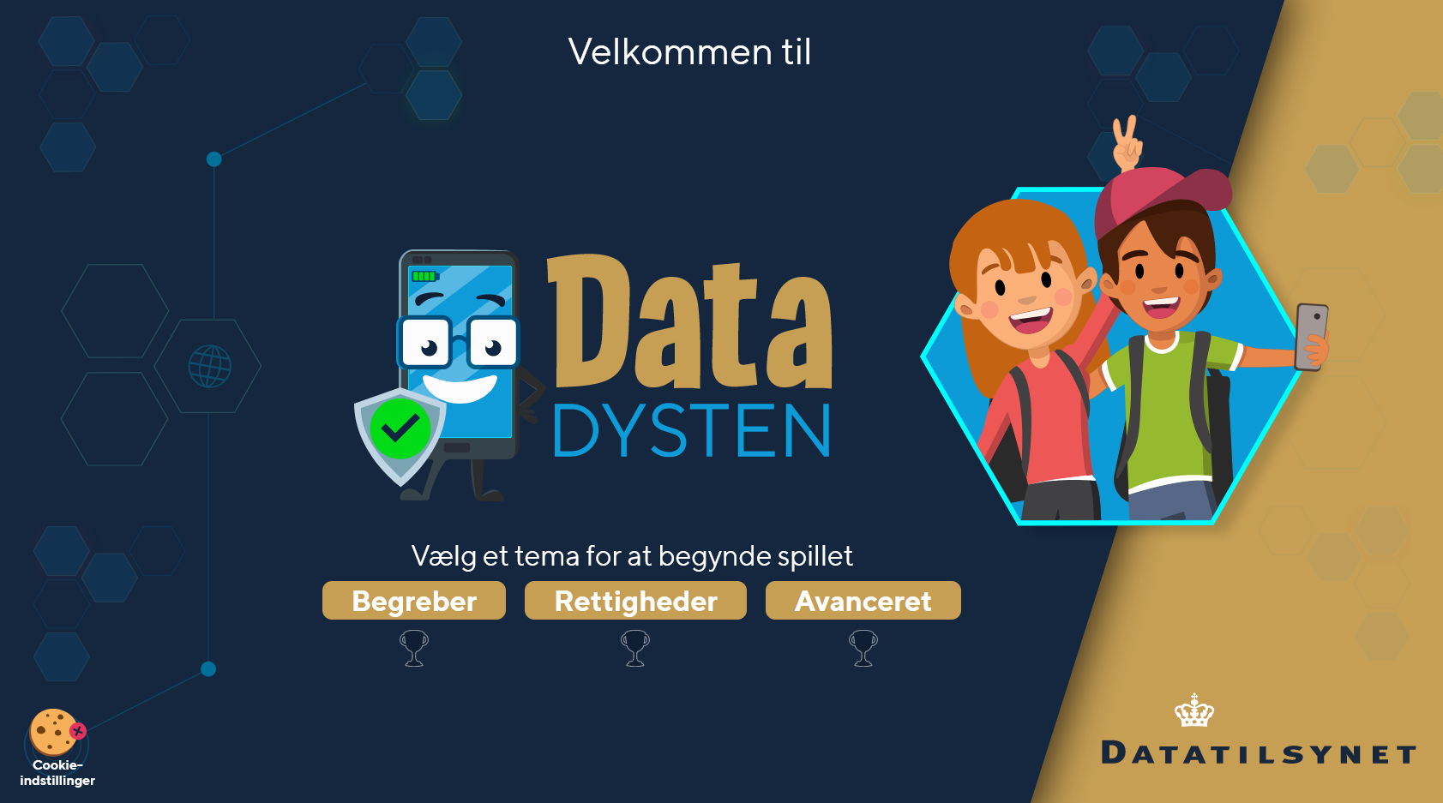

- Please provide the most relevant link on the authority’s website to the initiative, if applicable (The website content does not need to be in English)
https://datadysten.dk/

- Please provide any other relevant links that help explain the initiative or its impact or success (e.g. links to news reports or articles):
https://pro.ing.dk/compliancetech/note/datatilsynet-lancerer-digitalt-spil-om-databeskyttelse
https://www.forstå.dk/forloeb/datadysten/11547
https://www.securityuser.com/dk/Nyheder/Samfund/nyt-sjovt-spil-for-born-og-unge-om-databeskyttelse1

GPA Rules and Procedures, Rule 6.2 ‘Assembly documents’: Without prejudice to section 4.2, Assembly documents, including accreditation and observer applications may be submitted in English or in another language. In the latter case, the documents shall be accompanied by an English version. Members with the ability and the resources to do so are encouraged to translate proposed resolutions and other Assembly documents such as the Assembly Rules and Procedures.

