GPA Global Privacy and Data Protection Awards 2022
Entry Form
To submit an entry to the GPA Global Privacy and Data Protection Awards please complete and email this form to secretariat@globalprivacyassembly.org no later than 17 June 2022.
Note: GPA member authorities can submit as many entries as they wish, but a separate form should be used for each different entry, submitted by the deadline above.
Languages: The GPA documentation Rule 6.2 applies.
- CONTACT DETAILS FOR THIS ENTRY
Privacy/Data Protection Authority: | Information and Data Protection Commissioner of Albania (IDP)
Person completing this form: | Denada Hysi
 | First name | Last name
Job title: | Specialist of Projects and International Relations
Email address: | Denada.hysi@idp.al

- ELIGIBILITY
By submitting this entry, I confirm that (please tick all boxes to confirm):
☒ | The Authority is a member of the Global Privacy Assembly
☒ | The initiative described in this entry was undertaken since January 2020.
☒ | I am aware that the information in the entry (other than the contact details in 1(a) above) will be publicised by the GPA Secretariat.

- CATEGORIES
Please indicate which category you wish to enter.
Please tick one; please use a separate form for each category you wish to enter:
☒ | Education and Public Awareness
☐ | Accountability
☐ | Dispute Resolution and Enforcement
☐ | Innovation
☐ | People’s Choice
- DESCRIPTION OF THE INITIATIVE

- Please provide a brief summary of the initiative (no more than 75 words)
The Information and Data Protection Commissioner’s Office prepared a questionnaire addressed to Public Authorities on assessing the level of awareness of public sector’s employees about the right to the protection of personal data in the Republic of Albania.
Based on the results obtained therefrom, the Commissioner’s Office received clear information regarding the level of knowledge by public sector officials about the obligations in the field of personal data protection, and identified the most important issues, the needs for professional development and further training of the employees of these institutions.

- Please provide a full description of the initiative (no more than 350 words)
In the framework of the International Data Protection Day (28 January), the Information and Data Protection Commissioner’s Office held a meeting to introduce the results of the first ever inclusive questionnaire on the assessment of knowledge of public authorities on the right to personal data protection. This questionnaire was addressed to public authorities, in particular to those that process personal data on a significant scale or regularly and systematically.

The questionnaire was distributed to 121 institutions of public sector, including central government institutions, local government institutions, independent institutions and other institutions. It resulted that 1704 public officials had filled in the questionnaire.

The questionnaire consisted of 21 questions, which had multiple answering alternatives. The content and questions of the questionnaire were compiled by the Commissioner’s Office. The questionnaire was submitted to the officials of public administration institutions, with various numbers of employees, in order to assess their knowledge on the right to protection of personal data, criteria and norms for the legal processing of such data, etc. The questionnaire was circulated via e-mail to the official addresses of institutions, to the Coordinators for Information Rights or the Personal Data Protection Officers thereof.

The participants who filled in the questionnaire are respectively: 50% of them are employees of central government institutions, 13% of local government institutions, 21% of independent institutions, and 16% of them belong to other institutions. From the questionnaire, it resulted that there is lack of knowledge on the implementation of the Law, and they have limited knowledge on some of the main definitions of the law such as “personal data”, ‘sensitive data”, “controller”, “processor”, “personal data processing”, “consent of the data subject” etc. Moreover, there is lack of knowledge on the basic principles on which personal data processing is based on, such as lawful processing, collection of data for specific purposes, the data adequacy and accuracy, the legal criteria for processing personal data and the cases when data can be processed.

- Please explain why you think the initiative deserves to be recognised by an award (no more than 200 words)
Over the last years, the Information and Data Protection Commissioner’s Office has set among its key priorities the awareness-raising activities with particular focus on the public sector in Albania. The initiative we introduce today is aimed at triggering an inclusive and sustainable campaign of awareness-raising in this sector, with the main objective consisting in fostering a culture of accountability and responsibility.

- Please include a photograph or image, if you wish (This will be published with your entry on the GPA website. The image can be pasted into the box below, be sent as an attachment or a link may be provided)
The photos below are taken during the meeting held by IDP Commissioner’s Office presenting the results of the questionnaire.

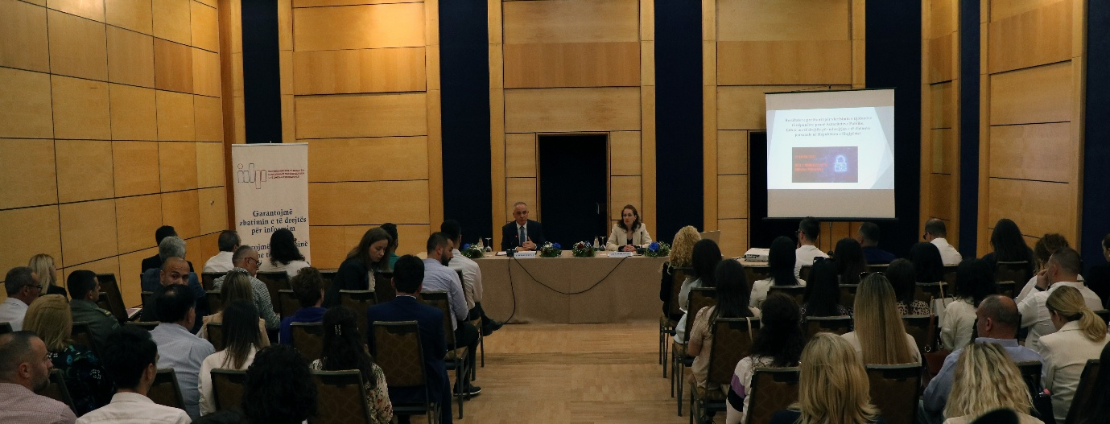

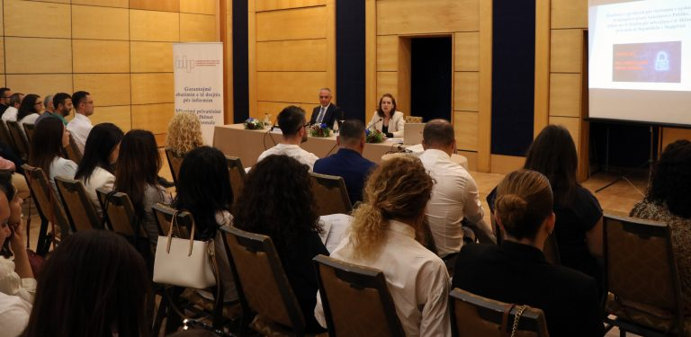

- Please provide the most relevant link on the authority’s website to the initiative, if applicable (The website content does not need to be in English)
https://www.idp.al/2022/01/28/28-janar-dita-e-mbrojtjes-se-te-dhenave-personale-2/ (its launch)
https://www.idp.al/2022/05/16/18610/
https://www.idp.al/wp-content/uploads/2022/05/Pyetesori_per_diten_e_mbrojtjes_se_te_dhenave_personale.pdf (results of the questionnaire)

- Please provide any other relevant links that help explain the initiative or its impact or success (e.g. links to news reports or articles):
https://www.idp.al/2022/01/28/28-janar-dita-e-mbrojtjes-se-te-dhenave-personale-2/

https://ata.gov.al/2022/05/16/mbrojtja-e-te-dhenave-personale-kontrollues-publik-te pergjegjshem-dhe-transparent/

GPA Rules and Procedures, Rule 6.2 ‘Assembly documents’: Without prejudice to section 4.2, Assembly documents, including accreditation and observer applications may be submitted in English or in another language. In the latter case, the documents shall be accompanied by an English version. Members with the ability and the resources to do so are encouraged to translate proposed resolutions and other Assembly documents such as the Assembly Rules and Procedures.

