GPA Global Privacy and Data Protection Awards 2022
Entry Form
To submit an entry to the GPA Global Privacy and Data Protection Awards please complete and email this form to secretariat@globalprivacyassembly.org no later than 17 June 2022.
Note: GPA member authorities can submit as many entries as they wish, but a separate form should be used for each different entry, submitted by the deadline above.
Languages: The GPA documentation Rule 6.2 applies.
- CONTACT DETAILS FOR THIS ENTRY
Privacy/Data Protection Authority: | Office of Data Protection, Abu Dhabi Global Market
Person completing this form: | Sayid | Madar
 | First name | Last name
Job title: | Head of Operations, Office of Data Protection
Email address: | sayid.madar@adgm.com

- ELIGIBILITY
By submitting this entry, I confirm that (please tick all boxes to confirm):
☒ | The Authority is a member of the Global Privacy Assembly
☒ | The initiative described in this entry was undertaken since January 2020.
☒ | I am aware that the information in the entry (other than the contact details in 1(a) above) will be publicised by the GPA Secretariat.

- CATEGORIES
Please indicate which category you wish to enter.
Please tick one; please use a separate form for each category you wish to enter:
☐ | Education and Public Awareness
☐ | Accountability
☐ | Dispute Resolution and Enforcement
☒ | Innovation
☐ | People’s Choice
- DESCRIPTION OF THE INITIATIVE

- Please provide a brief summary of the initiative (no more than 75 words)
ADGM Office of Data Protection (“ODP”) has solved the issue of identifying Data Controllers in its jurisdiction and collecting all data protection registration fees from them through a strategic partnership with the ADGM Registrar of Companies (“Registrar”). In addition, the partnership allowed the ODP to gather insights and intelligence about the processing activities of all entities at a Controller level.

- Please provide a full description of the initiative (no more than 350 words)
Following the enactment of the ADGM Data Protection Regulations 2021 (“DPR 2021”), the ODP wanted to address this key challenge:

- How can we identify all Data Controllers in ADGM’s jurisdiction and collect data protection fees from new and existing entities whilst maintaining a user friendly experience for all stakeholders?

To be Established within ADGM as defined by the DPR 2021, all legal entities would need to be licenced by the Registrar to conduct activities within the jurisdiction. Therefore, the first touchpoint for any prospective businesses wanting to conduct any commercial or civil operations in ADGM is with the Registrar. The Registrar has in place a digital registry solution where all applications to incorporate legal persons in ADGM must be submitted electronically via the Registry Platform (https://www.registration.adgm.com/).

ODP worked with the Registrar to collect information and fee payments from Data Controllers as part of the online incorporation form within the Registry Platform. Through this arrangement, the ODP was able to collect 100% of the statutory data protection registration fees at the time of registration and incorporation for new businesses. For existing businesses, the process will capture entities during their yearly Annual Renewal filing. This approach not only ensures collection of statutory fees and information on Controllers, but streamlines the process and reduces burden on firms.

Furthermore, we embedded key questions into the Registry System to be completed during the registration and incorporation process. In particular, we were able to capture information which would support in the development of a risk rating methodology for assessing Controllers. The information collected at the time of incorporation – or during the annual renewal period includes:

- Types of personal data
- Categories of the data
- Lawful basis relied upon
- Transfer locations and mechanism(s) relied upon

When combined with other information held by the Registrar, the ODP can gather a wealth of intelligence which can be segmented by processing activity, business activity or sector. This allows us to target our supervision activities to high-risk activities and entities. Additionally, we can use the insights to feed into other policy objectives such as education and outreach.

- Please explain why you think the initiative deserves to be recognised by an award (no more than 200 words)
The ODP’s initiative seeks to fill a gap currently impacting many data protection authorities globally. Resourcing is an issue globally impacting both new and existing authorities. Whilst many data protection laws provide the legal basis to receive fees from Controllers– the collection of the fee itself can pose an even bigger challenge. We recognised this challenge early on and sought to explore ways to address it.

This initiative aims to demonstrate that strategic partnerships such as ones with the Registrar can provide data protection authorities with an innovative opportunity for a mutual win-win with limited cost implications. Ensuring Controllers comply with their notification and fee obligation whilst establishing good relations with the Registrar of Companies has many mutual benefits. For instance:
- Transparency of statutory fees, in particular, for SMEs.
- DP notification aligned with annual renewal filing date (one-stop-shop).
- Reduces non-payment risk for entities.
- Better service experience for regulated entities (i.e., no bulk emails/letters).

Since implementing this initiative, the ODP has collected 100% of all data protection registration fees for new businesses. In addition, we have collected from approximately 98% of existing businesses which are captured through our integration into the annual renewal filing process. There are currently 4800 entities in our jurisdiction.

- Please include a photograph or image, if you wish (This will be published with your entry on the GPA website. The image can be pasted into the box below, be sent as an attachment or a link may be provided)
The image below shows the highlighted ‘Data Protection’ section currently included within the Registrar of Companies Registry Solution. The register is publicly available here: https://www.registration.adgm.com/

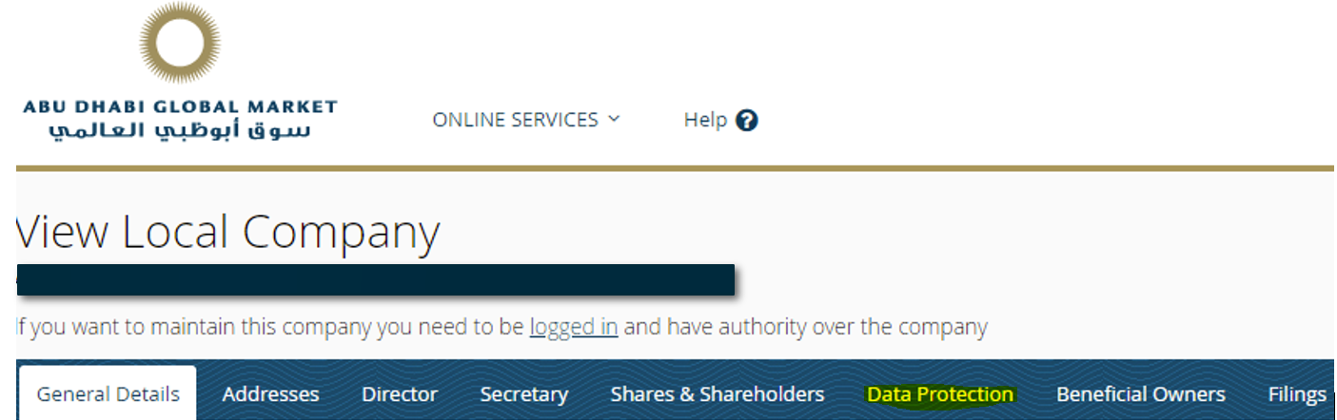

- Please provide the most relevant link on the authority’s website to the initiative, if applicable (The website content does not need to be in English)

- Please provide any other relevant links that help explain the initiative or its impact or success (e.g. links to news reports or articles):
https://www.registration.adgm.com/

GPA Rules and Procedures, Rule 6.2 ‘Assembly documents’: Without prejudice to section 4.2, Assembly documents, including accreditation and observer applications may be submitted in English or in another language. In the latter case, the documents shall be accompanied by an English version. Members with the ability and the resources to do so are encouraged to translate proposed resolutions and other Assembly documents such as the Assembly Rules and Procedures.
ADGM’s jurisdiction extends across the entirety of Al Maryah Island in Abu Dhabi, UAE.
Article 62(1) of the DPR 2021

