GPA Global Privacy and Data Protection Awards 2022
Entry Form
To submit an entry to the GPA Global Privacy and Data Protection Awards please complete and email this form to secretariat@globalprivacyassembly.org no later than 17 June 2022.
Note: GPA member authorities can submit as many entries as they wish, but a separate form should be used for each different entry, submitted by the deadline above.
Languages: The GPA documentation Rule 6.2 applies.
- CONTACT DETAILS FOR THIS ENTRY
Privacy/Data Protection Authority: | Personal Data Protection Authority – KVKK
Person completing this form: | Kumru DÖNE
 | First name | Last name
Job title: | Personal Data Protection Expert
Email address: | kumru.done@kvkk.gov.tr

- ELIGIBILITY
By submitting this entry, I confirm that (please tick all boxes to confirm):
☒ | The Authority is a member of the Global Privacy Assembly
☒ | The initiative described in this entry was undertaken since January 2020.
☒ | I am aware that the information in the entry (other than the contact details in 1(a) above) will be publicised by the GPA Secretariat.

- CATEGORIES
Please indicate which category you wish to enter.
Please tick one; please use a separate form for each category you wish to enter:
☒ | Education and Public Awareness
☐ | Accountability
☐ | Dispute Resolution and Enforcement
☐ | Innovation
☐ | People’s Choice
- DESCRIPTION OF THE INITIATIVE

- Please provide a brief summary of the initiative (no more than 75 words)
Raising personal data awareness to children in the younger age group through the character in a cartoon broadcast on the official state television in Turkey called “Data Crew”

- Please provide a full description of the initiative (no more than 350 words)
“Data Crew” is a project that raises awareness about personal data in children aged 6-12 through a character in a cartoon broadcast on state television in Turkey. In this project, which is actually a musical show, various cities in Turkey were visited and children were met. The project has been carried out in 48 sessions in 13 cities so far. It was aimed that children have fun while watching the "Data Crew" shows, and that they are informed according to their ages about what personal data is, what they should pay attention to when sharing them, and how important personal data is. Children were made to realize that malicious people in online environments may reflect their behaviours, faces and even their living spaces differently on the Internet. In addition, it was tried to raise awareness of families about the sharing and protection of personal data. Families were told that the privacy and security settings of social media accounts and smart devices should be consciously regulated, and that some games played online may cause psychological and physical problems as well as personal data security. The data crew project was a good example of cooperation between a cartoon and an authority. Another importance of the project is that it was implemented on the World Children's Rights Day.

- Please explain why you think the initiative deserves to be recognised by an award (no more than 200 words)
This project succeeded in explaining the most important issues of the digital age, personal data and privacy, to children, without boring them, moreover, by entertaining them. At the same time, it has shown that with a well-considered collaboration, an awareness study can be designed for each age group, suitable for that age group. In addition, it was not carried out only in the city where the authority is located, it was tried to ensure equality of opportunity in raising the awareness of children by going to various cities. This project was a huge effort that required money, time, energy and sacrifice.

- Please include a photograph or image, if you wish (This will be published with your entry on the GPA website. The image can be pasted into the box below, be sent as an attachment or a link may be provided)
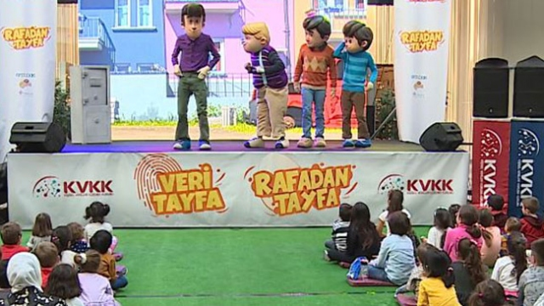

- Please provide the most relevant link on the authority’s website to the initiative, if applicable (The website content does not need to be in English)

- Please provide any other relevant links that help explain the initiative or its impact or success (e.g. links to news reports or articles):
https://www.youtube.com/watch?v=SK7FYowoQFU (an introduction video)

GPA Rules and Procedures, Rule 6.2 ‘Assembly documents’: Without prejudice to section 4.2, Assembly documents, including accreditation and observer applications may be submitted in English or in another language. In the latter case, the documents shall be accompanied by an English version. Members with the ability and the resources to do so are encouraged to translate proposed resolutions and other Assembly documents such as the Assembly Rules and Procedures.

