GPA Global Privacy and Data Protection Awards 2022
Entry Form
To submit an entry to the GPA Global Privacy and Data Protection Awards please complete and email this form to secretariat@globalprivacyassembly.org no later than 17 June 2022.
Note: GPA member authorities can submit as many entries as they wish, but a separate form should be used for each different entry, submitted by the deadline above.
Languages: The GPA documentation Rule 6.2 applies.
- CONTACT DETAILS FOR THIS ENTRY
Privacy/Data Protection Authority: | Commission for personal data protection
Person completing this form: | Hristo | Alaminov
 | First name | Last name
Job title: | Head of International Cooperation and Project Management Department
Email address: | halaminov@cpdp.bg

- ELIGIBILITY
By submitting this entry, I confirm that (please tick all boxes to confirm):
☒ | The Authority is a member of the Global Privacy Assembly
☒ | The initiative described in this entry was undertaken since January 2020.
☒ | I am aware that the information in the entry (other than the contact details in 1(a) above) will be publicised by the GPA Secretariat.

- CATEGORIES
Please indicate which category you wish to enter.
Please tick one; please use a separate form for each category you wish to enter:
☐ | Education and Public Awareness
☐ | Accountability
☐ | Dispute Resolution and Enforcement
☒ | Innovation
☐ | People’s Choice
- DESCRIPTION OF THE INITIATIVE

- Please provide a brief summary of the initiative (no more than 75 words)
"GDPR in your pocket" is an innovative awareness raising software package – mobile and desktop application, designed to introduce applicable privacy legislation to citizens and small and medium-sized enterprises in an easy to use and understand way and give them practical knowledge and advice on their rights or obligations under the European Union and national law in the field of personal data protection. The application’s content is currently available in English, Italian, Bulgarian, German and French.

- Please provide a full description of the initiative (no more than 350 words)
The Commission for Personal Data Protection of the Republic of Bulgaria in cooperation with public sector institution and businesses, academia and NGOs from Italy and Bulgaria has implemented an innovative initiative to ensuring the highest level of protection of privacy and personal data through contemporary tools for small and medium-sized enterprises and citizens by jointly developing the software package "GDPR in your pocket" (mobile app and desktop application for Windows 10/11).
The tool aims to introduce in accessible, clear and understandable way the GDPR, European Union law, applicable national legislation (of Bulgaria, Italy, Germany and France) and international legal acts in the area of personal data protection, as well as the guidelines of the European Data Protection Board (EDPB), European Data Protection Supervisor (EDPS).
Users can choose between 5 languages ​​- English, German, French, Italian and Bulgarian - to access the constantly updated sections "Legal Library", "GDPR Dictionary", "Guide for citizens" and "Guide for SMEs". All sections use a boost engine to provide via full text, key word or quoted text all three methods of precision, sensitivity, and specific search.
The application provides users with the ability to bookmark content items that they may want to read later, as well as the ability to save locally in the memory of your device the texts of their favourite documents, which allows them to access content offline.
The Legal library gives access to a rich collection of legal documents of the European Union and four EU Member States as well as the applicable international acts.
The interactive Advisory module provides practical guidance on GDPR rules to citizens and SMEs. It comprises the following components:
- GDPR made simple – a need-to-know guide explaining in a comprehensible, easy to understand way the rights of individuals and obligations placed on organisations;
- Decision support tools – help representatives of SMEs to find evidence-based solutions of key issues related to data protection.
- Frequently asked questions – gives answers to typical questions of citizens and SMEs based on experience.
- GDPR dictionary – legal terms and definitions introduced by GDPR.
- User friendly search tool throughout the overall content available in the Main menu.

- Please explain why you think the initiative deserves to be recognised by an award (no more than 200 words)
“GDPR in your pocket” is an interactive tool aimed to facilitate businesses all over the world in demonstrating compliance with the EU legal framework. It is a reliable source of first-hand contemporary information and at the same time free advisory tool in the field of privacy and personal data protection providing proven content about the applicable legislation. Although initially funded by the EU for its citizens and legal entities, its direct effect is global privacy, supporting businesses from North America, Africa, Asia, Australia, New Zealand and Middle East through prompt and detailed privacy and data protection knowledge. It is delivered in a consciously developed palette of frequently used languages (next version will be the Spanish one) in order to support the efforts of SMEs when entering the EU Single Market. Added value of the solution is spread widely beyond Europe by saving significant amounts of money for consultations, legal advices, etc. potentially spent by the SMEs across the globe. The algorithm of the tool finds evidence-based solutions of key issues related to the protection of privacy and personal data. Referring to the recent dynamic technological development the proposed pioneering approach can be easy multiplied in other close knowledge areas.

- Please include a photograph or image, if you wish (This will be published with your entry on the GPA website. The image can be pasted into the box below, be sent as an attachment or a link may be provided)
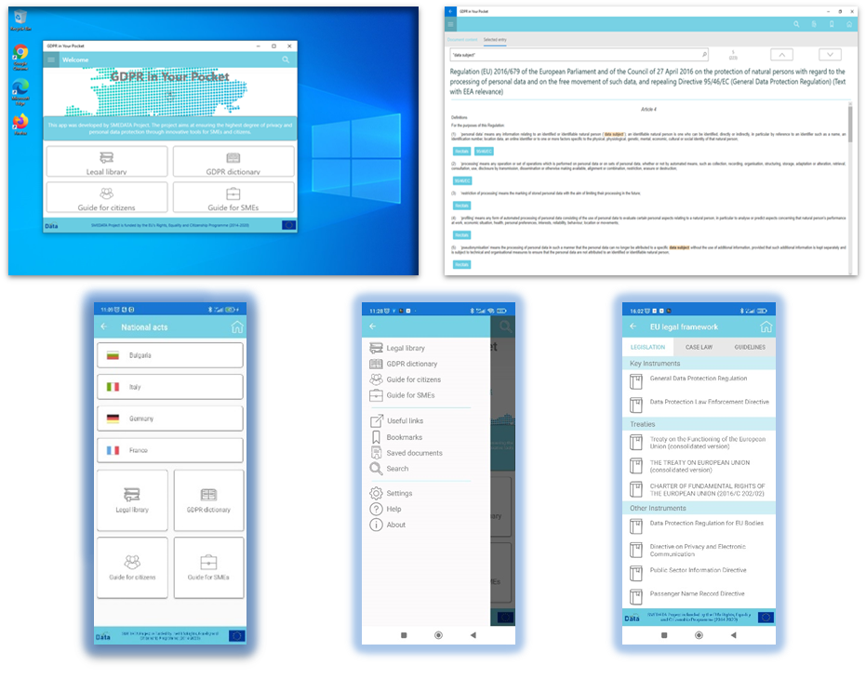

- Please provide the most relevant link on the authority’s website to the initiative, if applicable (The website content does not need to be in English)
https://www.cpdp.bg/en/index.php?p=element&aid=1271
https://smedata.eu/index.php/project/tools/gdpr-in-your-pocket/

- Please provide any other relevant links that help explain the initiative or its impact or success (e.g. links to news reports or articles):
The “GDPR in your pocket” app and desktop application can be freely downloaded from the Google Apps Store (for Android devices) and Apple (iOS devices), as well as desktop computers, using the following links:

• Google Play Store – https://play.google.com/store/apps/details?id=com.ApisEurope.SmeData.Mobile
• Apple App Store – https://apps.apple.com/tc/app/gdpr-in-your-pocket/id1474950057
• Microsoft Store – https://apps.microsoft.com/store/detail/gdpr-in-your-pocket/9N13FG496BB7?hl=en-gb&gl=GB

GPA Rules and Procedures, Rule 6.2 ‘Assembly documents’: Without prejudice to section 4.2, Assembly documents, including accreditation and observer applications may be submitted in English or in another language. In the latter case, the documents shall be accompanied by an English version. Members with the ability and the resources to do so are encouraged to translate proposed resolutions and other Assembly documents such as the Assembly Rules and Procedures.

