GPA Global Privacy and Data Protection Awards 2022
Entry Form
To submit an entry to the GPA Global Privacy and Data Protection Awards please complete and email this form to secretariat@globalprivacyassembly.org no later than 17 June 2022.
Note: GPA member authorities can submit as many entries as they wish, but a separate form should be used for each different entry, submitted by the deadline above.
Languages: The GPA documentation Rule 6.2 applies.
- CONTACT DETAILS FOR THIS ENTRY
Privacy/Data Protection Authority: | Information Commissioner’s Office
Person completing this form: | Michael | Murray
 | First name | Last name
Job title: | Head of Regulatory Strategy
Email address: | michael.murray@ico.org.uk / gpa@ico.org.uk

- ELIGIBILITY
By submitting this entry, I confirm that (please tick all boxes to confirm):
☒ | The Authority is a member of the Global Privacy Assembly
☒ | The initiative described in this entry was undertaken since January 2020.
☒ | I am aware that the information in the entry (other than the contact details in 1(a) above) will be publicised by the GPA Secretariat.

- CATEGORIES
Please indicate which category you wish to enter.
Please tick one; please use a separate form for each category you wish to enter:
☒ | Education and Public Awareness
☐ | Accountability
☐ | Dispute Resolution and Enforcement
☐ | Innovation
☐ | People’s Choice
- DESCRIPTION OF THE INITIATIVE

- Please provide a brief summary of the initiative (no more than 75 words)
The Children’s code (formally known as the Age Appropriate Design Code) is a code of practice that sets out how online services likely to be accessed by children (eg apps, online games, and social media) should protect them in the digital world.

To educate children about their data protection rights and how the Children’s code supports them, the ICO has created free resources for teachers to use in schools and to share with parents.

- Please provide a full description of the initiative (no more than 350 words)
The Children’s code is a data protection code of practice for online services, such as apps, online games, and web and social media sites, likely to be accessed by children under the age of 18.

The code is designed to support children’s data protection rights within the digital world and fundamentally, to support the best interests of the child.

The ICO wanted to make sure children were aware of their rights when using online services, so undertook research that found most children get information about online safety from schools and parents. Ensuring that schools and parents were giving children high quality, helpful information meant the ICO worked with education specialists to develop a suite of school resources for teachers to use when discussing privacy issues and the value of personal data. These include information that can be given to parents to support children’s use of online services at home.

The schools resources are:
- aligned to the curriculums across England, Scotland, Wales and Northern Ireland;
- split by primary and secondary school level; and
- are free to download and use.

They include:
- lesson plans on what counts as personal data, why it’s valuable and how to keep it safe when using social media;
- lesson plans to help children identify where they can go to for support, including what they should if they suspect an app, game or website is misusing their data or not conforming to the Children’s code;
- a set of worksheets for each lesson plan to facilitate discussion;
- an infographic to give to parents/carers to support children’s use of online services at home; and
- background summaries for teachers to explain what the Children’s code is.

The ICO has worked with Government across England, Scotland, Wales and Northern Ireland as well as education specialists, civil society and charities to share these resources with teachers.

The ICO also worked directly with ParentZone, a charity that equips parents and schools with the skills to support children’s online experiences. ParentZone created guides for parents on the Children’s code so that children were receiving high quality information and support at home as well as in the classroom.

- Please explain why you think the initiative deserves to be recognised by an award (no more than 200 words)
The Children’s code is a world leading code to support children in the digital world.

The ICO’s education campaign ensures that children are aware of, and able to assert their data protection rights and that their parents and teachers are able to support them.

These resources enable schools, teachers and parents who may lack knowledge of data protection or lack confidence in their tech skills, to communicate effectively with children about their rights online.

With the rise of distance learning and home schooling as a result of the COVID-19 pandemic, teachers and parents are busier than ever and children are spending increasing amounts of time online. The ICO’s school resources enable parents and teachers to quickly and easily discuss with children what their data is and how to ensure they keep it safe when using online services.

This is a new and innovative approach for the ICO, proactively working closely with schools, educators and parents to ensure children are receiving a high quality education about data protection and their rights online and create a generation of informed young people that are able to protect their personal data and make informed choices about using online services.

- Please include a photograph or image, if you wish (This will be published with your entry on the GPA website. The image can be pasted into the box below, be sent as an attachment or a link may be provided)
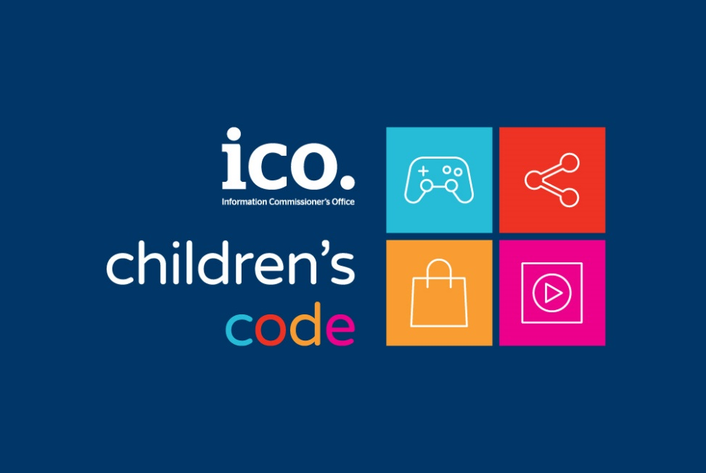

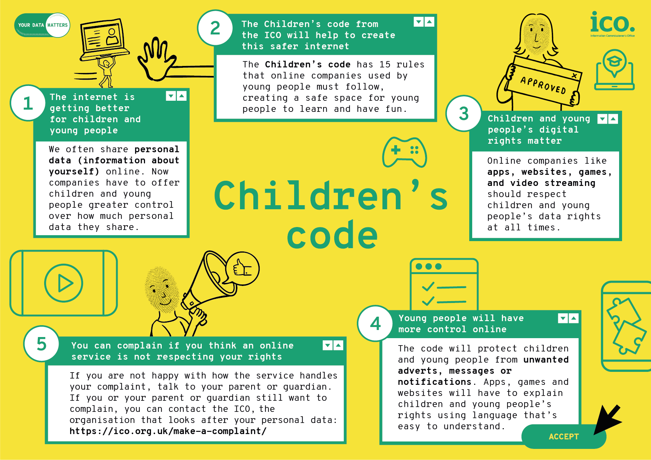

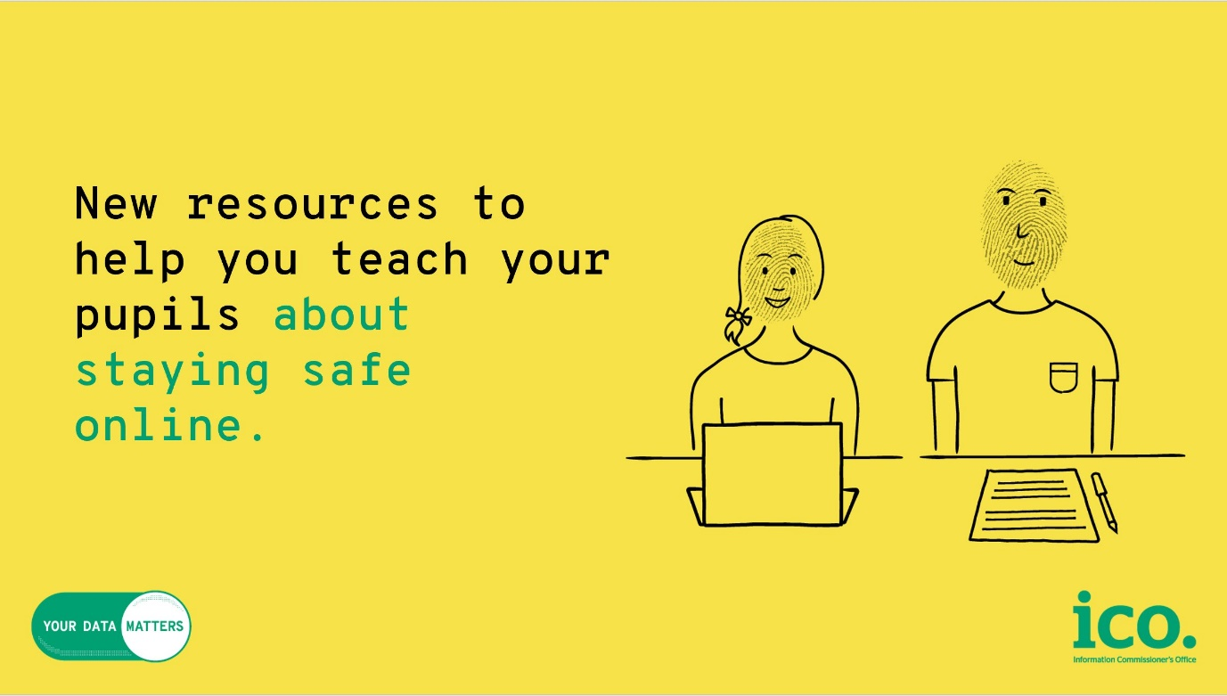

- Please provide the most relevant link on the authority’s website to the initiative, if applicable (The website content does not need to be in English)
https://ico.org.uk/for-organisations/posters-stickers-and-e-learning/school-resources/

- Please provide any other relevant links that help explain the initiative or its impact or success (e.g. links to news reports or articles):
https://parentzone.org.uk/article/childrens-code-what-you-need-know

https://parentzone.org.uk/article/age-appropriate-design-code

https://ico.org.uk/about-the-ico/news-and-events/news-and-blogs/2021/07/new-class-resources-will-help-empower-young-people-to-take-control-of-their-online-privacy/?s=03

https://hwb.gov.wales/zones/keeping-safe-online/resources/a-practitioner-s-guide-to-children-s-rights-online

https://saferinternet.org.uk/resource-information-commissioners-office-resources

GPA Rules and Procedures, Rule 6.2 ‘Assembly documents’: Without prejudice to section 4.2, Assembly documents, including accreditation and observer applications may be submitted in English or in another language. In the latter case, the documents shall be accompanied by an English version. Members with the ability and the resources to do so are encouraged to translate proposed resolutions and other Assembly documents such as the Assembly Rules and Procedures.

