GPA Global Privacy and Data Protection Awards 2022
Entry Form
To submit an entry to the GPA Global Privacy and Data Protection Awards please complete and email this form to secretariat@globalprivacyassembly.org no later than 17 June 2022.
Note: GPA member authorities can submit as many entries as they wish, but a separate form should be used for each different entry, submitted by the deadline above.
Languages: The GPA documentation Rule 6.2 applies.
- CONTACT DETAILS FOR THIS ENTRY
Privacy/Data Protection Authority: | The Office of the Privacy Commissioner for Bermuda (PrivCom)
Person completing this form: | Cha’Von | Clarke-Joell
 | First name | Last name
Job title: | Assistant Commissioner for Policy & Engagement
Email address: | ccj@privacy.bm

- ELIGIBILITY
By submitting this entry, I confirm that (please tick all boxes to confirm):
☒ | The Authority is a member of the Global Privacy Assembly
☒ | The initiative described in this entry was undertaken since January 2020.
☒ | I am aware that the information in the entry (other than the contact details in 1(a) above) will be publicised by the GPA Secretariat.

- CATEGORIES
Please indicate which category you wish to enter.
Please tick one; please use a separate form for each category you wish to enter:
☒ | Education and Public Awareness
☐ | Accountability
☐ | Dispute Resolution and Enforcement
☐ | Innovation
☐ | People’s Choice
- DESCRIPTION OF THE INITIATIVE

- Please provide a brief summary of the initiative (no more than 75 words)
Bermuda is at the crossroads of the Atlantic, physically, culturally, and economically.
In the privacy context, two polar ideologies are often presented as in conflict: the protection of individual rights versus business success. Due to the unique characteristics of the island, the Office of the Privacy Commissioner (PrivCom) created a regulatory philosophy using the theme of Mid-Atlantic Privacy to help organisations navigate towards developing privacy practices to protect rights and support business innovate while protecting privacy.

- Please provide a full description of the initiative (no more than 350 words)
Leaning on the well-travelled phrase of “privacy is a journey, not a destination”, PrivCom’s Mid-Atlantic Privacy Compass is a roadmap to help organisations with framing their privacy programme goals. It is also the philosophy that guides the work of the Office of the Privacy Commissioner for Bermuda.

Bermuda’s location in the middle of the Atlantic Ocean has been a benefit to the island for many years, offering the best of multiple worlds to create a prosperous and successful community. From a data protection standpoint, there are two schools of thought on each side of the Atlantic Ocean, or so the stereotypes go. Europe calls for respect for individual rights to privacy, while the United States encourages a free-market, business-friendly approach. Many organisations and even countries may find themselves in the position that Bermuda has been in, so often throughout its history, of being forced to choose a side. The Office of the Privacy Commissioner rejects this either-or narrative and offers the Mid-Atlantic Privacy Compass to help organisations navigate towards finding win-win scenarios while protecting privacy.

The Mid-Atlantic Privacy Compass consists of four cardinal points: Ethics, Oversight, Incentives & Individuals that highlight critical privacy-related considerations. The ordinal points of Responsibility, Community, Stewardship, and Interoperability complete the compass by serving as guide markers for organisations, oversight groups, and society. The Compass guidance supports organisations at every stage of their compliance journey, and highlights industry standards such as the Fair Information Practices (FIPs) and Privacy by Design principles.

Each point on the Compass contemplates how to navigate privacy, data protection, and innovation with a human-centric focus. The goal of the Compass is to provide a broader view of data privacy and to serve as a tool to help organisations with strategic decisions as data protection practices become more mature in the level of specificity with which procedural actions must be considered.

The Mid-Atlantic Privacy Compass is available to everyone, free of charge on the PrivCom website.

- Please explain why you think the initiative deserves to be recognised by an award (no more than 200 words)
As a small island, crossroads country, Bermuda’s public policies have historically been influenced by, or discussed in relation to, larger jurisdictions. Bermuda is developing its first precedent for privacy and data protection, so outlining the broad concepts of responsibility, duties, and mutually beneficial goals are critical first steps.

The Mid-Atlantic Privacy Compass is an opportunity to set the narrative for a modern regulatory structure that involves constructive community co-operation and protection of rights in a meaningful way. A clean slate provides an opportunity to describe these issues in novel ways.

It was critical to find language that spoke to the community. Here, we punctuated our stories with local references and culture and drew from common knowledge in the neighbouring regions of North America, Europe, the Caribbean, and Africa.

By embracing our fusion culture, identifying universal privacy best practices, and supporting organisations with navigating the tides of privacy, PrivCom’s Compass empowers both innovation and and the protection of individual rights.

We humbly submit that the creativity and forward thinking applied to design the Mid-Atlantic Privacy Compass should be recognised to empower similar jurisdictions with unique cultural and privacy challenges, as well as jurisdictions seeking to create new rules and regimes.

- Please include a photograph or image, if you wish (This will be published with your entry on the GPA website. The image can be pasted into the box below, be sent as an attachment or a link may be provided)
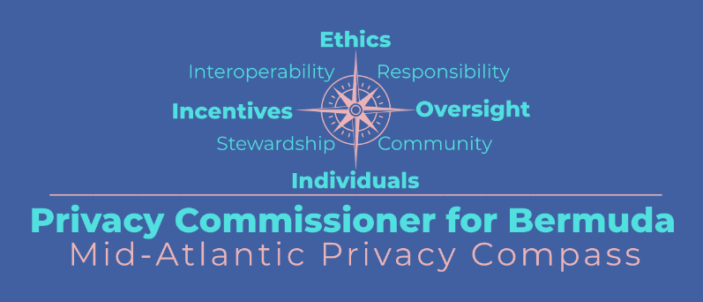

- Please provide the most relevant link on the authority’s website to the initiative, if applicable (The website content does not need to be in English)
https://www.privacy.bm/mid-atlantic-privacy-compass

- Please provide any other relevant links that help explain the initiative or its impact or success (e.g. links to news reports or articles):
https://www.privacy.bm/post/a-look-back-at-2020-top-10-most-visited-blog-posts
https://www.youtube.com/watch?v=hKTqkP5pbKk
https://beesmont.bm/wp-content/uploads/2020/09/Data-Protection-Update-October-2020.pdf

GPA Rules and Procedures, Rule 6.2 ‘Assembly documents’: Without prejudice to section 4.2, Assembly documents, including accreditation and observer applications may be submitted in English or in another language. In the latter case, the documents shall be accompanied by an English version. Members with the ability and the resources to do so are encouraged to translate proposed resolutions and other Assembly documents such as the Assembly Rules and Procedures.

