GPA Global Privacy and Data Protection Awards 2022
Entry Form
To submit an entry to the GPA Global Privacy and Data Protection Awards please complete and email this form to secretariat@globalprivacyassembly.org no later than 17 June 2022.
Note: GPA member authorities can submit as many entries as they wish, but a separate form should be used for each different entry, submitted by the deadline above.
Languages: The GPA documentation Rule 6.2 applies.
- CONTACT DETAILS FOR THIS ENTRY
Privacy/Data Protection Authority: | Austrian Data Protection Authority
Person completing this form: | Andreas | Zavadil
 | First name | Last name
Job title: | Legal desk officer
Email address: | andreas.zavadil@dsb.gv.at

- ELIGIBILITY
By submitting this entry, I confirm that (please tick all boxes to confirm):
☒ | The Authority is a member of the Global Privacy Assembly
☒ | The initiative described in this entry was undertaken since January 2020.
☒ | I am aware that the information in the entry (other than the contact details in 1(a) above) will be publicised by the GPA Secretariat.

- CATEGORIES
Please indicate which category you wish to enter.
Please tick one; please use a separate form for each category you wish to enter:
☒ | Education and Public Awareness
☐ | Accountability
☐ | Dispute Resolution and Enforcement
☐ | Innovation
☐ | People’s Choice
- DESCRIPTION OF THE INITIATIVE

- Please provide a brief summary of the initiative (no more than 75 words)
With the project “privacy4kids” we aim to raise awareness about privacy of children in the digital age. Together with the University of Vienna, the Austrian Data Protection Authority created short informational videos for children regarding various topics such as privacy threats in social media, internet fraud and children’s data protection rights.

- Please provide a full description of the initiative (no more than 350 words)
With the project “privacy4kids” we aim to raise awareness about privacy of children in the digital age.

The project consisted of three steps. As first step, a course at the University of Vienna, Department of Innovation and Digitalisation in Law, was organised. During this course, students conducted research on content concerning privacy issues relevant for and addressed to children, and later elaborated and prepared the material content for the next step, video creation. The content covers a broad range of topics such as privacy threats in social media, internet fraud and children’s data protection rights.

As a second step, the content was used to create 22 informational videos for children. For this purpose, we invited external experts (such as experts from the Austrian Ministry of Education and developmental psychologists) to eventually design the videos in a way that attracts the attention of children, therefore maximising their learning effect. For each topic, two different types of videos are available, one for children around the age 6-10 and one for teenagers around the age 10-14.

Finally, the videos were published at www.privacy4kids.at. They can be accessed without any costs. Furthermore, we created an informational paper for schools and teachers with instructions on how the videos and the particular privacy topics can be addressed during classes. The informational paper was published at https://www.privacy4kids.at/fuer-schulen/.

The videos aim to sensitise children and parents to the opportunities, challenges and dangers of the digital age and to help them understand what they can do to protect their privacy. The project output will also serve as role model for controllers on how to provide information addressed specifically to a child pursuant to Article 12 (1) GDPR.

- Please explain why you think the initiative deserves to be recognised by an award (no more than 200 words)
Nowadays, children are confronted with the internet and smartphones at an extreme early age and grow up with social networks like Instagram, Snapchat and TikTok as well as the use of instant messenger services like WhatsApp. Due to this nearly natural integration into their everyday life, children are usually not aware of the dangers that arise from the use of such platforms. They do not know what the abuse of their data can result in and what they can do to protect themselves.

This is why there are strong legal safeguards in place under the European Data Protection framework to protect children and their personal data. However, these measures have to be complimented by adequate information about possible risks and tools to mitigate them.

Since the GDPR took effect, there has been a boost of information materials concerning data protection and other privacy related issues. However, there is little information on the protection of children’s rights in the online context which targets children themselves and which provides information in an entertaining manner, attracting the attention of children and encouraging them to actually read (or in case of videos, watch) such information. To fill this gap, the project “privacy4kids” was created.

The informational videos and papers are in German. Based on the statistics, there are roughly 1.5 million children living in Austria and roughly 11.3 million children living in Germany. Therefore, the videos and information can be spread to potentially 12.8 million children.

Please note that we have the intention to expand the information and the available languages.

- Please include a photograph or image, if you wish (This will be published with your entry on the GPA website. The image can be pasted into the box below, be sent as an attachment or a link may be provided)
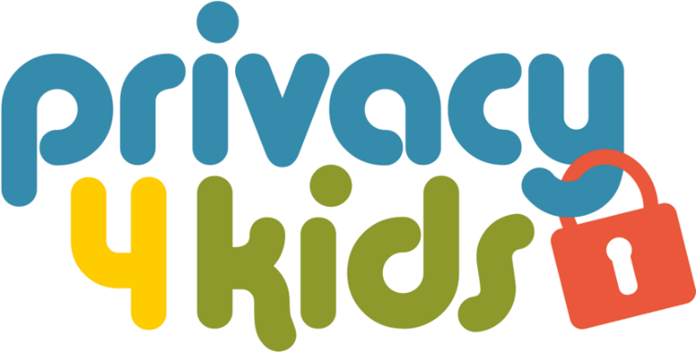

- Please provide the most relevant link on the authority’s website to the initiative, if applicable (The website content does not need to be in English)
www.privacy4kids.at

- Please provide any other relevant links that help explain the initiative or its impact or success (e.g. links to news reports or articles):
See the fact sheet:

https://www.privacy4kids.at/fileadmin/user_upload/p_privacy4kids/PRIVACY4KIDS_FACTSHEET_20220525.pdf

GPA Rules and Procedures, Rule 6.2 ‘Assembly documents’: Without prejudice to section 4.2, Assembly documents, including accreditation and observer applications may be submitted in English or in another language. In the latter case, the documents shall be accompanied by an English version. Members with the ability and the resources to do so are encouraged to translate proposed resolutions and other Assembly documents such as the Assembly Rules and Procedures.

