GPA Global Privacy and Data Protection Awards 2022
Entry Form
To submit an entry to the GPA Global Privacy and Data Protection Awards please complete and email this form to secretariat@globalprivacyassembly.org no later than 17 June 2022.
Note: GPA member authorities can submit as many entries as they wish, but a separate form should be used for each different entry, submitted by the deadline above.
Languages: The GPA documentation Rule 6.2 applies.
- CONTACT DETAILS FOR THIS ENTRY
Privacy/Data Protection Authority: | Office of the Australian Information Commissioner (OAIC)
Person completing this form: | Andrew Stokes
 | First name | Last name
Job title: | Director, Strategic Communications
Email address: | andrew.stokes@oaic.gov.au; corporate@oaic.gov.au

- ELIGIBILITY
By submitting this entry, I confirm that (please tick all boxes to confirm):
☒ | The Authority is a member of the Global Privacy Assembly
☒ | The initiative described in this entry was undertaken since January 2020.
☒ | I am aware that the information in the entry (other than the contact details in 1(a) above) will be publicised by the GPA Secretariat.

- CATEGORIES
Please indicate which category you wish to enter.
Please tick one; please use a separate form for each category you wish to enter:
☒ | Education and Public Awareness
☐ | Accountability
☐ | Dispute Resolution and Enforcement
☐ | Innovation
☐ | People’s Choice
- DESCRIPTION OF THE INITIATIVE

- Please provide a brief summary of the initiative (no more than 75 words)
The Office of the Australian Information Commissioner (OAIC) publishes statistics bi-annually about data breaches reported under the Notifiable Data Breaches (NDB) scheme to assist entities and the public to understand privacy risks identified through the scheme. The provision of clear information on data breach causes supports entities to assess and improve their security postures to minimise this risk. The reports are highly anticipated by industry, garner significant media coverage and are a sought-after presentation topic.

- Please provide a full description of the initiative (no more than 350 words)
The NDB scheme was introduced in February 2018 and is one of the key changes to the Privacy Act 1988 in recent years. Under the scheme, entities covered by the Privacy Act must notify affected individuals and the OAIC when they experience a data breach that is likely to result in serious harm to any individual whose personal information is involved.

The OAIC publishes detailed statistics about notifications received every 6 months. The reports include charts, commentary and comparisons to previous reporting periods and draw out the:
- industry sectors that notify the most data breaches
- sources of breaches
- number of affected individuals
- kinds of personal information involved
- time taken by entities to identify and notify breaches.

Reports include case studies on areas for improved practice, data breach response best practices and illustrative scenarios. Reports are provided as a PDF and in HTML for accessibility purposes. See the most recent report: Notifiable Data Breaches Report: July–December 2021.

As the key external communications vehicle for the NDB scheme, a robust communication strategy supports the launch of each report and generally comprises:
- a media release with key messages for entities
- engagement with key government stakeholders and industry associations through the provision of briefings, talking points and sample content
- a social media campaign targeted at both regulated entities and the public
- presentations on trends, insights and emerging themes.

Additionally, the OAIC provides detailed guidance and advice for regulated entities on their obligations under the NDB scheme and how to prevent and respond to data breaches. We also provide advice for individuals about responding to data breach notifications. In 2021, we launched 2 new resources for individuals:
- Act quickly if you are affected by a data breach poster
- Easy English resource on what to do if there is a data breach.

These education and awareness activities support the NDB scheme to achieve its objectives, which are to:
- provide a safer and more transparent environment for individuals
- improve compliance with privacy obligations
- provide entities with a framework for responding to data breaches
- provide an evidence base to inform government policy and industry practice.

- Please explain why you think the initiative deserves to be recognised by an award (no more than 200 words)
The OAIC’s NDB reports and supporting communication activities are key to the scheme achieving its central objective, which is to protect individuals. The reports help entities and the public understand privacy risks identified through the scheme and enable the OAIC to communicate trends and emerging risks (without publicising the details of specific incidents). Generally, the OAIC is seeing entities engage with the scheme and take steps to remedy breaches and mitigate harm to individuals.

Below are some metrics that demonstrate the high level of interest and engagement with the reports:
- NDB reports garner broad and sustained media coverage. Between 1 January and 8 June 2022, more than 290 articles referenced the NDB scheme and the OAIC – 249 of these articles included data from NDB reports.
- The OAIC’s notifiable data breaches statistics webpage attracted 5,925 visits and the July to December 2021 report 7,033 visits between 1 January and 8 June 2022.
- The OAIC has given 4 NDB presentations in the 2020–21 financial year and featured NDB issues as part of many other speaking engagements.
- The social media campaign for the July to December 2021 report received over 32,000 impressions.

- Please include a photograph or image, if you wish (This will be published with your entry on the GPA website. The image can be pasted into the box below, be sent as an attachment or a link may be provided)
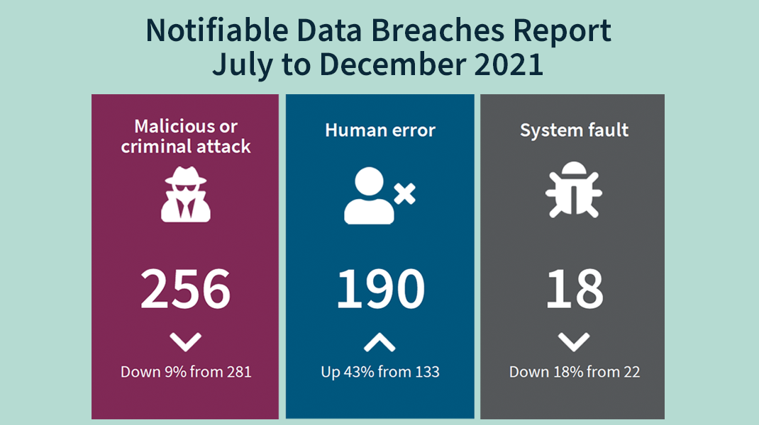

- Please provide the most relevant link on the authority’s website to the initiative, if applicable (The website content does not need to be in English)
Notifiable data breaches statistics - https://www.oaic.gov.au/privacy/notifiable-data-breaches/notifiable-data-breaches-statistics

- Please provide any other relevant links that help explain the initiative or its impact or success (e.g. links to news reports or articles):
Example media coverage:
- ‘464 Australian data breaches reported to the OAIC in latter half of 2021’, ZDNet
- ‘Australian data breach statistics revealed in OAIC report’, ITBrief
- ‘Australia’s Health Sector Is Still Number One for Data Breaches, OAIC Report Confirms’, Gizmodo
- ‘Data breaches on the rise in second half of 2021’, InnovationAus
- ‘Health remains most breached sector; human errors rise by 43%’, Hospital and Healthcare
- ‘OAIC report reveals 464 reported breaches 2H 2021, 17% from emailing PII to the wrong person’, iTWire
- ‘Data breaches rise but fewer occur in federal agencies’, The Mandarin
- ‘Industry target of malicious, criminal attacks’, insuranceNEWS
- ‘Call for data handlers to take more care’, PS News
- ‘As data breach notifications rise, so does organisation accountability: OAIC’, ARN

Example social media post and engagement: https://www.linkedin.com/feed/update/urn:li:activity:6901651133610258432

GPA Rules and Procedures, Rule 6.2 ‘Assembly documents’: Without prejudice to section 4.2, Assembly documents, including accreditation and observer applications may be submitted in English or in another language. In the latter case, the documents shall be accompanied by an English version. Members with the ability and the resources to do so are encouraged to translate proposed resolutions and other Assembly documents such as the Assembly Rules and Procedures.

