GPA Global Privacy and Data Protection Awards 2022
Entry Form
To submit an entry to the GPA Global Privacy and Data Protection Awards please complete and email this form to secretariat@globalprivacyassembly.org no later than 17 June 2022.
Note: GPA member authorities can submit as many entries as they wish, but a separate form should be used for each different entry, submitted by the deadline above.
Languages: The GPA documentation Rule 6.2 applies.
- CONTACT DETAILS FOR THIS ENTRY
Privacy/Data Protection Authority: | Office of the Australian Information Commissioner (OAIC)
Person completing this form: | Andrew Stokes
 | First name | Last name
Job title: | Director, Strategic Communications
Email address: | andrew.stokes@oaic.gov.au; corporate@oaic.gov.au

- ELIGIBILITY
By submitting this entry, I confirm that (please tick all boxes to confirm):
☒ | The Authority is a member of the Global Privacy Assembly
☒ | The initiative described in this entry was undertaken since January 2020.
☒ | I am aware that the information in the entry (other than the contact details in 1(a) above) will be publicised by the GPA Secretariat.

- CATEGORIES
Please indicate which category you wish to enter.
Please tick one; please use a separate form for each category you wish to enter:
☒ | Education and Public Awareness
☐ | Accountability
☐ | Dispute Resolution and Enforcement
☐ | Innovation
☐ | People’s Choice
- DESCRIPTION OF THE INITIATIVE

- Please provide a brief summary of the initiative (no more than 75 words)
The Office of the Australian Information Commissioner (OAIC) led the Australia-wide campaign for Privacy Awareness Week (PAW) 2022. Our campaign highlighted privacy as the foundation of trust and attracted a record 653 government and private sector supporters. The OAIC developed dynamic PAW 2022 branding, a dedicated website, a comprehensive supporter toolkit and privacy tips for individuals, businesses and government agencies. OAIC speakers took part in 12 events with a combined audience of over 2,000 people.

- Please provide a full description of the initiative (no more than 350 words)
PAW is an initiative of the Asia Pacific Privacy Authorities (APPA) Forum held every year to promote and raise awareness of privacy issues and the importance of protecting personal information. The OAIC leads PAW activities in Australia in partnership with state and territory privacy regulators.

PAW 2022 ran from 2 to 8 May with the theme Privacy: The foundation of trust, which was selected by APPA members and adopted by all Australian jurisdictions.

The OAIC’s core objectives for PAW are to:
- increase individuals’ awareness of privacy rights and risks and how to manage them
- engage with regulated entities through the PAW supporter program and enhance their understanding of their privacy obligations and the OAIC’s regulatory stance, encourage best practice and leverage them to reach individuals.

The OAIC’s key activities for PAW included:
- the development of dynamic PAW 2022 branding, a dedicated PAW website and design assets for the 2022 campaign to express the APPA theme in a way relevant to the Australian context (design assets included posters, social media images, factsheets, virtual backgrounds, PowerPoint template, sample presentation, website and email banners, sample written content and a crossword)
- the development of privacy tips for individuals, businesses and government agencies
- supporter recruitment and engagement
- the development of a toolkit [zip] with resources, content and creative ideas to assist supporters to raise privacy awareness and promote good privacy practices to their internal and external stakeholders
- a virtual OAIC launch event and delivery of a standard presentation by OAIC speakers to target stakeholders
- the execution of media and social media strategies
- internal engagement including branch presentations, regular email updates, competitions and an informal staff event to ensure OAIC staff felt valued and part of the campaign.
Many of the resources were developed to have longevity and provide a framework for communicating the OAIC’s key messages and promoting other guidance beyond PAW. For example, the OAIC will re-use the privacy tips for individuals, businesses and government agencies as the core building blocks for a strong privacy foundation, linking to relevant guidance. This approach leverages the brand recognition that was built during PAW to maximise cut-through.

- Please explain why you think the initiative deserves to be recognised by an award (no more than 200 words)
The OAIC executed a successful campaign that achieved our objectives. Among the measures of success, we:

- achieved the highest number of supporters to date – 653 government agencies and private sector organisations signed up, up 4% from 2021 and 77% from 5 years ago
- took part in 12 events with a combined audience of 2,000 people – this includes over 540 people watching the OAIC’s virtual launch live or on-demand
- achieved a total social media reach over 42,000 through OAIC channels – posts by PAW supporters extend the campaign’s reach by hundreds of thousands.

The OAIC conducted a supporter survey post-campaign. All respondents said they will sign up to support PAW 2023 and the majority ranked the website and supporter toolkit as ‘very useful’.

Among the feedback: ‘I just wanted to say that I think PAW is a really valuable opportunity for organisations to really engage with workers and draw attention to areas of privacy that relate to their workplace, as well as to them as individuals. Webinars offered by OAIC and others during PAW week are an amazing opportunity for me as a Privacy Officer to increase my knowledge and understanding of some of the intricacies also. Keep up the great work!’

- Please include a photograph or image, if you wish (This will be published with your entry on the GPA website. The image can be pasted into the box below, be sent as an attachment or a link may be provided)
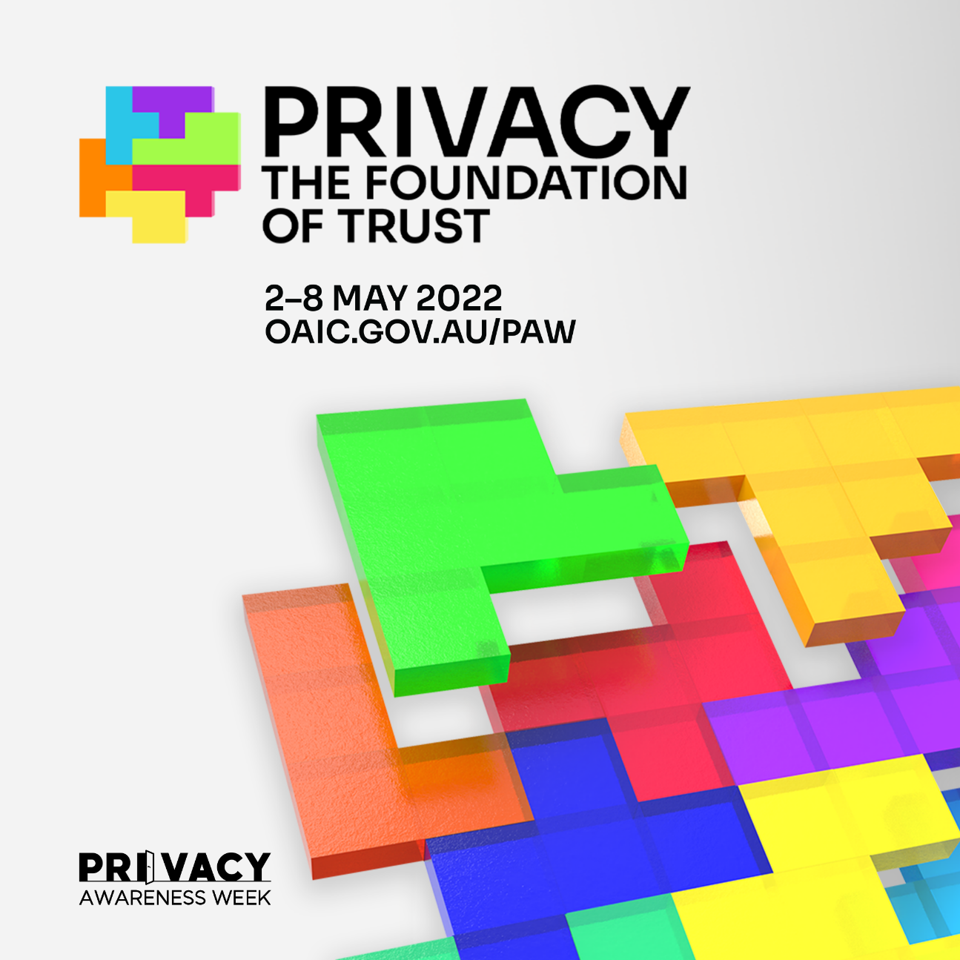

- Please provide the most relevant link on the authority’s website to the initiative, if applicable (The website content does not need to be in English)
Privacy Awareness Week 2022 website – https://education.oaic.gov.au/paw2022/

- Please provide any other relevant links that help explain the initiative or its impact or success (e.g. links to news reports or articles):
Example media coverage - https://psnews.com.au/2022/05/02/privacy-goes-public-for-this-week/?state=aps

Below is a selection of articles published by supporters that leverage OAIC materials:

- ‘Privacy Awareness Week’, WorkSafe Guardian
- ‘PRIVACY AWARENESS WEEK 2022—PRIVACY: THE FOUNDATION OF TRUST’, Griffith University Library
- ‘Privacy Awareness Week 2022’, Australian National University Library
- ‘Proud Supporter of Privacy Awareness Week 2022!’, Acceleon
- ‘Good habits to protect your privacy’, Kalus Kenny Intelex
- ‘Privacy Awareness Week 2-8 May 2022’, The Mutual Bank
- ‘Privacy as a foundation of building trust’, Australian Catholic University
- ‘How solid are your privacy foundations?’, Maddocks
- ‘How to Handle Privacy Breaches’, Doll Martin
- ‘Digital Governance Quarterly Roundup’, Colin Biggers & Paisley Lawyers
- ‘Trust in photo management is the key to keeping photos safe’, Pixevety
- ‘It's Privacy Awareness Week. Are you privacy aware?’, Spark Helmore Lawyers
- ‘Privacy Awareness Week: 5 tips for improving your organisation’s privacy and cybersecurity practices’, Clyde & Co
- ‘HOW TO MAKE PRIVACY A PRIORITY FOR YOUR BUSINESS’, Data Zoo
- ‘It’s Time To Check Your Privacy’, Aurion
- ‘Privacy: Building the Foundation of Trust’, Privacy108
- ‘If you want to be trusted, you have to be trustworthy (PAW 2022)’, IIS Partners
- ‘Make a date with data security this Privacy Awareness Week’, Get Cyber Resilient
- ‘10 Business Security Tips for Privacy Awareness Week’, Pronto Software
- ‘Supporting Privacy Awareness Week’, Tax Practitioners Board
- ‘INSIGHTS: Privacy Awareness Week | 2 – 8 May 2022’, Meridian Lawyers

GPA Rules and Procedures, Rule 6.2 ‘Assembly documents’: Without prejudice to section 4.2, Assembly documents, including accreditation and observer applications may be submitted in English or in another language. In the latter case, the documents shall be accompanied by an English version. Members with the ability and the resources to do so are encouraged to translate proposed resolutions and other Assembly documents such as the Assembly Rules and Procedures.

