GPA Global Privacy and Data Protection Awards 2025
Entry Form
To submit an entry to the GPA Global Privacy and Data Protection Awards, please complete and email this form to secretariat@globalprivacyassembly.org no later than 16 June 2025.
Note: GPA member authorities can submit as many entries as they wish, but a separate form should be used for each different entry, submitted by the deadline above.
Languages: The GPA documentation Rule 6.2 applies.
- CONTACT DETAILS FOR THIS ENTRY
Privacy/Data Protection Authority: | National Privacy Commission Philippines
Person completing this form: | Roren Marie | Chin
 | First name | Last name
Job title: | Information Officer V/ Chief of the Public Information and Assistance Division
Email address: | roren.chin@privacy.gov.ph

- ELIGIBILITY
By submitting this entry, I confirm that (please tick all boxes to confirm):
☒ | The Authority is a member of the Global Privacy Assembly
☒ | The initiative described in this entry was undertaken before 16 June 2025.
☒ | I am aware that the information in the entry (other than the contact details in 1(a) above) will be publicised by the GPA Secretariat.

- CATEGORIES
Please indicate which category you wish to enter.
Please tick one; please use a separate form for each category you wish to enter:
☒ | Education and Public Awareness
☐ | Accountability
☐ | Dispute Resolution and Enforcement
☐ | Innovation
☐ | People’s Choice
- DESCRIPTION OF THE INITIATIVE

- Please provide a brief summary of the initiative (no more than 75 words)
Privacy Awareness Week (PAW) 2025 is an annual celebration and nationwide campaign led by the NPC to promote data privacy awareness and responsible data processing. Its 8th National Data Privacy Conference convened global privacy authorities, regulators, and professionals to discuss data privacy in AI governance, digital trust, and cross-border data flows. In collaboration with government and private institutions, PAW 2025 disseminated educational materials across sectors, fostering both international collaboration and grassroots engagement on data protection.

- Please provide a full description of the initiative (no more than 350 words)
Privacy Awareness Week (PAW) 2025 carried the theme “Global Privacy Matters: Navigating a Borderless Digital World and Expanding New Professional Horizons.” It focused on the growing importance of protecting personal data, especially in today’s digital world where artificial intelligence and technology are rapidly changing the way we live and work.
Through Proclamation No. 527, s. 2018, PAW is a yearly celebration led by the National Privacy Commission (NPC) to help people understand their rights when it comes to data privacy. In 2025, PAW became both a global and local platform for learning and collaboration.
One of the highlights of PAW 2025 was the 8th National Data Privacy Conference, which brought together global experts, regulators, and the public to talk about important topics like how to handle AI responsibly, build trust in digital platforms, and manage personal data that moves across borders. The event also featured the PAW Awards 2025, which recognized individuals and organizations that made outstanding efforts in promoting data privacy in the Philippines.
The conference was livestreamed on the NPC’s Facebook and YouTube pages, and local media helped spread the message further to a wider audience.
Beyond the conference, PAW 2025 encouraged schools, hospitals, government offices, and companies across the country to join the campaign by displaying privacy posters, stickers, brochures, and videos in public areas. Many also held their own seminars and activities to teach their communities about the importance of privacy.
By combining big international discussions with local efforts, PAW 2025 showed how everyone—whether in government, business, or the community—has a role to play in protecting personal data.

In all, PAW 2025 positioned the Philippines as a strong voice in the global privacy conversation and reminded everyone that in today’s digital age, privacy matters to all of us.

- Please explain why you think the initiative deserves to be recognised by an award (no more than 200 words)
PAW 2025 initiative exemplifies a holistic and impactful approach to advancing data privacy and public awareness in the digital age. Through a dynamic blend of international collaboration and local outreach, it effectively bridges the gap between high-level policy dialogue and community engagement. By convening global privacy authorities and industry experts at the 8th National Data Privacy Conference, the initiative helped shape discourse on critical issues such as AI governance and cross-border data flows, aligning local efforts with global standards.
Simultaneously, its grassroots campaign empowered citizens, organizations, and institutions across the Philippines through accessible educational tools and activities. From government offices to classrooms, PAW 2025 brought data protection to the forefront of national consciousness, emphasizing that privacy is a shared responsibility.
The campaign’s strategic use of digital platforms, media coverage, and sectoral partnerships significantly amplified its impact and accessibility. Its inclusive, forward-thinking approach reflects the NPC’s commitment to creating a privacy-literate society equipped to navigate an increasingly borderless digital world.
This comprehensive, multi-sectoral model of privacy advocacy makes PAW 2025 worthy of international recognition in the Education and Public Awareness category.

- Please include a photograph or image, if you wish (This will be published with your entry on the GPA website. The image can be pasted into the box below, be sent as an attachment or a link may be provided)
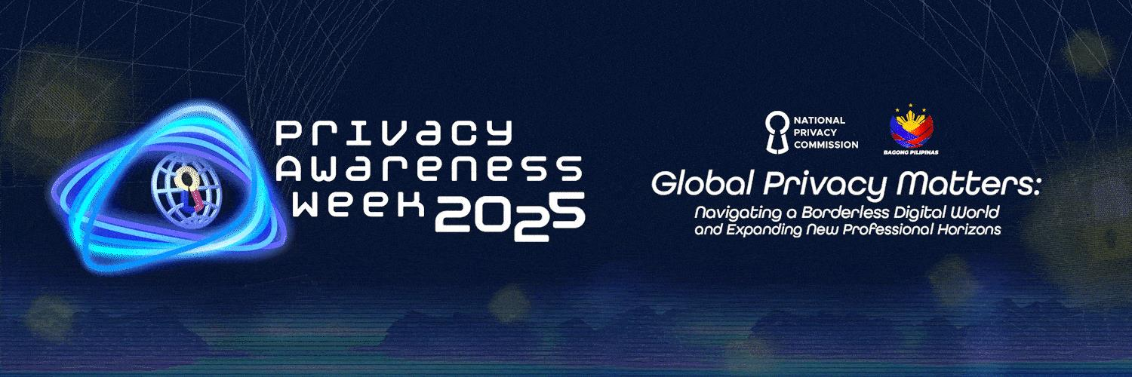

- Please provide the most relevant link on the authority’s website to the initiative, if applicable (The website content does not need to be in English)
https://privacy.gov.ph/paw2025/

- Please provide any other relevant links that help explain the initiative or its impact or success (e.g. links to news reports or articles):
News:

https://www.abs-cbn.com/news/technology/2025/5/30/global-privacy-in-the-ai-era-tech-takeaways-from-the-8th-national-data-privacy-conference-1456

PAW 2025 was supported by private and public institutions:

https://toyota.com.ph/news/2025-data-privacy-awareness-week
https://psa.gov.ph/content/psa-celebrates-privacy-awareness-week-2025
https://www.samsung.com/ph/info/privacy/
https://www.ue.edu.ph/cal/ue-supports-privacy-awareness-week/

GPA Rules and Procedures, Rule 6.2 ‘Assembly documents’: Without prejudice to section 4.2, Assembly documents, including accreditation and observer applications may be submitted in English or in another language. In the latter case, the documents shall be accompanied by an English version. Members with the ability and the resources to do so are encouraged to translate proposed resolutions and other Assembly documents such as the Assembly Rules and Procedures.

