GPA Global Privacy and Data Protection Awards 2025
Entry Form
To submit an entry to the GPA Global Privacy and Data Protection Awards, please complete and email this form to secretariat@globalprivacyassembly.org no later than 16 June 2025.
Note: GPA member authorities can submit as many entries as they wish, but a separate form should be used for each different entry, submitted by the deadline above.
Languages: The GPA documentation Rule 6.2 applies.
- CONTACT DETAILS FOR THIS ENTRY
Privacy/Data Protection Authority: | Albanian Information and Data Protection Commissioner
Person completing this form: | Denada | Hysi
 | First name | Last name
Job title: | Head of Projects and Integration Sector
Email address: | info@idp.al

- ELIGIBILITY
By submitting this entry, I confirm that (please tick all boxes to confirm):
☒ | The Authority is a member of the Global Privacy Assembly
☒ | The initiative described in this entry was undertaken before 16 June 2025.
☒ | I am aware that the information in the entry (other than the contact details in 1(a) above) will be publicised by the GPA Secretariat.

- CATEGORIES
Please indicate which category you wish to enter.
Please tick one; please use a separate form for each category you wish to enter:
☒ | Education and Public Awareness
☐ | Accountability
☐ | Dispute Resolution and Enforcement
☐ | Innovation
☐ | People’s Choice
- DESCRIPTION OF THE INITIATIVE

- Please provide a brief summary of the initiative (no more than 75 words)
The Information and Data Protection Commissioner of the Republic of Albania (IDP) in cooperation with the OSCE Presence in Albania, carried out regional awareness-raising activities in the field of education, regarding legal obligations for the protection of personal data, with a particular focus on the processing of young generation (minors') data. During these activities, an informative questionnaire was also presented, aimed at assessing knowledge of the legislation on personal data protection.

- Please provide a full description of the initiative (no more than 350 words)
The IDP places great importance on raising awareness and fostering a social culture that prioritizes the protection of fundamental human rights and freedoms.
As part of its efforts to raise awareness about personal data protection, the developed questionnaire was implemented in a user-friendly and innovative way. Participants could access it by scanning a QR code (barcode) with their mobile phones. This approach made it quick and easy for users to engage, without needing to download any extra apps or sign up. Scanning the QR code took participants to a specially designed webpage, optimized for mobile browsers, ensuring instant, smooth access with no technical barriers.
A core feature of this process was ensuring the complete anonymity of the users. The system didn’t gather any personal or identifiable information from the users' devices, meaning no IP addresses, location data, or other sensitive information was recorded. All responses were stored in an anonymized way, linked only to a randomly generated ID created at the beginning of the questionnaire, with no connection to the participant’s identity.
Once the data collection period ended, the results were processed and analyzed using a specialized statistical platform. This platform generated clear visual representations, such as pie charts, showing the percentage of responses for each question. This made it easier to interpret and understand the participants' level of knowledge and awareness about personal data protection legislation.

- Please explain why you think the initiative deserves to be recognised by an award (no more than 200 words)
This initiative innovatively addresses a very sensitive aspect of personal data protection — the processing of young generation data (minors), a category that is particularly protected under the General Data Protection Regulation (GDPR). The young generation, which is highly exposed to technology and digital platforms, requires special measures to ensure the protection of their privacy and personal data.
Through the anonymized questionnaire and secure data collection methods, the initiative not only educates the youth and those involved in the process about their legal rights but also demonstrates compliance with the highest standards of data protection. This careful approach is crucial for creating an environment of trust and for promoting responsible awareness regarding the processing of minors' personal data.
In this way, the initiative contributes to empowering the young generation by giving them the opportunity to understand their rights and actively participate in protecting their privacy. It thus fulfills the legal requirements for personal data protection and serves as an excellent example of best practices in the field of data protection.

- Please include a photograph or image, if you wish (This will be published with your entry on the GPA website. The image can be pasted into the box below, be sent as an attachment or a link may be provided)
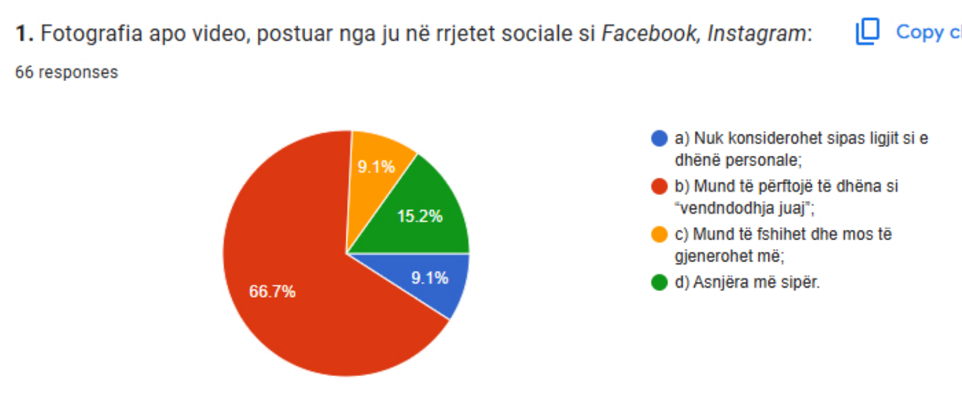

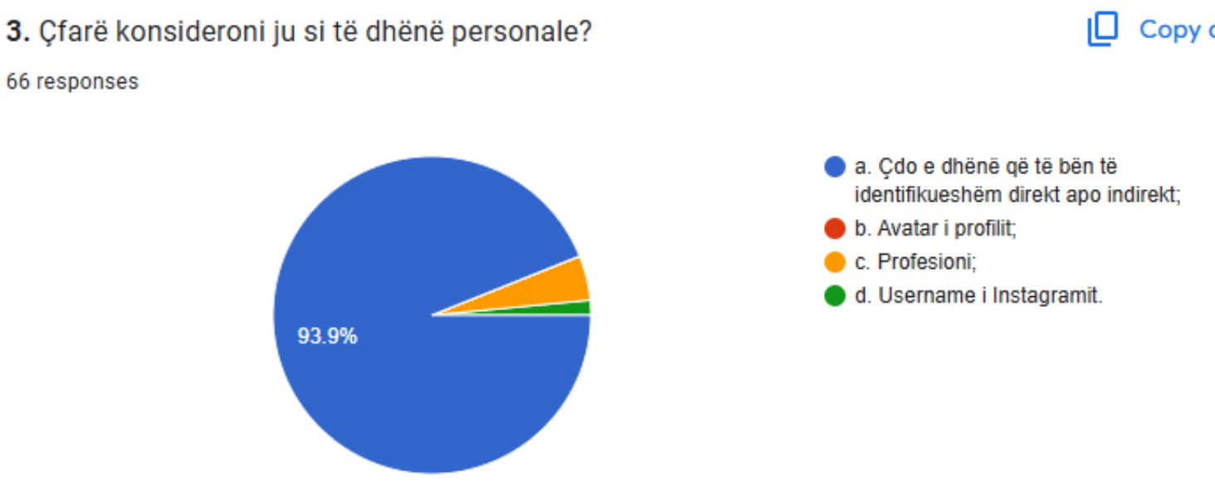
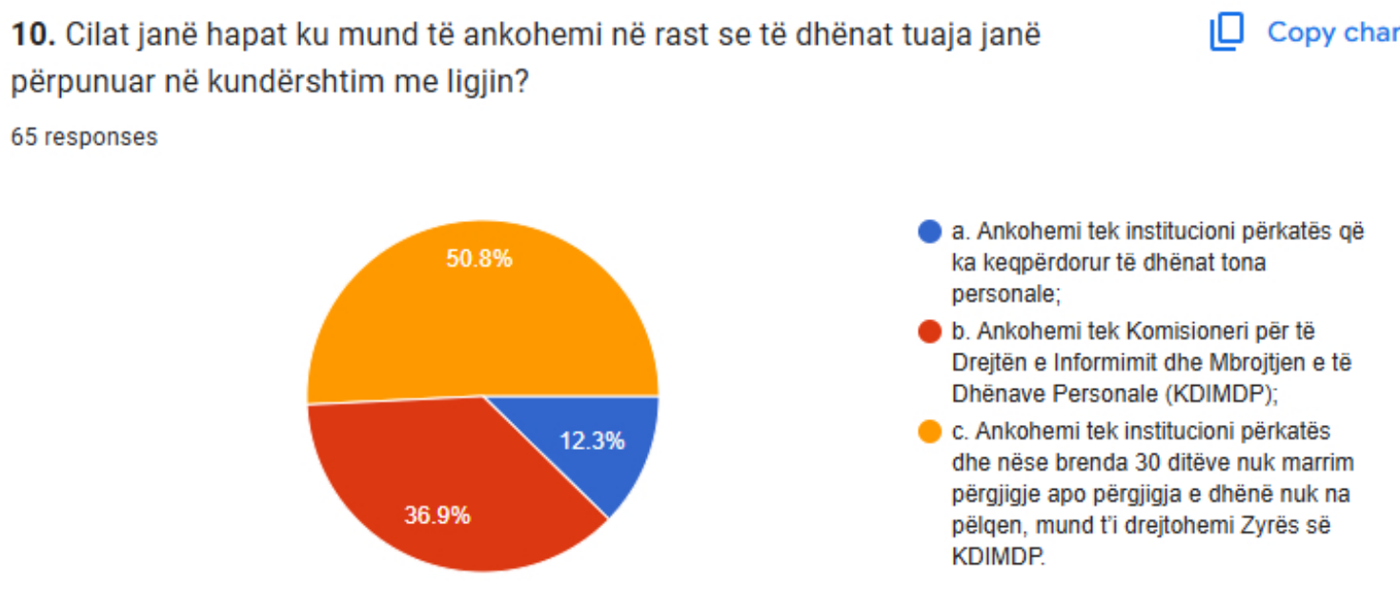

- Please provide the most relevant link on the authority’s website to the initiative, if applicable (The website content does not need to be in English)

- Please provide any other relevant links that help explain the initiative or its impact or success (e.g. links to news reports or articles):

GPA Rules and Procedures, Rule 6.2 ‘Assembly documents’: Without prejudice to section 4.2, Assembly documents, including accreditation and observer applications may be submitted in English or in another language. In the latter case, the documents shall be accompanied by an English version. Members with the ability and the resources to do so are encouraged to translate proposed resolutions and other Assembly documents such as the Assembly Rules and Procedures.

