GPA Global Privacy and Data Protection Awards 2025
Entry Form
To submit an entry to the GPA Global Privacy and Data Protection Awards, please complete and email this form to secretariat@globalprivacyassembly.org no later than 16 June 2025.
Note: GPA member authorities can submit as many entries as they wish, but a separate form should be used for each different entry, submitted by the deadline above.
Languages: The GPA documentation Rule 6.2 applies.
- CONTACT DETAILS FOR THIS ENTRY
Privacy/Data Protection Authority: | CNIL_ France  Commission Nationale de l’Informatique et des Libertés
Person completing this form: | Jennifer | ELBAZ
 | First name | Last name
Job title: | Education and public awareness officer
Email address: | jelbaz@cnil.fr

- ELIGIBILITY
By submitting this entry, I confirm that (please tick all boxes to confirm):
☒ | The Authority is a member of the Global Privacy Assembly
☒ | The initiative described in this entry was undertaken before 16 June 2025.
☒ | I am aware that the information in the entry (other than the contact details in 1(a) above) will be publicised by the GPA Secretariat.

- CATEGORIES
Please indicate which category you wish to enter.
Please tick one; please use a separate form for each category you wish to enter:
☒ | Education and Public Awareness
☐ | Accountability
☐ | Dispute Resolution and Enforcement
☐ | Innovation
☐ | People’s Choice
- DESCRIPTION OF THE INITIATIVE

- Please provide a brief summary of the initiative (no more than 75 words)
After producing educational resources for elementary school pupils, the CNIL decided to turn its attention to teenagers, aged 11 to 15 years old.
As teenagers read by themselves mangas, we decided to produce the format they are used to, they like: a manga.
With “Privacy Agency”, inspired by the codes of manga, CNIL takes a straightforward approach to the digital risks that concern young people: hacking, cyber-bullying, identity theft...

- Please provide a full description of the initiative (no more than 350 words)
Digital technology is omnipresent in young people lives (social networks, applications, video games, etc.), and mangas play an important role in the development of reading among teenagers. So it's only natural that CNIL has chosen this attractive format to raise awareness among 11-15 year-olds of the issues and risks associated with their use.

Combining intrigue, humor and education, this first volume titled “The phantom network” follows the adventures of two Privacy Agency investigators, Inaya and Isidore. They set out to find out why the names of three high school students, victims of online misadventures and ostracized from their class. They are on a list found in a room that was deliberately set on fire...

To produce this book, the CNIL drew on the combined talents of Faouzi Boughida, video game scriptwriter, and Grelin, illustrator and comic strip author.

The book tackles concrete subjects: hacking and identity theft, cyberbullying, e-reputation and cybersecurity. All through a story with twists and turns, dynamic drawings and engaging characters.

- Please explain why you think the initiative deserves to be recognised by an award (no more than 200 words)
1. The manga will be translated in English in the next weeks, which will greatly narrow the audience and enable a very large number of teenagers to access content.
2. Derived from teenagers' digital work, led by 2 departments within the CNIL : research lab and last mile departments, the content is directly derived from research works, linking target information levels, practices with CNIL doctrine.
The research works has enabled the subject of privacy to be widely disseminated in the world of research, politics and among educators. https://hal.science/hal-04919994
3. The campaign has been produced with CNIL's own funds, no third party has been involved.
4. This package of resources is part of the CNIL’s strategy to protect minors, and more over CNIL, the GPA strategy.
5. An immersive and educational format to encourage discussion about online privacy, a complete set on similar topics for teenagers, educators and parents with tailor made information and activities.
6. 900 manga downloaded in a week on the CNIL website + 200 emails received to get the printed version (already sent).

- Please include a photograph or image, if you wish (This will be published with your entry on the GPA website. The image can be pasted into the box below, be sent as an attachment or a link may be provided)
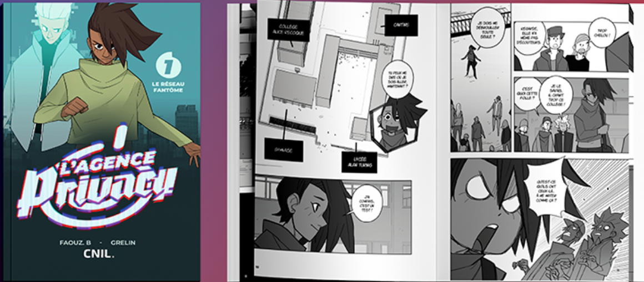

- Please provide the most relevant link on the authority’s website to the initiative, if applicable (The website content does not need to be in English)
https://cnil.fr/fr/reseaufantome

- Please provide any other relevant links that help explain the initiative or its impact or success (e.g. links to news reports or articles):

Press release :
Online and paper magazine, read by 10 000 teenagers, teachers :
https://www.geekjunior.fr/protection-donnees-personnelles-et-vie-privee-cnil-manga-63895/
French ministry of education, informing teachers at a national level :
https://eduscol.education.fr/4121/veille-education-numerique-2024-2025#VEN26062025
General digital information website :
https://www.frandroid.com/culture-tech/web/2647265_voici-lagence-privacy-le-nouveau-manga-de-la-cnil-pour-sensibiliser-a-la-vie-privee-en-ligne
MSN news webpage :
https://www.msn.com/fr-fr/actualite/technologie-et-sciences/voici-l-agence-privacy-le-nouveau-manga-de-la-cnil-pour-sensibiliser-%C3%A0-la-vie-priv%C3%A9e-en-ligne/ar-AA1GDzYm
Advertising, communication online and paper magazine :
https://www.cbnews.fr/digital/image-cnil-se-lance-manga-expliquer-donnees-personnelles-aux-11-15-ans-image-93523

GPA Rules and Procedures, Rule 6.2 ‘Assembly documents’: Without prejudice to section 4.2, Assembly documents, including accreditation and observer applications may be submitted in English or in another language. In the latter case, the documents shall be accompanied by an English version. Members with the ability and the resources to do so are encouraged to translate proposed resolutions and other Assembly documents such as the Assembly Rules and Procedures.

