GPA Global Privacy and Data Protection Awards 2025
Entry Form
To submit an entry to the GPA Global Privacy and Data Protection Awards, please complete and email this form to secretariat@globalprivacyassembly.org no later than 16 June 2025.
Note: GPA member authorities can submit as many entries as they wish, but a separate form should be used for each different entry, submitted by the deadline above.
Languages: The GPA documentation Rule 6.2 applies.
- CONTACT DETAILS FOR THIS ENTRY
Privacy/Data Protection Authority: | CNIL_ France  Commission Nationale de l’Informatique et des Libertés
Person completing this form: | Jennifer | ELBAZ
 | First name | Last name
Job title: | Education and public awareness officer
Email address: | jelbaz@cnil.fr

- ELIGIBILITY
By submitting this entry, I confirm that (please tick all boxes to confirm):
☒ | The Authority is a member of the Global Privacy Assembly
☒ | The initiative described in this entry was undertaken before 16 June 2025.
☒ | I am aware that the information in the entry (other than the contact details in 1(a) above) will be publicised by the GPA Secretariat.

- CATEGORIES
Please indicate which category you wish to enter.
Please tick one; please use a separate form for each category you wish to enter:
☒ | Education and Public Awareness
☐ | Accountability
☐ | Dispute Resolution and Enforcement
☐ | Innovation
☐ | People’s Choice
- DESCRIPTION OF THE INITIATIVE

- Please provide a brief summary of the initiative (no more than 75 words)
After producing educational resources for elementary school pupils, CNIL decided to turn its attention to teenagers, aged 11 to 15 years old, their parents and teachers.
The content offers teenagers an overview of their digital practices, making the Internet tangible, to help them understand what they can't see, but which may have consequences for their real lives, particularly practices linked with their personal data.

- Please provide a full description of the initiative (no more than 350 words)
For teenagers, a document that unfolds like a road map, offers different content on each side.

On the one side, a map hand drawn allows several levels of reading : meta or detailed.

It’s possible to read following the reading path, including 8 milestones.
Each step corresponds to a number described in the legend, explaining the opportunities and risks linked to personal data.

On the other side, 5 factsheets help learning more about :
-online identity,
-tips for protecting privacy,
-knowing rights,
-understanding what osint is,
-a list of questions to ask when receiving or viewing online content.

For adults, a booklet covers the following topics:
-first smartphone,
-cyberbullying,
-online services,
-cybersecurity,
-specific advice for parents and teachers,

Resources aimed directly at teenagers are also available in a special format for dyslexics and an audio version for those who can't read or prefer to listen.

- Please explain why you think the initiative deserves to be recognised by an award (no more than 200 words)
1. Derived from teenagers' digital work, led by 2 departments within the CNIL : research lab and last mile departments, the content is directly derived from research works, linking target information levels, practices with CNIL doctrine.
The research works has enabled the subject of privacy to be widely disseminated in the world of research, politics and among educators. https://hal.science/hal-04919994
2. Resources have been produced with teenagers, everything has been tested with them.
Even the colorful design has been tested with target groups. The drawings have been specially designed to help them understand and retain information.
3. The campaign has been produced with CNIL's own funds, no third party has been involved.
4. This package of resources is part of the CNIL’s strategy to protect minors, and more over CNIL, the GPA strategy.
5. It includes a complete set for teenagers, educators and parents on the same topics with tailor-made information and activities

- Please include a photograph or image, if you wish (This will be published with your entry on the GPA website. The image can be pasted into the box below, be sent as an attachment or a link may be provided)
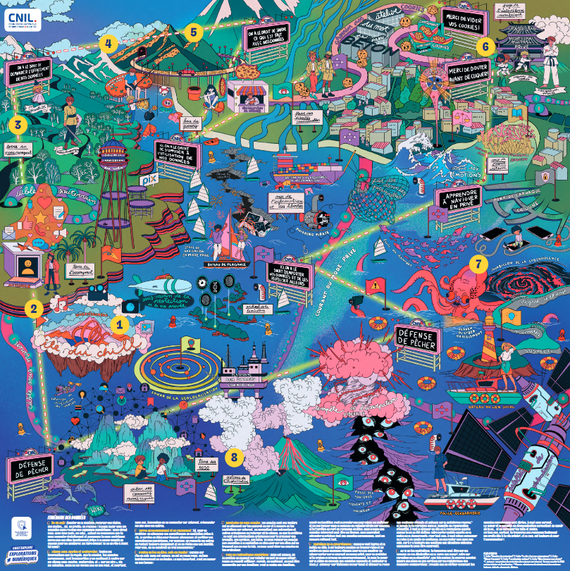

- Please provide the most relevant link on the authority’s website to the initiative, if applicable (The website content does not need to be in English)
https://www.cnil.fr/fr/prudence-internet-ressources-11-15-ans
Listen to the audio files
Access the files in a DYS-friendly format

- Please provide any other relevant links that help explain the initiative or its impact or success (e.g. links to news reports or articles):
Press release :

Advertising, communication online and paper magazine :
https://www.cbnews.fr/digital/image-numerique-cnil-propose-ressources-pedagogiques-11-15-ans-91496

General digital information website :
https://www.frandroid.com/culture-tech/web/2647265_voici-lagence-privacy-le-nouveau-manga-de-la-cnil-pour-sensibiliser-a-la-vie-privee-en-ligne

State website for young people :
https://www.jeunes.gouv.fr/tous-ensemble-prudence-sur-internet-des-ressources-pour-les-jeunes-de-11-15-ans-avec-la-cnil-2658

French north academy :
https://dane.site.ac-lille.fr/2025/03/21/un-ocean-de-donnees-apprendre-a-naviguer-sur-internet-sans-crainte/
https://espace62.site.ac-lille.fr/drane-un-ocean-de-donnees-apprendre-a-naviguer-sur-internet-sans-crainte/

National French school for librarians :
https://www.enssib.fr/bibliotheque-numerique/notices/73054-fiche-mission-un-ocean-de-donnees

GPA Rules and Procedures, Rule 6.2 ‘Assembly documents’: Without prejudice to section 4.2, Assembly documents, including accreditation and observer applications may be submitted in English or in another language. In the latter case, the documents shall be accompanied by an English version. Members with the ability and the resources to do so are encouraged to translate proposed resolutions and other Assembly documents such as the Assembly Rules and Procedures.

