GPA Global Privacy and Data Protection Awards 2025
Entry Form
To submit an entry to the GPA Global Privacy and Data Protection Awards, please complete and email this form to secretariat@globalprivacyassembly.org no later than 16 June 2025.
Note: GPA member authorities can submit as many entries as they wish, but a separate form should be used for each different entry, submitted by the deadline above.
Languages: The GPA documentation Rule 6.2 applies.
- CONTACT DETAILS FOR THIS ENTRY
Privacy/Data Protection Authority: | Croatian Personal Data Protection Agency
Person completing this form: | Anamarija | Mladinić
 | First name | Last name
Job title: | Head of Sector for EU, International Cooperation and Legal Affairs
Email address: | anamarija.mladinic@azop.hr

- ELIGIBILITY
By submitting this entry, I confirm that (please tick all boxes to confirm):
☒ | The Authority is a member of the Global Privacy Assembly
☒ | The initiative described in this entry was undertaken before 16 June 2025.
☒ | I am aware that the information in the entry (other than the contact details in 1(a) above) will be publicised by the GPA Secretariat.

- CATEGORIES
Please indicate which category you wish to enter.
Please tick one; please use a separate form for each category you wish to enter:
☒ | Education and Public Awareness
☒ | Accountability
☐ | Dispute Resolution and Enforcement
☒ | Innovation
☐ | People’s Choice
- DESCRIPTION OF THE INITIATIVE

- Please provide a brief summary of the initiative (no more than 75 words)
Olivia is an innovative, open-source, multilingual digital tool developed by the Croatian Personal Data Protection Agency and partners to help SMEs achieve GDPR compliance. Combining virtual teaching and assistance, Olivia offers fifteen data protection courses, practical templates, twenty webinars, and a small online academy. Launched in 2024, it is regularly updated and supports knowledge-building for data controllers and processors. Olivia strengthens GDPR expertise, promotes a culture of privacy, and encourages EU-wide collaboration through its scalable, interoperable design.

- Please provide a full description of the initiative (no more than 350 words)
Although the General Data Protection Regulation (GDPR) has been in force since May 2018, achieving full compliance remains a significant challenge, particularly for small and medium-sized enterprises (SMEs). To address these challenges, the Croatian Personal Data Protection Agency, in cooperation with its partners, developed Olivia: an innovative, open-source, user-friendly, and interoperable digital tool specifically designed to support SMEs throughout their GDPR compliance journey.

Olivia offers a comprehensive package of educational and practical resources. It includes fifteen data protection courses that address all key obligations of data controllers and processors as defined by the GDPR. Each course consists of both theoretical and practical components. In the theoretical part, users can explore lessons explaining specific GDPR obligations, view educational videos, and take quizzes to assess their knowledge. The practical modules provide data controllers with templates and tools to generate internal documentation that demonstrates compliance and accountability. Additionally, the Olivia platform hosts twenty webinars covering a range of data protection topics. These webinars are permanently accessible and free of charge to all interested stakeholders.

Olivia is a virtual teacher and assistant at the same time. Olivia contains a small online academy that offers to SMEs, but also to all data controllers, a series of learning modules to improve their knowledge in the field of personal data protection, and also serves as a practical tool to help organisations create internal documents to prove their compliance and accountability. It was successfully launched in 2024 and will be regularly updated to ensure its continued relevance and effectiveness. The Croatian DPA is now working on the development of modules on the interplay between GDPR and Artificial Intelligence.

To further support users, a detailed user manual, handbook, and an instructional video have been developed and uploaded to the Olivia platform to serve as a lasting educational resource. The "Olivia" digital tool has empowered SMEs, but also data protection officers across the EU, to improve GDPR compliance through user-friendly support, educational resources, and international collaboration. It enhances SMEs’ expertise, encourages a culture of privacy, and promotes EU-wide engagement through its open-source, multilingual design. Olivia is adaptable and scalable, enabling the seamless integration of new modules and language versions to support GDPR compliance across diverse national contexts.

- Please explain why you think the initiative deserves to be recognised by an award (no more than 200 words)
Olivia deserves recognition because it represents a pioneering, practical, and sustainable response to a genuine need among SMEs for GDPR compliance support. Despite being in force since 2018, the GDPR remains challenging, especially for smaller businesses with limited resources. Olivia bridges this gap through an open-source, interoperable, user-friendly digital tool that combines high-quality educational resources with practical compliance support, empowering SMEs to meet their legal obligations confidently and effectively.
The initiative goes beyond traditional training by offering fifteen structured data protection courses, practical templates to generate internal compliance documents, twenty permanently accessible webinars, and educational videos, all freely available in English. This innovative approach fosters a culture of privacy, strengthens the data protection ecosystem, and supports the consistent application of GDPR principles across various national contexts.

Moreover, Olivia promotes international cooperation and future-proofs its impact by enabling seamless integration of new modules. By combining education, practical tools, and international collaboration, Olivia sets a unique and replicable standard for raising awareness and improving compliance across the EU and wider. This makes Olivia truly worthy of recognition as an outstanding and innovative data protection initiative.

- Please include a photograph or image, if you wish (This will be published with your entry on the GPA website. The image can be pasted into the box below, be sent as an attachment or a link may be provided)
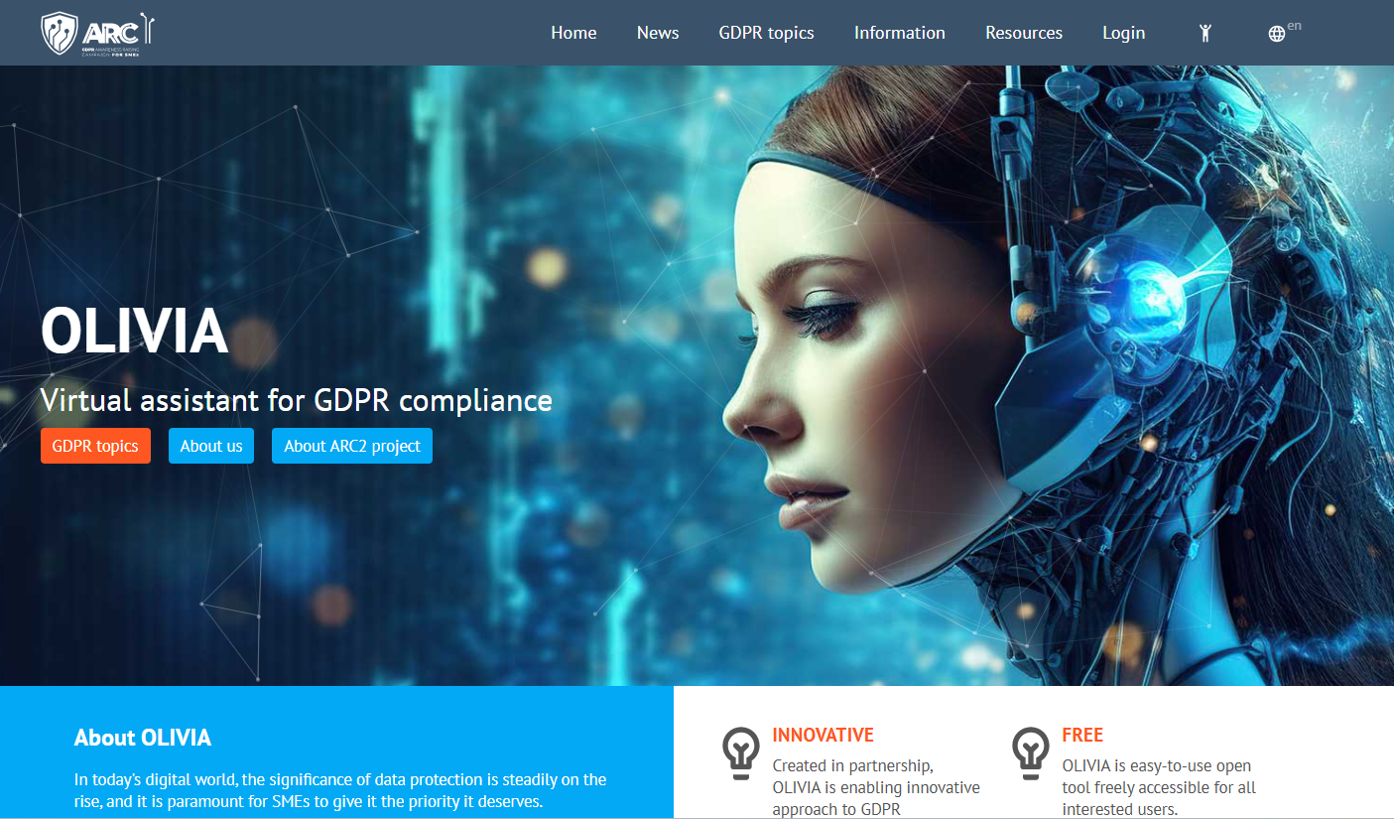

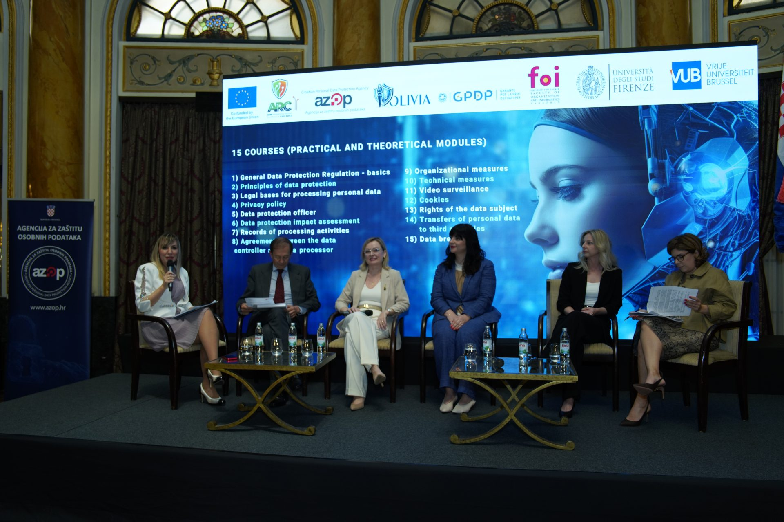

- Please provide the most relevant link on the authority’s website to the initiative, if applicable (The website content does not need to be in English)
https://olivia-gdpr-arc.eu/en

- Please provide any other relevant links that help explain the initiative or its impact or success (e.g. links to news reports or articles):
https://azop.hr/data-protection-day-2024-presenting-arc2-olivia-web-tool-and-discussing-ai/
https://azop.hr/final-event-arc2-olivia/
https://azop.hr/olivia-innovative-gdpr-compliance-tool-showcased-to-edpb/
https://azop.hr/data-protection-day-2025-olivia-ai/

https://azop.hr/predstavljen-i-testiran-web-alat-olivia-za-poduzetnike/
https://www.netokracija.com/azop-olivia-gdpr-kako-se-uskladiti-219654
https://gdpr-2018.hr/33/olivia-virtualna-asistentica-za-uskla-ivanje-s-gdpr-om-uniqueidRCViWTptZHJrD63HGNzcjx4emcEX4DIiAg_rzFJ8D5c/
https://hall.research.vub.be/introducing-olivia-a-comprehensive-digital-tool-for-the-gdpr-compliance-based-on-the-arc-ii-project
https://mrezazena.com/zenske-snage-za-gdpr-uskladenost/
https://azop.hr/arc-2-international-conferencerisks-and-gdpr-compliance-in-the-age-of-artificial-intelligence/
https://azop.hr/european-data-protection-day-2024-entrepreneurs-and-new-technologies/
https://azop.hr/ravnatelj-zdravko-vukic-predstavio-web-alat-olivia-na-simpoziju-privatnosti-u-veneciji/

GPA Rules and Procedures, Rule 6.2 ‘Assembly documents’: Without prejudice to section 4.2, Assembly documents, including accreditation and observer applications may be submitted in English or in another language. In the latter case, the documents shall be accompanied by an English version. Members with the ability and the resources to do so are encouraged to translate proposed resolutions and other Assembly documents such as the Assembly Rules and Procedures.

