GPA Global Privacy and Data Protection Awards 2025
Entry Form
To submit an entry to the GPA Global Privacy and Data Protection Awards, please complete and email this form to secretariat@globalprivacyassembly.org no later than 16 June 2025.
Note: GPA member authorities can submit as many entries as they wish, but a separate form should be used for each different entry, submitted by the deadline above.
Languages: The GPA documentation Rule 6.2 applies.
- CONTACT DETAILS FOR THIS ENTRY
Privacy/Data Protection Authority: | Autoriteit Persoonsgegevens (Dutch Data Protection Authority)
Person completing this form: | Quinten | Snijders
 | First name | Last name
Job title: | Spokesperson
Email address: | q.snijder@autoriteitpersoonsgegevens.nl

- ELIGIBILITY
By submitting this entry, I confirm that (please tick all boxes to confirm):
☒ | The Authority is a member of the Global Privacy Assembly
☒ | The initiative described in this entry was undertaken before 16 June 2025.
☒ | I am aware that the information in the entry (other than the contact details in 1(a) above) will be publicised by the GPA Secretariat.

- CATEGORIES
Please indicate which category you wish to enter.
Please tick one; please use a separate form for each category you wish to enter:
☒ | Education and Public Awareness
☐ | Accountability
☐ | Dispute Resolution and Enforcement
☐ | Innovation
☐ | People’s Choice
- DESCRIPTION OF THE INITIATIVE

- Please provide a brief summary of the initiative (no more than 75 words)
The Dutch DPA created a national advertisement campaign focussing on creating (more) awareness of the privacy risks associated with unlawful use of tracking cookies, targeting businesses and the general public. This was done in addition to intensified national supervision on cookie compliance, resulting in more guidance on tracking cookies and more investigations focusing on tracking cookies.

- Please provide a full description of the initiative (no more than 350 words)
In cooperation with a creative agency (Mensch), the Dutch DPA created an awareness campaign focussing on creating (more) awareness of the privacy risks associated with unlawful uses of tracking cookies. The campaign was created to aid the intensified national supervision on cookie use. It featured ads in the streets, on websites, in cinemas and on the radio during a two-week period in December 2024. The ads featured four different individuals with a lot of personal data animated around their heads. Ranging from the not so personal (“likes books”) to the very personal (“eating disorder” or “compulsive disorder”). Illustrating the fact that cookies make it possible for many companies to stick certain labels on your personal online profile, whether it’s (partly) correct or not.

The campaign targeted businesses and the general public, similar in appearance but with a different message for each target group. Businesses were being addressed in a very direct manner, these ads said: “Cookies know everything about your customers. Do you think that’s normal? Change your cookie policy and prevent getting a fine. Learn how on our website.” The ads for the general public focussed on what people can do to minimize the risks to their privacy posed by cookies. It said: “How are you being profiled? Protect your privacy. Adjust your cookie settings. Learn how on our website.” The campaign page on our website featured useful information for the general public and businesses alike.

- Please explain why you think the initiative deserves to be recognised by an award (no more than 200 words)
We live in an age where most of the people have a significant amount of ‘cookie weariness’. Most people find (tracking) cookies annoying and would rather not have them, but they have accepted them as a ‘necessary evil’. To break through this weariness we have tried to let people look at cookies from a different angle. Partly by illustrating that tracking cookies make it possible to label people at a much more detailed level than most people realize. And also by not solely focusing on the general public, but placing the responsibility where it belongs: with the companies who have websites with large amounts of tracking cookies. By taking this approach we hope to have inspired more people to stop unthinkingly and automatically accept all cookies on websites that have willingly made it more difficult (or impossible) to not accept tracking cookies.

- Please include a photograph or image, if you wish (This will be published with your entry on the GPA website. The image can be pasted into the box below, be sent as an attachment or a link may be provided)
For some animated examples of the campaign, go to this link: https://www.bestandenpostbus.nl/s/TjXB11qxNqQXtfr
Use this password to gain access to the files: GPAwards2025!

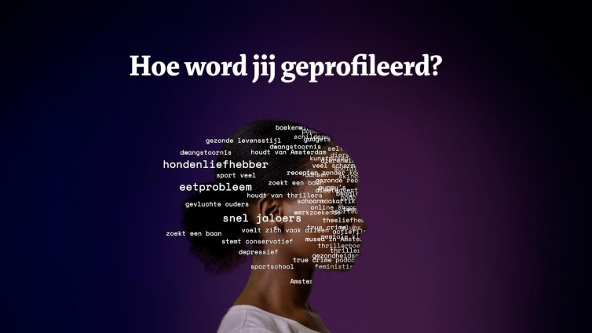
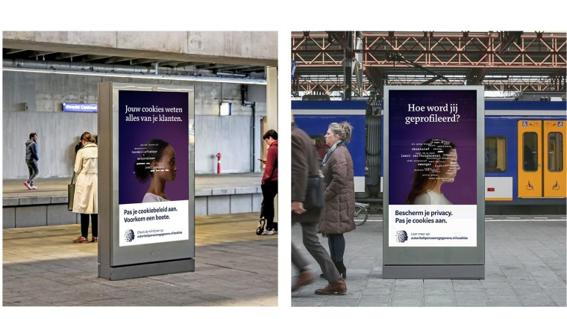

- Please provide the most relevant link on the authority’s website to the initiative, if applicable (The website content does not need to be in English)
https://autoriteitpersoonsgegevens.nl/cookies
https://www.autoriteitpersoonsgegevens.nl/actueel/ap-lanceert-campagne-over-privacyrisicos-van-cookies

- Please provide any other relevant links that help explain the initiative or its impact or success (e.g. links to news reports or articles):
https://privacy-web.nl/nieuws/ap-lanceert-campagne-over-privacyrisicos-van-cookies/

GPA Rules and Procedures, Rule 6.2 ‘Assembly documents’: Without prejudice to section 4.2, Assembly documents, including accreditation and observer applications may be submitted in English or in another language. In the latter case, the documents shall be accompanied by an English version. Members with the ability and the resources to do so are encouraged to translate proposed resolutions and other Assembly documents such as the Assembly Rules and Procedures.

