GPA Global Privacy and Data Protection Awards 2025
Entry Form
To submit an entry to the GPA Global Privacy and Data Protection Awards, please complete and email this form to secretariat@globalprivacyassembly.org no later than 16 June 2025.
Note: GPA member authorities can submit as many entries as they wish, but a separate form should be used for each different entry, submitted by the deadline above.
Languages: The GPA documentation Rule 6.2 applies.
- CONTACT DETAILS FOR THIS ENTRY
Privacy/Data Protection Authority: | Hellenic Data Protection Authority
Person completing this form: | - Vasilios  - Amalia | Zorkadis  Logiaki
 | First name | Last name
Job title: | - General Director  - Communications and PR Officer
Email address: | - zorkadis@dpa.gr  - logiaki@dpa.gr

- ELIGIBILITY
By submitting this entry, I confirm that (please tick all boxes to confirm):
☒ | The Authority is a member of the Global Privacy Assembly
☒ | The initiative described in this entry was undertaken before 16 June 2025.
☒ | I am aware that the information in the entry (other than the contact details in 1(a) above) will be publicised by the GPA Secretariat.

- CATEGORIES
Please indicate which category you wish to enter.
Please tick one; please use a separate form for each category you wish to enter:
☒ | Education and Public Awareness
☐ | Accountability
☐ | Dispute Resolution and Enforcement
☐ | Innovation
☐ | People’s Choice
- DESCRIPTION OF THE INITIATIVE

- Please provide a brief summary of the initiative (no more than 75 words)
The Hellenic Data Protection Authority (HDPA) developed a comprehensive educational program on data protection and the privacy of school-aged children, particularly in the context of using electronic services, aiming to inform and raise their awareness about their right to data protection. As a result, the augmented reality game Tzimanious was created, along with educational material for students and teachers.

- Please provide a full description of the initiative (no more than 350 words)
Τhe Hellenic Data Protection Authority developed a comprehensive privacy education initiative specifically tailored for children, focusing on the safe and informed use of online services, as part of the project 'byDefault', funded by the European Union’s CERV program.

In its initial phase, the project developed educational resources that featured clear learning objectives and age-appropriate messaging. These materials were then evaluated and refined to ensure pedagogical effectiveness, incorporating a variety of learning methods to engage diverse student needs and learning styles.

An educational tool was developed to train primary and secondary school students, with the goal of strengthening their understanding of privacy and data protection. This tool is a hybrid physical-digital augmented reality (AR) game called Tzimanious (meaning “smart cookie”). Through gameplay, students learn to navigate the Internet wisely and cleverly, gradually developing a form of digital expertise.

The AR game combines both physical and digital (“phygital”) features: it consists of physical components, such as a board, pawns and cards, as well as digital elements (an app must be installed on the mobile or tablet to be used during the game process) and aims to make students aware of how to protect their personal data. It is played by 2 to 6 players or groups. The goal of each player/group is to move their pawn through the eight stations of the game, answering questions about personal data and collecting as many diamonds as possible.

Ultimately, the AR game and the accompanying educational material are expected to be incorporated into the school curriculum at both primary and secondary levels. This development stems from a proposal submitted by the Hellenic Data Protection Authority to the Minister of Education, who proved to be an enthusiastic supporter of the initiative.

Furthermore, as part of the project, a training and support program for teacher development has been created in order to establish a culture of responsibility and respect for personal data within the educational community. This is achieved by enhancing teachers' knowledge and skills, thereby increasing their ability to promote these issues among their students.

- Please explain why you think the initiative deserves to be recognised by an award (no more than 200 words)
The interactive AR game combines a traditional board game format with modern technology to keep children engaged and encourage organic peer-to-peer sharing, thereby enhancing learning outcomes.

It addresses key topics such as Internet and social media use, the concept of personal data, and risks related to sharing children’s data online. It also offers practical guidance on navigating social networks, recognizing suspicious behavior, understanding cookies, and identifying manipulation tactics online.

The game was pilot-tested in real classroom settings after a 4-hour webinar that trained participating teachers. Over 500 students from more than 20 classrooms across public and private schools in Greece took part in the pilot phase. Results showed a positive impact on both learning and classroom dynamics.

Combining Augmented Reality (AR) with Game-Based Learning (GBL) proved pedagogically effective: AR enables interaction with real-world learning objects like maps and books, while GBL introduces a playful element. Together, they create an immersive and engaging educational experience.

The game is ready for use in schools, and the HDPA plans to make it accessible to any other interested stakeholders.

- Please include a photograph or image, if you wish (This will be published with your entry on the GPA website. The image can be pasted into the box below, be sent as an attachment or a link may be provided)
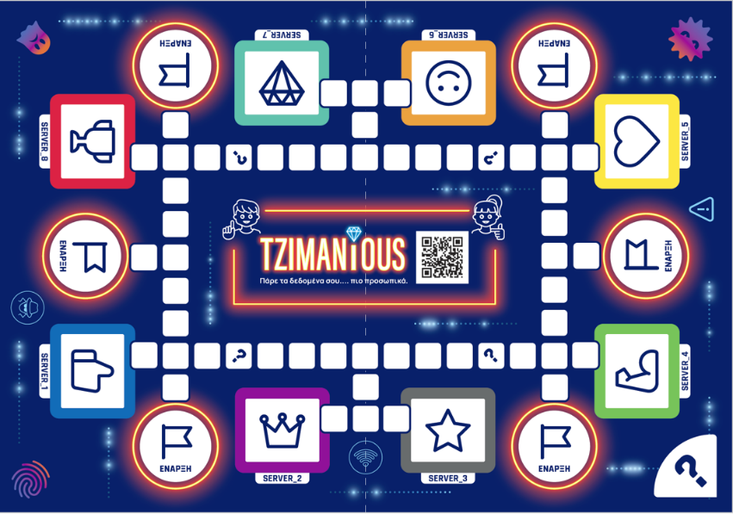

- Please provide the most relevant link on the authority’s website to the initiative, if applicable (The website content does not need to be in English)
- Tzimanious - Playing Together in Augmented Reality: A Board Game for Youth Engagement → https://www.dpa.gr/en/enimerwtiko/themes/tzimaniousen

- ByDefault Deliverables

- byDefault Deliverables Related to the Training Material for Children:

Deliverable D3.1
Learning resources and scenarios

Deliverable D3.2
Educational Tools

- byDefault Deliverables Related to the Training Material for Teachers:

Deliverable D4.1
Training material and methodology

Deliverable D4.2
Training Platform

- Please provide any other relevant links that help explain the initiative or its impact or success (e.g. links to news reports or articles):
- Presentation - ByDefault Project Outcomes – Pilot Education and Assessment – Effectiveness of the training

- Presentation - Training students on personal data protection: The AR physical digital game Tzimanious

- ByDefault Newsletter, issue 3, p. 10

- Representative News Articles

News article 1 (“epixeiro.gr” online platform) [in Greek]
byDefault: Promoting Awareness and Sensitization of Key Social and Professional Groups in Data Protection
News article 2 (“Kathimerini” newspaper online edition) [in Greek]:
Creating “Experts” in Personal Data

GPA Rules and Procedures, Rule 6.2 ‘Assembly documents’: Without prejudice to section 4.2, Assembly documents, including accreditation and observer applications may be submitted in English or in another language. In the latter case, the documents shall be accompanied by an English version. Members with the ability and the resources to do so are encouraged to translate proposed resolutions and other Assembly documents such as the Assembly Rules and Procedures.

