GPA Global Privacy and Data Protection Awards 2025
Entry Form
To submit an entry to the GPA Global Privacy and Data Protection Awards, please complete and email this form to secretariat@globalprivacyassembly.org no later than 16 June 2025.
Note: GPA member authorities can submit as many entries as they wish, but a separate form should be used for each different entry, submitted by the deadline above.
Languages: The GPA documentation Rule 6.2 applies.
- CONTACT DETAILS FOR THIS ENTRY
Privacy/Data Protection Authority: | Institute for Transparency, Access to Public Information and Data Protection of the State of Mexico and Municipalities (Infoem)
Person completing this form: | José | Martínez Vilchis
 | First name | Last name
Job title: | President Commissioner of Infoem
Email address: | jose.martinez@infoem.org.mx

- ELIGIBILITY
By submitting this entry, I confirm that (please tick all boxes to confirm):
☒ | The Authority is a member of the Global Privacy Assembly
☒ | The initiative described in this entry was undertaken before 16 June 2025.
☒ | I am aware that the information in the entry (other than the contact details in 1(a) above) will be publicised by the GPA Secretariat.

- CATEGORIES
Please indicate which category you wish to enter.
Please tick one; please use a separate form for each category you wish to enter:
☒ | Education and Public Awareness
☐ | Accountability
☐ | Dispute Resolution and Enforcement
☐ | Innovation
☐ | People’s Choice
- DESCRIPTION OF THE INITIATIVE

- Please provide a brief summary of the initiative (no more than 75 words)
This initiative, aimed at high school students, seeks to raise awareness about digital violence and the importance of protecting personal data. It consists of an introductory talk on these topics, a screening of the film "The Cyberbully," and a subsequent discussion to reflect and discuss with students their experiences, perceptions, and lessons learned.

- Please provide a full description of the initiative (no more than 350 words)
The Film Discussion is an educational strategy designed to raise awareness among high school students about digital violence and personal data protection, especially in the context of social media. The activity is structured in three phases: an introductory talk, a screening of the film "The Cyberbully," and a final discussion.

In the first phase, privacy and digital rights specialists provide an accessible explanation of what digital violence is, how it manifests itself in virtual environments, and the basic principles of personal data protection. The film "The Cyberbully" is then presented, realistically portraying the consequences of online bullying and the irresponsible use of technology.

A discussion is then held with the students, who share their opinions, experiences, and reflections on what they have seen. This space allows for identifying real concerns among young people and reinforcing key messages about privacy, respect, and responsibility in the digital environment.

The initiative has proven highly effective in generating empathy, promoting open conversations on these issues, and strengthening awareness of digital rights among adolescents. It also encourages critical thinking and the prevention of risky online behavior.

- Please explain why you think the initiative deserves to be recognised by an award (no more than 200 words)
The Film Conversation deserves this recognition for its innovative, empathetic, and deeply human approach to addressing critical issues such as digital violence and personal data protection among adolescents. Through an audiovisual and participatory experience, it connects emotionally with students, facilitating their understanding of complex concepts such as cyberbullying, privacy, and the responsible use of technology.

The initiative is distinguished by its ability to translate legal and technical issues into accessible and meaningful messages for a key population: young people, who are highly vulnerable in digital environments. By fostering open dialogue after the film, the project not only educates but also transforms attitudes and behaviors, empowering students to make informed decisions about their digital lives.

Its impact goes beyond the classroom, as many of the insights generated permeate their homes and communities. Due to its comprehensive approach, its potential for replicability, and its commitment to more conscious and responsible digital citizenship, the Film Conversation represents a valuable contribution to data protection and deserves to be recognized globally.

- Please include a photograph or image, if you wish (This will be published with your entry on the GPA website. The image can be pasted into the box below, be sent as an attachment or a link may be provided)
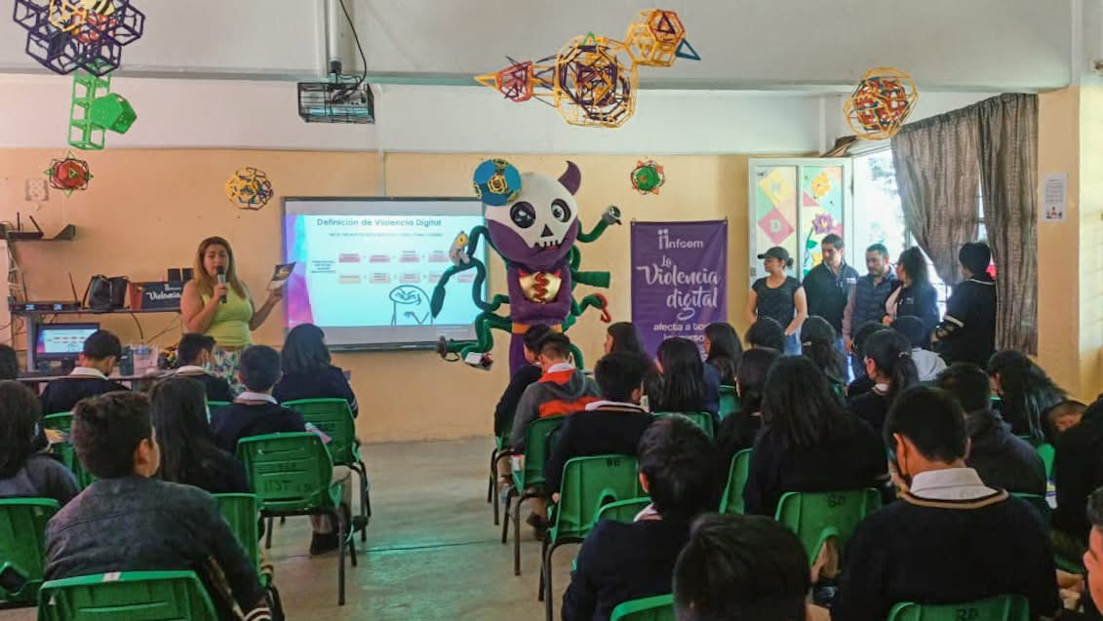

- Please provide the most relevant link on the authority’s website to the initiative, if applicable (The website content does not need to be in English)
https://www.facebook.com/share/19Dd5qxwwZ/?mibextid=wwXIfr

- Please provide any other relevant links that help explain the initiative or its impact or success (e.g. links to news reports or articles):
https://www.flipbookpdf.net/web/site/be943dacc0e0128663d320e6ba1ebea552b2ed8a202402.pdf.html

GPA Rules and Procedures, Rule 6.2 ‘Assembly documents’: Without prejudice to section 4.2, Assembly documents, including accreditation and observer applications may be submitted in English or in another language. In the latter case, the documents shall be accompanied by an English version. Members with the ability and the resources to do so are encouraged to translate proposed resolutions and other Assembly documents such as the Assembly Rules and Procedures.

