GPA Global Privacy and Data Protection Awards 2025
Entry Form
To submit an entry to the GPA Global Privacy and Data Protection Awards, please complete and email this form to secretariat@globalprivacyassembly.org no later than 16 June 2025.
Note: GPA member authorities can submit as many entries as they wish, but a separate form should be used for each different entry, submitted by the deadline above.
Languages: The GPA documentation Rule 6.2 applies.
- CONTACT DETAILS FOR THIS ENTRY
Privacy/Data Protection Authority: | Institute for Transparency, Access to Public Information and Data Protection of the State of Mexico and Municipalities (Infoem)
Person completing this form: | José | Martínez Vilchis
 | First name | Last name
Job title: | President Commissioner of Infoem
Email address: | jose.martinez@infoem.org.mx

- ELIGIBILITY
By submitting this entry, I confirm that (please tick all boxes to confirm):
☒ | The Authority is a member of the Global Privacy Assembly
☒ | The initiative described in this entry was undertaken before 16 June 2025.
☒ | I am aware that the information in the entry (other than the contact details in 1(a) above) will be publicised by the GPA Secretariat.

- CATEGORIES
Please indicate which category you wish to enter.
Please tick one; please use a separate form for each category you wish to enter:
☒ | Education and Public Awareness
☐ | Accountability
☐ | Dispute Resolution and Enforcement
☐ | Innovation
☐ | People’s Choice
- DESCRIPTION OF THE INITIATIVE

- Please provide a brief summary of the initiative (no more than 75 words)
The Infoem Digital Violence Website is an informational microsite that promotes the prevention and eradication of digital violence. It offers accessible content on the topic, including protection measures and legal foundations. As a digital tool, it allows reaching remote communities in the State of Mexico, guaranteeing equitable access to information and raising awareness about digital rights and the protection of personal data.

- Please provide a full description of the initiative (no more than 350 words)
The Digital Violence Website is a digital platform developed by the Institute for Transparency, Access to Public Information, and Protection of Personal Data of the State of Mexico and Municipalities (Infoem), with the goal of disseminating clear and accessible information about digital violence and how to prevent it. This microsite, hosted on Infoem's institutional portal, offers educational content on the different types of digital violence, its consequences, prevention strategies, and legal foundations for eradicating it.

The tool is designed to be inclusive and easy to navigate, allowing access from different devices and facilitating access for people in rural or remote communities in the State of Mexico. Its digital nature makes it a far-reaching resource, overcoming geographical barriers and raising awareness in sectors that might otherwise not have access to this type of information.

In addition to providing written content, the site includes visual resources, infographics, and links to applicable regulations, making it a reliable and up-to-date resource. This initiative strengthens the right to personal data protection and a life free from violence in digital environments, promoting an informed and empowered citizenry in the face of the risks of the technological age.

- Please explain why you think the initiative deserves to be recognised by an award (no more than 200 words)
Infoem's Digital Violence Website deserves recognition for its accessible, inclusive, and strategic approach to addressing one of the most urgent challenges in the digital environment: online violence. This tool not only informs, but also educates and empowers citizens through clear, visual, and understandable content that explains how to identify, prevent, and respond to situations of digital violence.

Its digital design allows it to reach rural communities and hard-to-reach areas in the State of Mexico, democratizing knowledge and helping to close the digital divide in human rights and personal data protection. Furthermore, it integrates updated regulatory frameworks and materials, making it a reliable resource for students, teachers, parents, and public servants.

The initiative stands out for its territorial impact, its potential for replication in other entities, and its firm commitment to eradicating digital violence as a way to guarantee a dignified and safe life in virtual environments. For its real contribution to strengthening a responsible digital culture, it deserves global recognition.

- Please include a photograph or image, if you wish (This will be published with your entry on the GPA website. The image can be pasted into the box below, be sent as an attachment or a link may be provided)
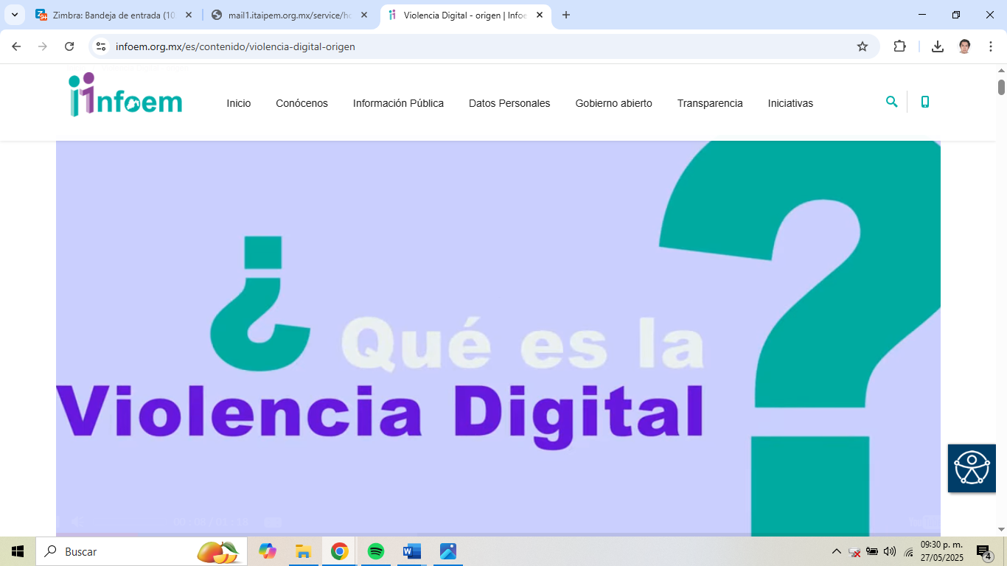

- Please provide the most relevant link on the authority’s website to the initiative, if applicable (The website content does not need to be in English)
https://www.infoem.org.mx/es/iniciativas/micrositio/violencia-digital

- Please provide any other relevant links that help explain the initiative or its impact or success (e.g. links to news reports or articles):
https://www.infoem.org.mx/es/contenido/violencia-digital-origen

GPA Rules and Procedures, Rule 6.2 ‘Assembly documents’: Without prejudice to section 4.2, Assembly documents, including accreditation and observer applications may be submitted in English or in another language. In the latter case, the documents shall be accompanied by an English version. Members with the ability and the resources to do so are encouraged to translate proposed resolutions and other Assembly documents such as the Assembly Rules and Procedures.

