GPA Global Privacy and Data Protection Awards 2025
Entry Form
To submit an entry to the GPA Global Privacy and Data Protection Awards, please complete and email this form to secretariat@globalprivacyassembly.org no later than 16 June 2025.
Note: GPA member authorities can submit as many entries as they wish, but a separate form should be used for each different entry, submitted by the deadline above.
Languages: The GPA documentation Rule 6.2 applies.
- CONTACT DETAILS FOR THIS ENTRY
Privacy/Data Protection Authority: | Information and Privacy Commissioner of Ontario (IPC)
Person completing this form: | Patricia | Kosseim
 | First name | Last name
Job title: | Commissioner
Email address: | commissioner.ipc@ipc.on.ca

- ELIGIBILITY
By submitting this entry, I confirm that (please tick all boxes to confirm):
☒ | The Authority is a member of the Global Privacy Assembly
☒ | The initiative described in this entry was undertaken before 16 June 2025.
☒ | I am aware that the information in the entry (other than the contact details in 1(a) above) will be publicised by the GPA Secretariat.

- CATEGORIES
Please indicate which category you wish to enter.
Please tick one; please use a separate form for each category you wish to enter:
☒ | Education and Public Awareness
☐ | Accountability
☐ | Dispute Resolution and Enforcement
☐ | Innovation
☐ | People’s Choice
- DESCRIPTION OF THE INITIATIVE

- Please provide a brief summary of the initiative (no more than 75 words)
Info Matters is a podcast about the latest issues in privacy and information access, hosted by Information and Privacy Commissioner Patricia Kosseim. Joined by guests from all walks of life — everybody from technology researchers and health system leaders to teachers and high school students — we explore crucial data-related issues in an accessible and engaging format. Topics run the gamut from the ethics of genetic research, to neurotechnology and mental privacy, and First Nations data sovereignty.

- Please provide a full description of the initiative (no more than 350 words)
Now entering its fifth season with over 40 episodes, Info Matters is dedicated to promoting information literacy and enhancing the public’s knowledge of their privacy and access rights. In each episode, we tackle some of the most pressing questions of our time: How can AI be used responsibly to advance health care? What are the human rights implications of facial recognition technology? What does Gen Z think about privacy? Info Matters also shares essential tips to help listeners stay safe and informed in a digital world, like how to avoid phishing and cyberattacks?
Privacy matters to each and every one of us—but in different ways, depending on who we are and our life circumstances. Info Matters features guests from a wide range of backgrounds to hear diverse experiences and shine a light on marginalized perspectives, including women and teenage girls, foster kids, health and child protection in equity seeking groups, patient advocates, victims of intimate partner violence, Indigenous communities, and people experiencing homelessness. Through this diversity, the show offers an intersectional look at privacy and information access.
Info Matters is also enhancing the public's trust in the IPC to uphold privacy and information access rights. Hosted by the Commissioner herself, the show helps to humanize data issues and demonstrates our commitment to serving everyday Ontarians. Fostering these human connections and listening to diverse perspectives are key to our overall vision of being a modern and effective regulator with real world impact.
Below are some of Info Matters’ most popular episodes.
Season 1 Episode 7: First Nations data sovereignty
This episode explores how principles of data ownership, access, control, and possession (OCAP) help promote the ethical use of data about First Nations, by First Nations, and for First Nations.
Season 2 Episode 2: Family ties: Using investigative genetic genealogy to solve crimes
Renowned DNA forensics expert Dr. Frederick Bieber speaks about the use of genetic genealogy by police and the potential privacy risks associated with this emerging technique.
Season 4 Episode 4: Artificial intelligence in health care: Balancing innovation with privacy
Dr. Devin Singh of Toronto’s Hospital for Sick Children speaks about balancing the benefits and risks of using artificial intelligence to improve health care diagnoses and treatments.

- Please explain why you think the initiative deserves to be recognised by an award (no more than 200 words)
Since its launch in 2021, Info Matters has been downloaded more than 20,000 times, reaching audiences in Canada and beyond. In 2023, the show was awarded a Canadian Podcast Award for Outstanding Technology Series, a testament to its success in bringing crucial information to the public. As of 2024, Info Matters was ranked by Feedspot as the #7 data security podcast worth listening to in 2024.
In the digital age, privacy education is more important than ever, but oftentimes, key information remains inaccessible to the general public. Info Matters fills a crucial knowledge gap, inviting listeners of all backgrounds to join in the conversation. It’s also arming listeners in Ontario with valuable knowledge about their own privacy and transparency rights, giving them the tools they need to protect themselves and their personal information.

- Please include a photograph or image, if you wish (This will be published with your entry on the GPA website. The image can be pasted into the box below, be sent as an attachment or a link may be provided)
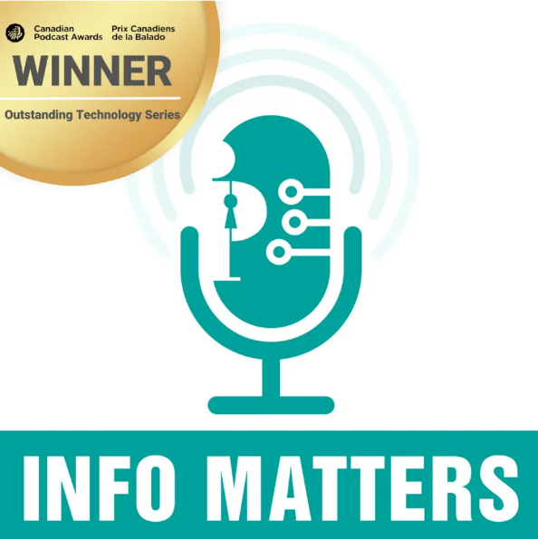

- Please provide the most relevant link on the authority’s website to the initiative, if applicable (The website content does not need to be in English)
https://www.ipc.on.ca/en/media-centre/multimedia/info-matters-podcast

- Please provide any other relevant links that help explain the initiative or its impact or success (e.g. links to news reports or articles):
To see Info Matters win a 2023 Canadian Podcast Award:

https://www.ipc.on.ca/en/media-centre/multimedia-resources/ipc-podcast-info-matters-wins-2023-canadian-podcast-award

GPA Rules and Procedures, Rule 6.2 ‘Assembly documents’: Without prejudice to section 4.2, Assembly documents, including accreditation and observer applications may be submitted in English or in another language. In the latter case, the documents shall be accompanied by an English version. Members with the ability and the resources to do so are encouraged to translate proposed resolutions and other Assembly documents such as the Assembly Rules and Procedures.

