GPA Global Privacy and Data Protection Awards 2025
Entry Form
To submit an entry to the GPA Global Privacy and Data Protection Awards, please complete and email this form to secretariat@globalprivacyassembly.org no later than 16 June 2025.
Note: GPA member authorities can submit as many entries as they wish, but a separate form should be used for each different entry, submitted by the deadline above.
Languages: The GPA documentation Rule 6.2 applies.
- CONTACT DETAILS FOR THIS ENTRY
Privacy/Data Protection Authority: | Information and Privacy Commissioner of Ontario (IPC)
Person completing this form: | Patricia | Kosseim
 | First name | Last name
Job title: | Commissioner
Email address: | commissioner.ipc@ipc.on.ca

- ELIGIBILITY
By submitting this entry, I confirm that (please tick all boxes to confirm):
☒ | The Authority is a member of the Global Privacy Assembly
☒ | The initiative described in this entry was undertaken before 16 June 2025.
☒ | I am aware that the information in the entry (other than the contact details in 1(a) above) will be publicised by the GPA Secretariat.

- CATEGORIES
Please indicate which category you wish to enter.
Please tick one; please use a separate form for each category you wish to enter:
☒ | Education and Public Awareness
☐ | Accountability
☐ | Dispute Resolution and Enforcement
☐ | Innovation
☐ | People’s Choice
- DESCRIPTION OF THE INITIATIVE

- Please provide a brief summary of the initiative (no more than 75 words)
The IPC has intensified its efforts to champion the privacy rights of children and youth through the creation of a Youth Advisory Council (YAC). The YAC gives young people the chance to express their views firsthand on the challenges they face in the online world and help promote children’s digital literacy and digital rights in a relevant way. Currently, the IPC is one of the only data protection authorities in the world to have a youth advisory council.

- Please provide a full description of the initiative (no more than 350 words)
The IPC’s YAC is a group of ten youth between the ages of 15 and 22 from different communities across the province of Ontario, with diverse backgrounds, experiences and outlooks. Over their two-year term, the council came together to share their perspectives, provide input on youth-focused initiatives, and champion privacy and information access rights among their peers.

Their contributions have played an instrumental role in advancing one of the IPC’s key strategic priorities: Children and Youth in a Digital World. Through regular online meetings, a full-day in-person retreat, and professional speaking opportunities, the YAC has provided thoughtful advice on a wide range of IPC projects, including initiatives such as:

- Youth Ambassador Toolkit - a key resource designed with youth for youth, to empower them with the knowledge, skills and tools they need to educate their peers about the importance of privacy and their privacy rights.
- Digital Privacy Charter - a set of twelve privacy best practices that schools can adopt to reaffirm their commitments to protect students’ privacy from ed tech platforms and empower students through privacy education and digital literacy.
- Privacy Pursuit Lesson Plans - a set of classroom-ready lesson plans designed to help educators teach students about privacy and data protection online.
- Frequently asked questions and answers about children’s access and privacy rights in the child welfare sector.

YAC voices have been embedded throughout the IPC’s work. They have been featured on our Info Matters podcast. On our Instagram account the YAC guided the development of digital content on topics that children and youth care about, including generative AI, age verification, online safety, and digital literacy.

Furthermore, YAC members have inspired privacy regulators and professionals across Canada by sharing their perspectives firsthand, as invited speakers at high-profile events such as the 2024 Annual Meeting of the Canadian Federal Provincial Territorial Privacy Commissioners and Ombuds and at the IAPP Canada Privacy Symposium 2025.

- Please explain why you think the initiative deserves to be recognised by an award (no more than 200 words)
Most privacy-related content is developed by and for adults and professionals. However, young people are most in need of privacy education and deserve to have a say related to the key issues that impact their daily lives in the classroom and online.

The IPC's YAC model has made a strong impact in Canadian and international privacy communities and has been recognized as a leading example of how to engage youth in the conversation. Being recognized with this award would further advance this model as a best practice among other privacy regulators. Currently, the IPC is one of the only data protection authorities in the world to have a youth council. By giving young people a platform to express their views on access and privacy issues that affect them, we have demonstrated that youth perspectives are a valuable and essential part of the privacy conversation.

The YAC’s work has been recognized at numerous conferences and forums including UNICEF, the Global Privacy Assembly (GPA), Victoria International Privacy & Security Summit (VIPSS), Asia Pacific Privacy Authorities (APPA), and Federal, Provincial and Territorial (FPT) Privacy Commissioner meetings.

- Please include a photograph or image, if you wish (This will be published with your entry on the GPA website. The image can be pasted into the box below, be sent as an attachment or a link may be provided)
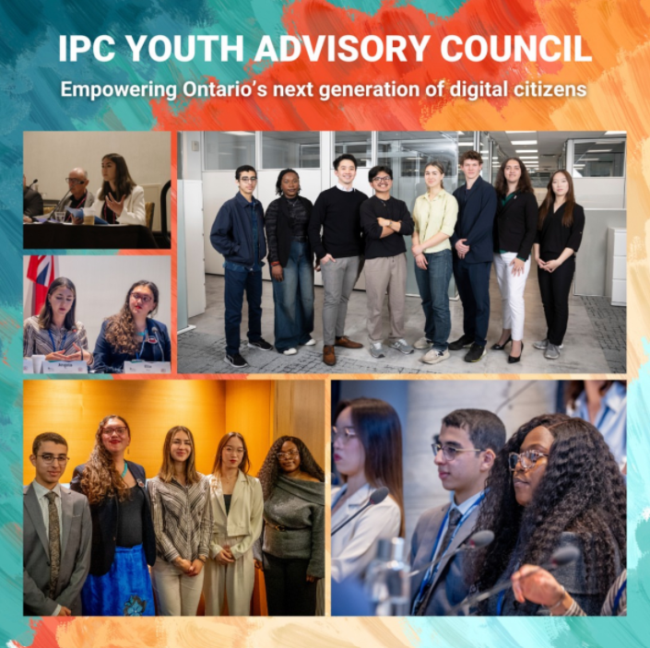

- Please provide the most relevant link on the authority’s website to the initiative, if applicable (The website content does not need to be in English)
https://www.ipc.on.ca/en/about-us/ipcs-youth-advisory-council

- Please provide any other relevant links that help explain the initiative or its impact or success (e.g. links to news reports or articles):
https://www.ipc.on.ca/en/media-centre/blog/empowering-young-people-todays-digital-world

https://www.ipc.on.ca/en/media-centre/blog/ontario-ipc-hosts-access-and-privacy-authorities-across-canada

https://www.ipc.on.ca/en/youth-ambassador-toolkit

https://www.ipc.on.ca/en/privacy-organizations/digital-privacy-charter-for-ontario-schools

https://www.ipc.on.ca/en/privacy-individuals/privacy-pursuit-lesson-plans

https://www.ipc.on.ca/en/media-centre/info-matters-podcast

https://www.instagram.com/accounts/login/?next=https%3A%2F%2Fwww.instagram.com%2Fipc.ontario%2F&is_from_rle

https://www.ipc.on.ca/en/resources/advocacy/fpt-toronto

https://youtu.be/7LNbZpj-5S8?si=blCeFD_DFA361cyz

https://www.ipc.on.ca/en/about-us/children-and-youth-in-a-digital-world

GPA Rules and Procedures, Rule 6.2 ‘Assembly documents’: Without prejudice to section 4.2, Assembly documents, including accreditation and observer applications may be submitted in English or in another language. In the latter case, the documents shall be accompanied by an English version. Members with the ability and the resources to do so are encouraged to translate proposed resolutions and other Assembly documents such as the Assembly Rules and Procedures.

