GPA Global Privacy and Data Protection Awards 2025
Entry Form
To submit an entry to the GPA Global Privacy and Data Protection Awards, please complete and email this form to secretariat@globalprivacyassembly.org no later than 16 June 2025.
Note: GPA member authorities can submit as many entries as they wish, but a separate form should be used for each different entry, submitted by the deadline above.
Languages: The GPA documentation Rule 6.2 applies.
- CONTACT DETAILS FOR THIS ENTRY
Privacy/Data Protection Authority: | Irish Data Protection Commission (DPC)
Person completing this form: | Gráinne | Hawkes
 | First name | Last name
Job title: | Deputy Commissioner, Head of International Affairs
Email address: | gxhawkes@dataprotection.ie

- ELIGIBILITY
By submitting this entry, I confirm that (please tick all boxes to confirm):
☒ | The Authority is a member of the Global Privacy Assembly
☒ | The initiative described in this entry was undertaken before 16 June 2025.
☒ | I am aware that the information in the entry (other than the contact details in 1(a) above) will be publicised by the GPA Secretariat.

- CATEGORIES
Please indicate which category you wish to enter.
Please tick one; please use a separate form for each category you wish to enter:
☒ | Education and Public Awareness
☐ | Accountability
☐ | Dispute Resolution and Enforcement
☐ | Innovation
☐ | People’s Choice
- DESCRIPTION OF THE INITIATIVE

- Please provide a brief summary of the initiative (no more than 75 words)
In December 2024, the Data Protection Commission (DPC) launched a “Data Protection Toolkit for Schools” dedicated to assisting schools with data protection obligations when processing children’s personal data. The DPC had identified several areas where schools, especially small primary schools with very limited resources, were experiencing data protection compliance challenges. The schools toolkit was produced to provide a data protection resource that would help ease the compliance burden whilst promoting effective protection of personal data.

- Please provide a full description of the initiative (no more than 350 words)
In 2023, the DPC consulted with a number of external organisations and management bodies in the education sector in order to gain a clearer picture of the specific concerns and challenges faced by schools which they felt merited particular attention in terms of guidance.
The DPC produced the “Data Protection Toolkit for Schools” in order to further assist schools in meeting their data protection obligations. This toolkit was specifically created to assist schools with their obligations as data controllers and to help them to comply with the General Data Protection Regulation and the Data Protection Act 2018 when processing the personal data of children.
The toolkit contains;
- A detailed guidance piece on different aspects of data protection law in the specific context of schools
- An FAQ section containing answers to questions commonly received by the DPC from the education sector
- An appendix containing three helpful resources for schools, namely:
- A sample template for Data Protection Impact Assessments (DPIAs)
- An infographic on what information to include in a Privacy Policy
- A “checklist” for schools on how to respond to a Subject Access Request (SAR)
The toolkit stands out from the DPC’s published guidance to date as there was a focus on making the guidance sector specific and visually dynamic with infographics, templates and colourful key takeaways.
Following the toolkit’s launch the DPC is planning to raise further awareness of this resource by running a series of information sessions targeting primary, post primary and recently/soon to be qualified teachers across Ireland in 2025.

- Please explain why you think the initiative deserves to be recognised by an award (no more than 200 words)
The DPC has created an innovative and convenient resource specifically designed for the education sector. It addresses the most common and persistent data processing challenges that the sector faces year to year in plain language and with examples that were tailored to be pertinent to them.
Given the complexities of data protection in schools, the toolkit is a valuable resource for principals, teachers, and Boards of Management nationwide to review numerous data processing concerns all within one convenient document. The toolkit offers essential guidance for schools on managing children’s data, handling access requests, and ensuring compliance, with key insights on consent, third-party data sharing, Data Protection Impact Assessments and CCTV policies.
At the forefront of the toolkit is the principle that the best interests of the child will be considered by the DPC in respect of a child’s data protection rights, taking into account their evolving capacity as they near the age of majority.
Following the toolkit’s launch in December 2024, we invited feedback from the public until 20 February. The feedback we received was extremely positive with the toolkit being described as an “excellent update” and “of huge value to schools.”

- Please include a photograph or image, if you wish (This will be published with your entry on the GPA website. The image can be pasted into the box below, be sent as an attachment or a link may be provided)
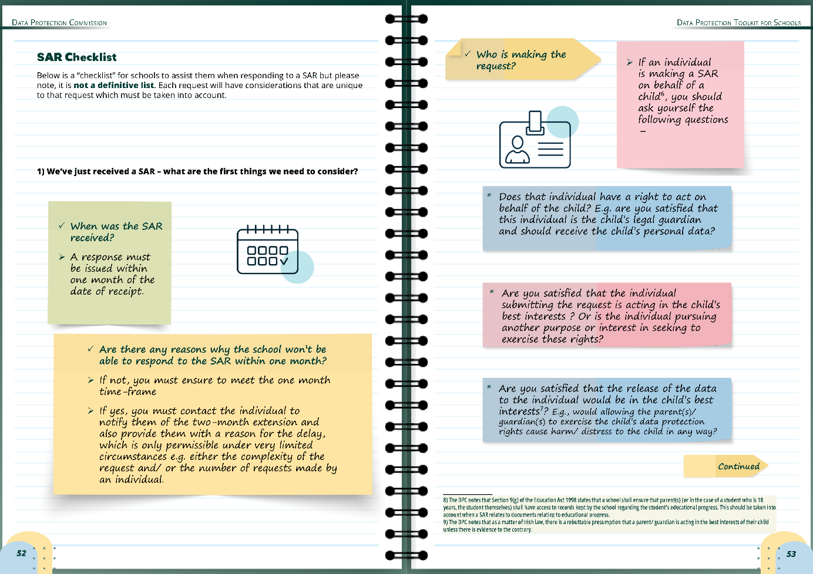
Image 1: A Section of the Toolkit’s Subject Access Request (SAR) Checklist

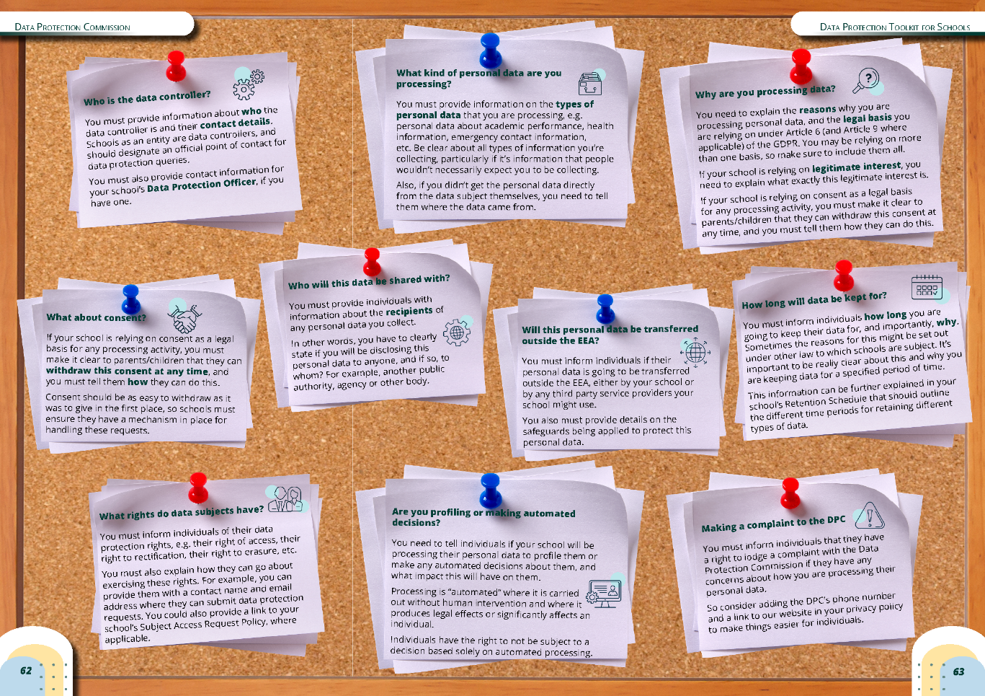
Image 2: The Toolkit’s Privacy Policy Infographic

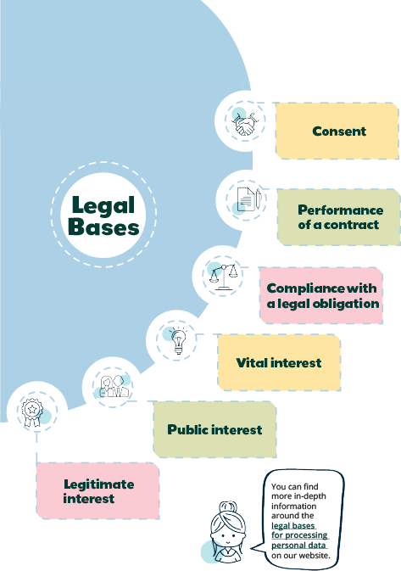
Image 3: A sample of some of the colourful key takeaway imagery throughout the Toolkit

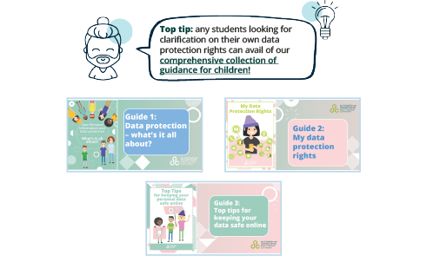



Images 4 and 5 above: Samples of the friendly prompts to other relevant guidance the DPC has published, seen throughout the Toolkit

- Please provide the most relevant link on the authority’s website to the initiative, if applicable (The website content does not need to be in English)
Toolkit for Schools

- Please provide any other relevant links that help explain the initiative or its impact or success (e.g. links to news reports or articles):
Irish Primary Principals’ Network newsletter page 4 (6 of 32) https://issuu.com/ippn/docs/leadership_issue_137_-_april_2025
Catholic Primary School Management Association newsletter page 8 https://www.cpsma.ie/wp-content/uploads/2024/10/CPSMA-Newsletter-81_Mar_2025.pdf
DPC publishes “Data Protection Toolkit for Schools” | 19/12/2024 | Data Protection Commission
Data Protection Toolkit for Schools | Data Protection Commission
Data Protection Commissioner’s Toolkit for… | Mason Hayes Curran
Schools as Data Controllers and Data Protection Commission’s Toolkit - Trilateral Research
RDJ LLP | Data Protection Commissioner publishes Toolkit for Schools
Law Society of Ireland Gazette
Ireland: DPC publishes data protection toolkit for schools | News | DataGuidance

GPA Rules and Procedures, Rule 6.2 ‘Assembly documents’: Without prejudice to section 4.2, Assembly documents, including accreditation and observer applications may be submitted in English or in another language. In the latter case, the documents shall be accompanied by an English version. Members with the ability and the resources to do so are encouraged to translate proposed resolutions and other Assembly documents such as the Assembly Rules and Procedures.

