GPA Global Privacy and Data Protection Awards 2025
Entry Form
To submit an entry to the GPA Global Privacy and Data Protection Awards, please complete and email this form to secretariat@globalprivacyassembly.org no later than 16 June 2025.
Note: GPA member authorities can submit as many entries as they wish, but a separate form should be used for each different entry, submitted by the deadline above.
Languages: The GPA documentation Rule 6.2 applies.
- CONTACT DETAILS FOR THIS ENTRY
Privacy/Data Protection Authority: | Office of the Privacy Commissioner, New Zealand
Person completing this form: | Stephanie | Gregor
 | First name | Last name
Job title: | Capability & Guidance Manager
Email address: | stephanie.gregor@privacy.org.nz

- ELIGIBILITY
By submitting this entry, I confirm that (please tick all boxes to confirm):
☒ | The Authority is a member of the Global Privacy Assembly
☒ | The initiative described in this entry was undertaken before 16 June 2025.
☒ | I am aware that the information in the entry (other than the contact details in 1(a) above) will be publicised by the GPA Secretariat.

- CATEGORIES
Please indicate which category you wish to enter.
Please tick one; please use a separate form for each category you wish to enter:
☒ | Education and Public Awareness
☐ | Accountability
☐ | Dispute Resolution and Enforcement
☐ | Innovation
☐ | People’s Choice
- DESCRIPTION OF THE INITIATIVE

- Please provide a brief summary of the initiative (no more than 75 words)
Poupou Matatapu is a comprehensive suite of guidance which sets our expectations about what good privacy practice looks like and then helps agencies get there. It systematically sets out the ten pou (pillars) of good privacy management and helps agencies towards reaching the outcomes we’ve described. The guidance provides examples on how agencies can achieve the outcomes as well as showing scenarios to help people better understand how privacy works in practice.

- Please provide a full description of the initiative (no more than 350 words)
The name Poupou (pillars) Matatapu (privacy) comes from te reo Māori, the indigenous language of Aotearoa New Zealand. Poupou Matatapu describes ten pou (pillars) that are fundamental to agency understanding and implementation of privacy.

The ten pou are:
- Governance
- Know your Personal Information
- Security and Internal Access Controls
- Transparency
- Building Capability and Awareness
- Breach Management
- Responding to requests and complaints well
- Assessing Risk
- Measure and Monitor
- Privacy Management Plan

Each of the first nine pou can be worked through sequentially to help agencies develop a full understanding of their privacy capability and preparedness, and the Privacy Management Plan pou provides a template for agencies to record and assess their compliance, and develop an improvement plan. Poupou Matatapu utilises archetype examples of different kinds of agencies common in New Zealand (e.g. a tech company, a government department, a charity) and descriptions of how these agencies can comply with privacy requirements.

Poupou came about because we found that organisations’ privacy programmes are often reactive, responding to a specific event or inquiry but not having the time or resources to proactively implement a strategy. Organisations improve practice by responding to the event but then lose momentum. Building an effective privacy management system requires continuous improvement to lift capability, maintain good practice once this is achieved, and establish a privacy culture that reflects the values of each organisation.

We asked organisations what they struggled with when complying with the Privacy Act and what would help manage their privacy obligations and risk. We also asked how we could help them to build a privacy-protective culture throughout their organisation. The answer was clear guidance that outlined our expectations as a regulator and provided practical examples.
Poupou has broad support from our regulated sector and benefited from input from privacy professionals throughout Aotearoa.

Poupou Matatapu is not designed to stand alone. OPC has a Compliance and Regulatory Action Framework which allows us to assess whether agencies have worked towards the outcomes as outlined in Poupou Matatapu. Poupou Matatapu is a key part of how we communicate privacy in speeches, other guidance and media statements.

- Please explain why you think the initiative deserves to be recognised by an award (no more than 200 words)
Poupou Matatapu signals a shift in how OPC helps New Zealand agencies do privacy well. Underpinning Poupou Matatapu is our commitment to explaining in clear, accessible language how agencies can meet their privacy obligations.

We recognise that privacy teams in agencies are not always fully resourced, and that it is incredibly useful to provide busy individuals who don’t know where to start thinking about privacy with a clear, straightforward way to assess their privacy compliance. This is particularly important in small agencies. They can see themselves in the archetype examples and this makes privacy real for them. Now that they understand more clearly what is required of them they are supported to make meaningful changes to their privacy programmes.

As an office we regularly speak to varied audiences across New Zealand and attendees report to us that the approach we take in Poupou Matatapu is what makes the requirements of the Privacy Act click for them. Suddenly privacy isn’t so scary or hard to comply with. Poupou Matatapu allows agencies that may previously have struggled to meet their privacy obligations understand what they need to do, which is why it deserves to be recognised by this award.

- Please include a photograph or image, if you wish (This will be published with your entry on the GPA website. The image can be pasted into the box below, be sent as an attachment or a link may be provided)
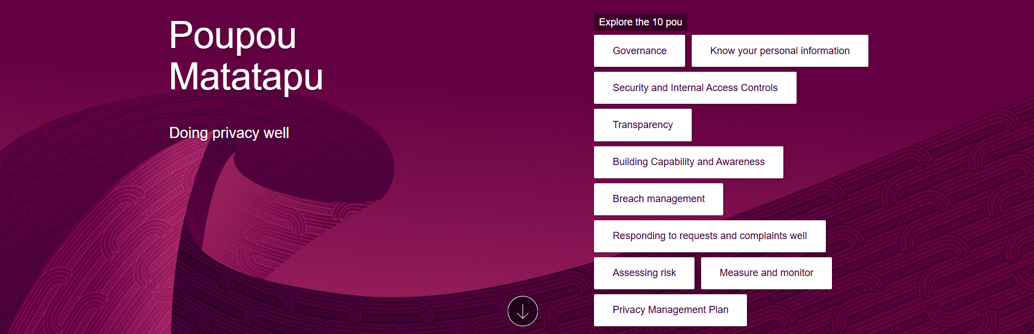

- Please provide the most relevant link on the authority’s website to the initiative, if applicable (The website content does not need to be in English)
https://www.privacy.org.nz/responsibilities/poupou-matatapu-doing-privacy-well/

- Please provide any other relevant links that help explain the initiative or its impact or success (e.g. links to news reports or articles):
https://iapp.org/news/a/notes-from-the-asia-pacific-region-toolkit-helps-nz-organizations-do-privacy-well

https://www.minterellison.co.nz/insights/privacy-commissioner-releases-new-guidance-on-good-privacy-practice

GPA Rules and Procedures, Rule 6.2 ‘Assembly documents’: Without prejudice to section 4.2, Assembly documents, including accreditation and observer applications may be submitted in English or in another language. In the latter case, the documents shall be accompanied by an English version. Members with the ability and the resources to do so are encouraged to translate proposed resolutions and other Assembly documents such as the Assembly Rules and Procedures.

