GPA Global Privacy and Data Protection Awards 2025
Entry Form
To submit an entry to the GPA Global Privacy and Data Protection Awards, please complete and email this form to secretariat@globalprivacyassembly.org no later than 16 June 2025.
Note: GPA member authorities can submit as many entries as they wish, but a separate form should be used for each different entry, submitted by the deadline above.
Languages: The GPA documentation Rule 6.2 applies.
- CONTACT DETAILS FOR THIS ENTRY
Privacy/Data Protection Authority: | The Personal Data Protection Service of Georgia
Person completing this form: | Ana Tokhadze
 | First name | Last name
Job title: | Head of International Relations, Analytics  and Strategic Development Department
Email address: | atokhadze@pdps.ge

- ELIGIBILITY
By submitting this entry, I confirm that (please tick all boxes to confirm):
☒ | The Authority is a member of the Global Privacy Assembly
☒ | The initiative described in this entry was undertaken before 16 June 2025.
☒ | I am aware that the information in the entry (other than the contact details in 1(a) above) will be publicised by the GPA Secretariat.

- CATEGORIES
Please indicate which category you wish to enter.
Please tick one; please use a separate form for each category you wish to enter:
☒ | Education and Public Awareness
☐ | Accountability
☐ | Dispute Resolution and Enforcement
☐ | Innovation
☐ | People’s Choice
- DESCRIPTION OF THE INITIATIVE

- Please provide a brief summary of the initiative (no more than 75 words)
The educational project “Confidentiality Lessons,” initiated by the Personal Data Protection Service of Georgia, targets students in both private and public schools. Special materials, including an educational-cognitive newspaper and brochures, address the processing of minors’ personal data in online spaces and school environments. Weekly meetings are held at the Service’s offices in Tbilisi and Batumi, and the project includes regional visits, especially to ethnic minority areas, focusing on Armenian- and Azerbaijani-speaking students.

- Please provide a full description of the initiative (no more than 350 words)
Starting February 1, 2025, the conference space at the Personal Data Protection Service of Georgia is fully dedicated to conducting “Confidentiality Lessons” for schoolchildren every Tuesday. On this day, meetings are held in two separate sessions. At the same time, visits to schools in the regions are planned and carried out in parallel.
The project aims to raise awareness among minors regarding the protection of personal data. During the “Confidentiality Lessons,” students in grades VI–XII receive information on the importance of data protection and learn to evaluate the risks that may arise from the illegal or careless disclosure of data. The trainings are conducted by the service’s lawyers, who deliver this information to the students through simple, interactive, and engaging presentations.
At the same meetings, special publications are distributed to students and teachers:
- An educational and entertaining journal for children — this publication introduces minors to the importance of personal data protection in a simple, interactive, and fun way. It covers the following topics: why it is necessary to understand human rights; what personal information is and how to protect it; how to stay safe on the Internet; and why a culture of data protection is important in personal relationships. Additionally, the journal includes several engaging activities for children, such as quizzes, crosswords, scanwords, and other educational exercises that make learning enjoyable. The goal of the journal is to help children learn from an early age how to protect themselves in both the digital and real worlds.
- Brochure on Data Processing in the Digital World - With the development of digital technologies, children are increasingly active on social networks (such as Facebook and Instagram), entertainment apps (like TikTok and various games), and more. While the online space offers many opportunities, it also presents certain risks regarding children’s privacy and the protection of their personal data. This guide helps children understand how minors’ personal data is processed in the digital environment, learn the rules for safe internet behavior, and receive practical advice on how to protect themselves online.
- Guide on the Protection of Personal Data in Educational Institutions - Educational institutions collect a large amount of personal data, the protection of which is mandatory under the Law of Georgia “On Personal Data Protection.” This guide provides information on the following topics: the obligations of educational institutions in relation to personal data protection; the rights of parents, legal representatives, and employees of educational institutions concerning data processing; the meaning of a data breach (incident); and the actions an educational institution should take upon discovering one. The guide serves as a practical resource for teachers, administrative staff, and parents—anyone committed to ensuring that children’s data is protected in accordance with the law.

- Please explain why you think the initiative deserves to be recognised by an award (no more than 200 words)
The “Confidentiality Lessons,” initiative deserves recognition as it addresses a pressing need - empowering children with knowledge and practical skills in personal data protection. It is the first systematic, long-term educational project in Georgia specifically designed for schoolchildren to raise awareness regarding data protection issues.
The initiative combines face-to-face meetings and visits to the Service’s office with purpose-built printed materials, including an interactive newspaper and brochures. The meetings are led by the Service’s lawyers, who explain complex legal issues to children in a way that is both understandable and engaging.
The project has already enabled hundreds of students to gain a deeper understanding of the importance of data protection. The initiative helps foster safe online behavior among children, raises awareness, and educates them to become responsible and informed citizens.
This initiative is focused on achieving tangible results. It demonstrates the responsibility of an independent data protection supervisory authority to safeguard children’s rights.

- Please include a photograph or image, if you wish (This will be published with your entry on the GPA website. The image can be pasted into the box below, be sent as an attachment or a link may be provided)
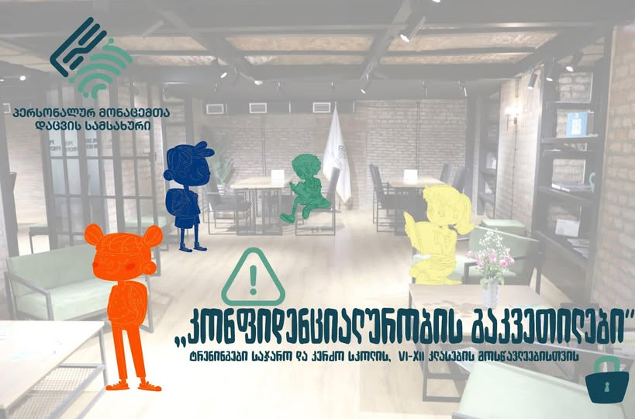

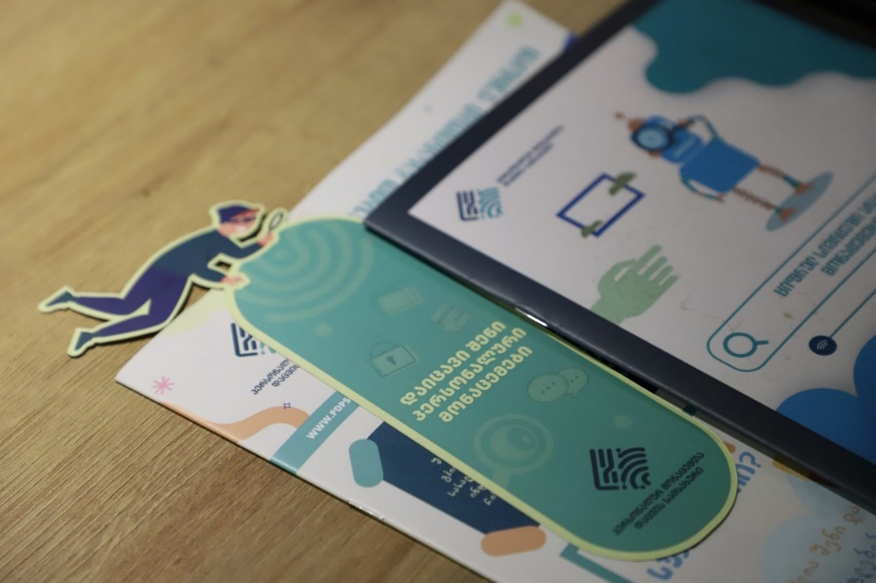

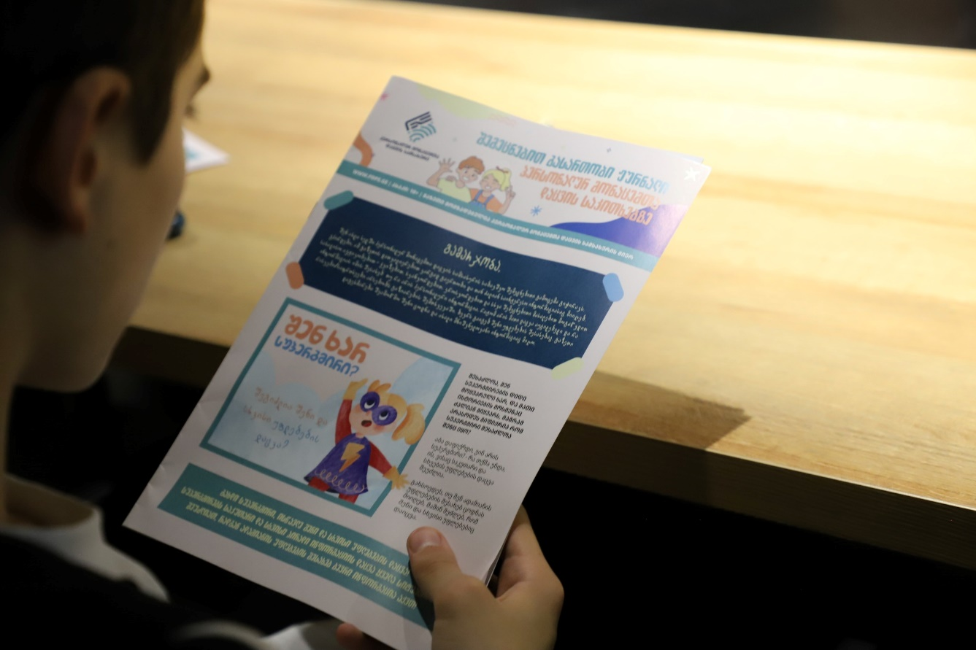

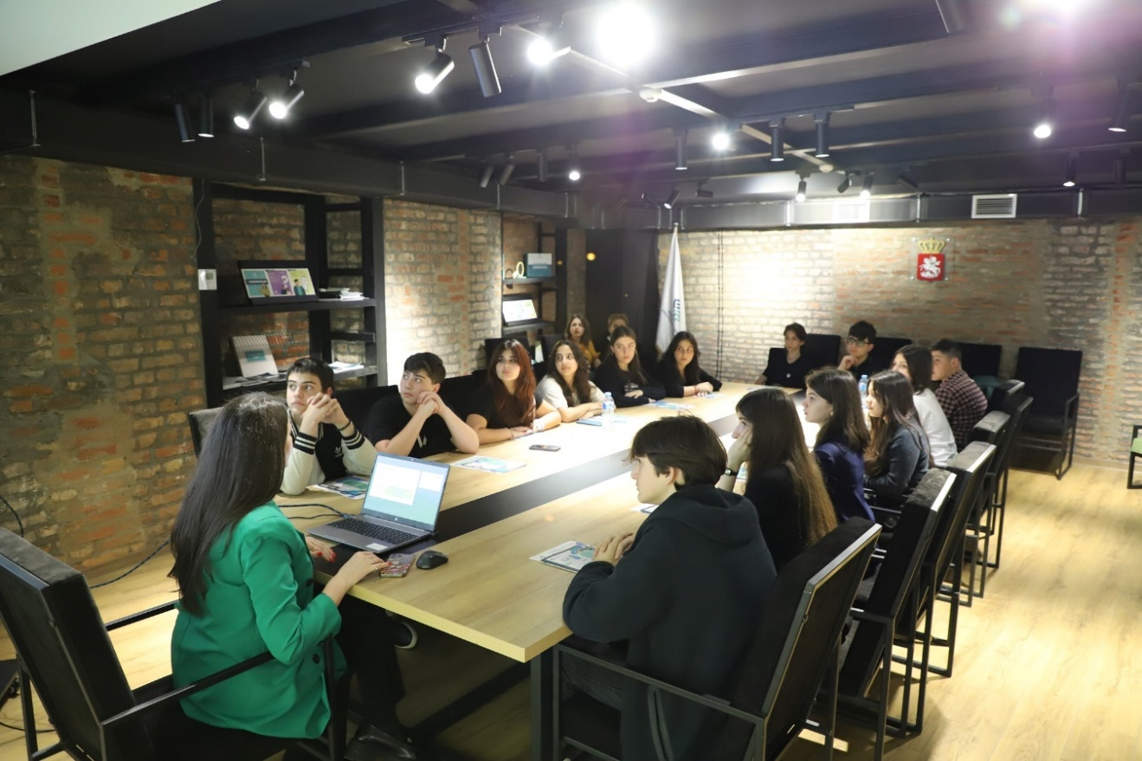

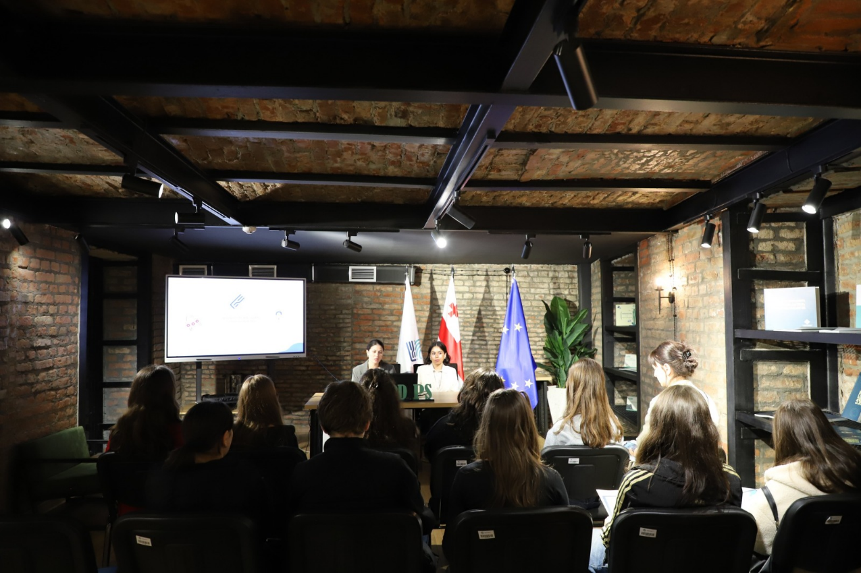



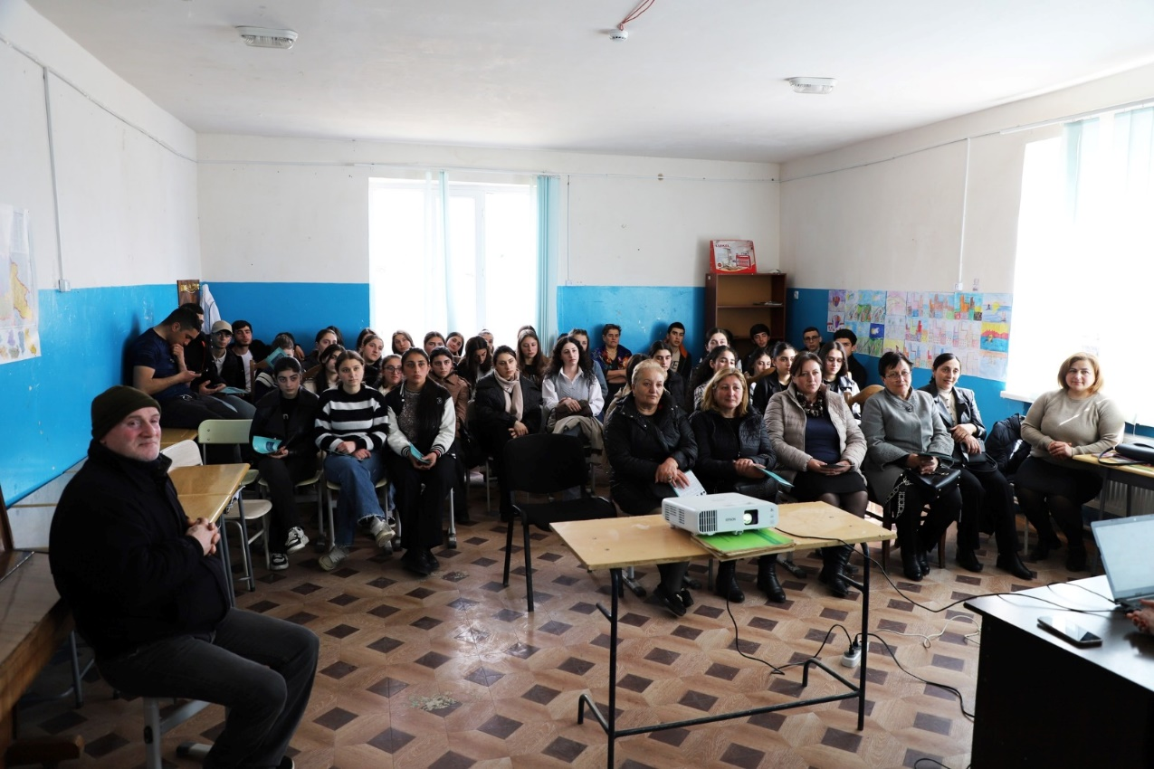

- Please provide the most relevant link on the authority’s website to the initiative, if applicable (The website content does not need to be in English)
Project Announcement

https://www.facebook.com/photo/?fbid=588302390497560&set=a.106155958712208

Documents

- An educational and entertaining journal for children - https://pdps.ge/files/content/%E1%83%A1%E1%83%90%E1%83%91%E1%83%90%E1%83%95%E1%83%A8%E1%83%95%E1%83%9D%20%E1%83%A8%E1%83%94%E1%83%9B%E1%83%94%E1%83%AA%E1%83%9C%E1%83%94%E1%83%91%E1%83%98%E1%83%97%E1%83%98%20%E1%83%92%E1%83%90%E1%83%96%E1%83%94%E1%83%97%E1%83%98_1748592408.pdf
- Guide on the Protection of Personal Data in Educational Institutions - https://pdps.ge/files/content/PDPS%20-%20%E1%83%A1%E1%83%90%E1%83%92%E1%83%90%E1%83%9C%E1%83%9B%E1%83%90%E1%83%9C%E1%83%90%E1%83%97%E1%83%9A%E1%83%94%E1%83%91%E1%83%9A%E1%83%9D%20%E1%83%A1%E1%83%A4%E1%83%94%E1%83%A0%E1%83%9D_1749127592.pdf
- Brochure on Data Processing in the Digital World
https://pdps.ge/files/content/PDPS%20-%20Booklet%202%20-%20Web_1748938610.pdf

- Please provide any other relevant links that help explain the initiative or its impact or success (e.g. links to news reports or articles):
Links to Photos Taken at Meetings

- https://www.facebook.com/share/p/1CoxhttSFT/
- https://www.facebook.com/share/p/15bkaPFPzJ/
- https://www.facebook.com/share/p/1VqhT4E9Ld/

GPA Rules and Procedures, Rule 6.2 ‘Assembly documents’: Without prejudice to section 4.2, Assembly documents, including accreditation and observer applications may be submitted in English or in another language. In the latter case, the documents shall be accompanied by an English version. Members with the ability and the resources to do so are encouraged to translate proposed resolutions and other Assembly documents such as the Assembly Rules and Procedures.

