GPA Global Privacy and Data Protection Awards 2025
Entry Form
To submit an entry to the GPA Global Privacy and Data Protection Awards, please complete and email this form to secretariat@globalprivacyassembly.org no later than 16 June 2025.
Note: GPA member authorities can submit as many entries as they wish, but a separate form should be used for each different entry, submitted by the deadline above.
Languages: The GPA documentation Rule 6.2 applies.
- CONTACT DETAILS FOR THIS ENTRY
Privacy/Data Protection Authority: | Turkish Personal Data Protection Authority
Person completing this form: | Ahmet Miraç Sönmez
 | First name | Last name
Job title: | Data Protection Expert
Email address: | ahmet.sonmez@kvkk.gov.tr

- ELIGIBILITY
By submitting this entry, I confirm that (please tick all boxes to confirm):
☒ | The Authority is a member of the Global Privacy Assembly
☒ | The initiative described in this entry was undertaken before 16 June 2025.
☒ | I am aware that the information in the entry (other than the contact details in 1(a) above) will be publicised by the GPA Secretariat.

- CATEGORIES
Please indicate which category you wish to enter.
Please tick one; please use a separate form for each category you wish to enter:
☒ | Education and Public Awareness
☐ | Accountability
☐ | Dispute Resolution and Enforcement
☐ | Innovation
☐ | People’s Choice
- DESCRIPTION OF THE INITIATIVE

- Please provide a brief summary of the initiative (no more than 75 words)
The Comic Book Project “Digital Adventures with Verinaz”

Scripted stories about the protection of children's personal data on different themes were presented in 5 cartoon magazines of the "Digital Adventures with Verinaz" series. All series were published in the official website of KVKK on 5th of June 2025.

This project aims to increase the awareness of secondary and high school students, their teachers, and their parents on the topic of protecting personal data. At the end of every issue, there are advises specially designed for children.

- Please provide a full description of the initiative (no more than 350 words)
Verinaz is a comic book hero who fights against various risks posed by emerging digital technologies such as online shopping, digital games, deepfakes, and artificial intelligence applications.

The cartoon’s main character is called “Verinaz”. “Veri” means data and “Naz” is a Turkish girl name. With the help of Verinaz different characters learn the methods against threats in the realm of personal data protection.

Last year (2024) 6 cartoon magazines of the "I'm Learning My Personal Data with Verican" series were published on the official website of KVKK which are still accessible on-line.

- Please explain why you think the initiative deserves to be recognised by an award (no more than 200 words)
In five issues topics such as protecting children’s privacy regarding biometric data, artificial intelligence, online shopping and digital games were covered and through her digital adventures, Verinaz guides both children and adults on the conscious use of digital technologies, emphasizing that protecting privacy in the digital world is just as important as in the physical world. Thus, she helps people stay safe in digital environments.

- Please include a photograph or image, if you wish (This will be published with your entry on the GPA website. The image can be pasted into the box below, be sent as an attachment or a link may be provided)
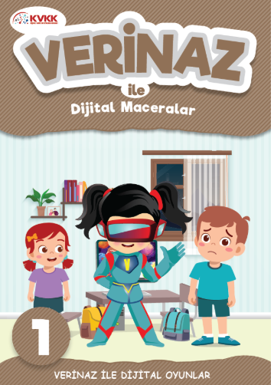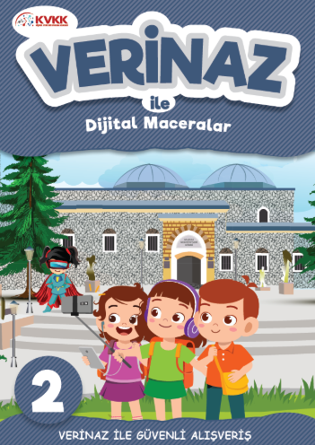

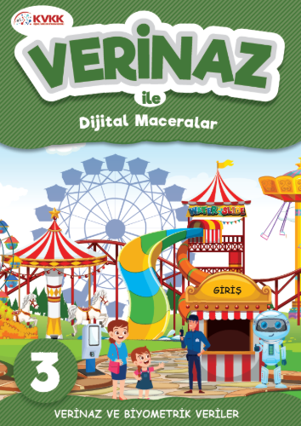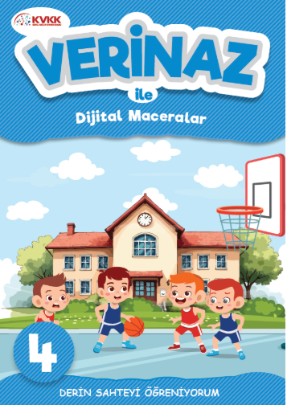

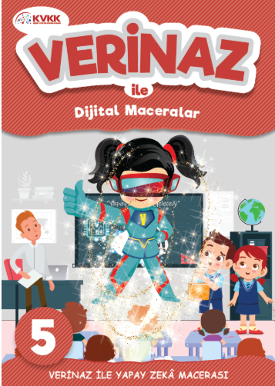

- Please provide the most relevant link on the authority’s website to the initiative, if applicable (The website content does not need to be in English)
The series can be reached via; https://kvkk.gov.tr/Icerik/8327/Verinaz-ile-Dijital-Maceralar

- Please provide any other relevant links that help explain the initiative or its impact or success (e.g. links to news reports or articles):

GPA Rules and Procedures, Rule 6.2 ‘Assembly documents’: Without prejudice to section 4.2, Assembly documents, including accreditation and observer applications may be submitted in English or in another language. In the latter case, the documents shall be accompanied by an English version. Members with the ability and the resources to do so are encouraged to translate proposed resolutions and other Assembly documents such as the Assembly Rules and Procedures.

