GPA Global Privacy and Data Protection Awards 2025
Entry Form
To submit an entry to the GPA Global Privacy and Data Protection Awards, please complete and email this form to secretariat@globalprivacyassembly.org no later than 16 June 2025.
Note: GPA member authorities can submit as many entries as they wish, but a separate form should be used for each different entry, submitted by the deadline above.
Languages: The GPA documentation Rule 6.2 applies.
- CONTACT DETAILS FOR THIS ENTRY
Privacy/Data Protection Authority: | National Privacy Commission
Person completing this form: | Ivy Grace | Villasoto
 | First name | Last name
Job title: | Chief, Policy Development Division
Email address: | grace.villasoto@privacy.gov.ph

- ELIGIBILITY
By submitting this entry, I confirm that (please tick all boxes to confirm):
☒ | The Authority is a member of the Global Privacy Assembly
☒ | The initiative described in this entry was undertaken before 16 June 2025.
☒ | I am aware that the information in the entry (other than the contact details in 1(a) above) will be publicised by the GPA Secretariat.

- CATEGORIES
Please indicate which category you wish to enter.
Please tick one; please use a separate form for each category you wish to enter:
☐ | Education and Public Awareness
☒ | Accountability
☐ | Dispute Resolution and Enforcement
☐ | Innovation
☐ | People’s Choice
- DESCRIPTION OF THE INITIATIVE

- Please provide a brief summary of the initiative (no more than 75 words)
The National Privacy Commission establishes standards and policies to ensure that personal information controllers and processors are accountable for protecting personal data, especially sensitive personal information. These issuances compel both government and private sector organizations to implement robust privacy policies and practices, ensuring they actively safeguard personal data.

By implementing these guidelines and policies, organizations demonstrate transparency and responsibility in privacy and data protection, reinforcing their commitment to accountability and building trust with data subjects and stakeholders.

- Please provide a full description of the initiative (no more than 350 words)
To support the effective implementation of the Data Privacy Act of 2012 (DPA), the National Privacy Commission (NPC) issues Circulars that prescribe, specify, or define policies and procedures designed to supplement and clarify the provisions of the DPA and its Implementing Rules and Regulations (IRR). These Circulars are intended to ensure effective implementation and enforcement of the DPA and its IRR, applying to all covered individuals or organizations, or to specific sectors.

Additionally, the NPC also issues Advisories that serve as a guide or recommendation on the interpretation of the provisions of the DPA and its IRR and best practices relating to the processing of personal data in compliance with the Act and its IRR applicable to all covered natural or judicial persons, or to a particular sector.

These circulars and advisories address emerging technologies, sector-specific practices, and fundamental principles of data privacy. They guide organizations in implementing accountability across all stages of personal data processing.

Foundational policies, such as those outlining the principles of consent, the concept of legitimate interest, data sharing agreements, and the implementation of security measures, serve as essential frameworks that offer comprehensive guidance for organizations. These policies help ensure compliance with legal and regulatory requirements and demonstrate accountability.

Meanwhile, advisories such as those on AI systems, child-oriented transparency, and deceptive design patterns reflect the NPC’s stance on emerging privacy challenges. Model clauses for cross-border data transfers also help organizations maintain accountability beyond national borders. Recent circulars, such as those on body-worn cameras and CCTV systems, emphasize the need for proportionality, transparency, and security in surveillance-related data collection.

Collectively, these issuances form a comprehensive framework intended to enable both public and private entities to establish robust and effective data governance structures. This ensures that accountability becomes not merely a policy, but a practice embedded in their operations, fostering a culture of accountability that permeates throughout the organization.

- Please explain why you think the initiative deserves to be recognised by an award (no more than 200 words)
In response to the rapidly evolving digital landscape and growing concerns over personal data protection, the NPC has remained steadfast in its commitment to strengthening data privacy standards and measures. This involves developing policies that help organizations be more accountable.

The NPC also emphasizes the importance of involving stakeholders in the development of policies. This includes soliciting public input during the drafting stage and conducting consultations to ensure that the policies address the challenges faced by entities implementing the Data Privacy Act. This collaborative process encourages organizations to adhere to these policies because they have been developed with broad input and scrutiny, increasing commitment to compliance and accountability in implementing data protection measures.

By outlining best practices and regulatory requirements, these policies issued by the NPC aim to ensure that organizations not only comply with legal obligations but also uphold ethical standards in data processing. They cover critical aspects such as data collection, storage, usage, and sharing, emphasizing the importance of transparency, consent, and safeguarding individuals' privacy rights. Through these resources, organizations can enhance their data handling processes and cultivate a culture of accountability in all facets of personal data processing.

- Please include a photograph or image, if you wish (This will be published with your entry on the GPA website. The image can be pasted into the box below, be sent as an attachment or a link may be provided)
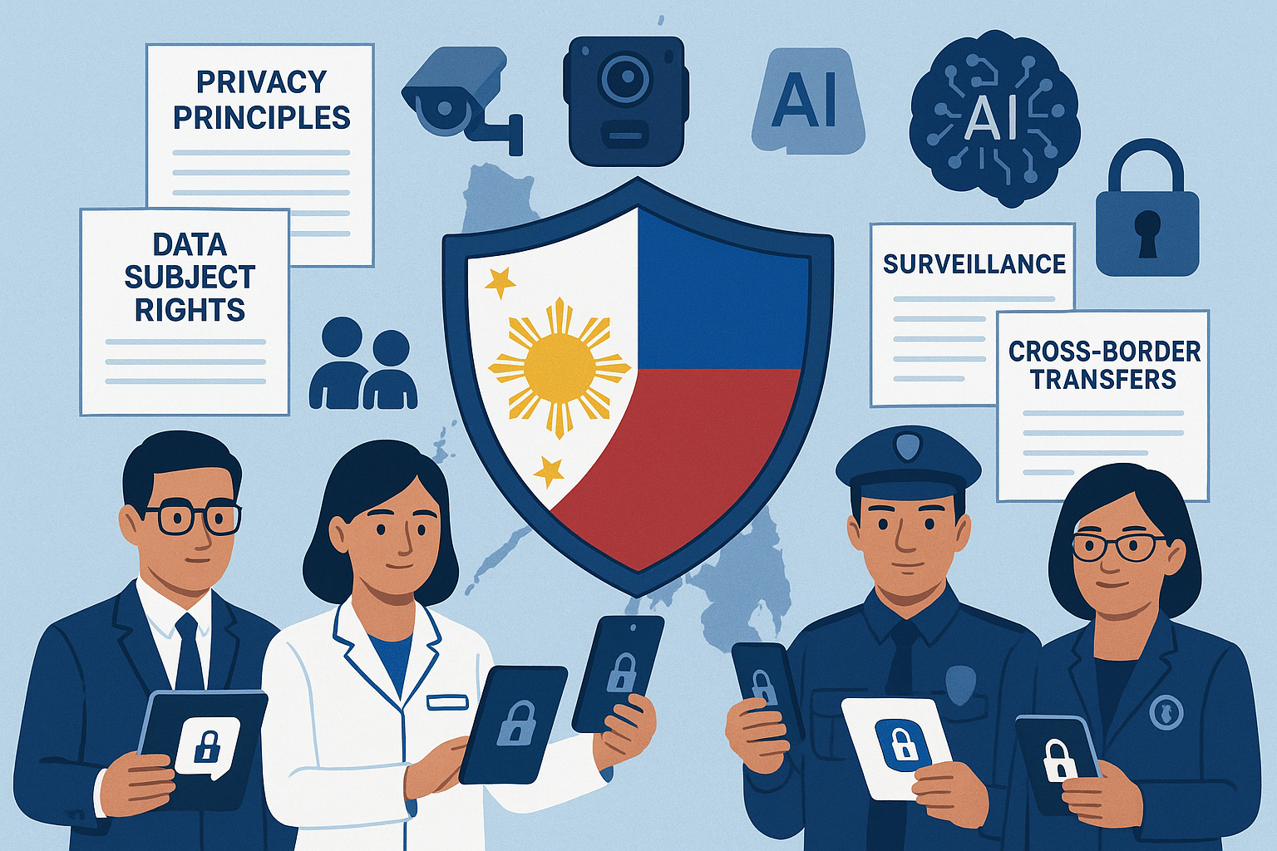
(AI-generated image)

- Please provide the most relevant link on the authority’s website to the initiative, if applicable (The website content does not need to be in English)
NPC Circulars and Advisories

- Please provide any other relevant links that help explain the initiative or its impact or success (e.g. links to news reports or articles):
https://privacy.gov.ph/npc-issues-guidelines-for-personal-data-processing-in-legal-proceedings/

https://privacy.gov.ph/npc-issues-circular-on-cctv-systems/

https://www.globalcompliancenews.com/2024/09/03/philippines-updated-framework-issued-on-the-use-of-closed-circuit-television-systems/

https://www.philstar.com/nation/2024/08/13/2377438/privacy-commission-updates-guidelines-cctv-use/amp/

https://privacy.gov.ph/npc-issues-guidelines-for-personal-data-processing-in-legal-proceedings/

https://privacy.gov.ph/npc-issues-circular-on-cctv-systems/

https://www.globalcompliancenews.com/2024/09/03/philippines-updated-framework-issued-on-the-use-of-closed-circuit-television-systems/

https://www.philstar.com/nation/2024/08/13/2377438/privacy-commission-updates-guidelines-cctv-use/amp/

GPA Rules and Procedures, Rule 6.2 ‘Assembly documents’: Without prejudice to section 4.2, Assembly documents, including accreditation and observer applications may be submitted in English or in another language. In the latter case, the documents shall be accompanied by an English version. Members with the ability and the resources to do so are encouraged to translate proposed resolutions and other Assembly documents such as the Assembly Rules and Procedures.

