GPA Global Privacy and Data Protection Awards 2025
Entry Form
To submit an entry to the GPA Global Privacy and Data Protection Awards, please complete and email this form to secretariat@globalprivacyassembly.org no later than 16 June 2025.
Note: GPA member authorities can submit as many entries as they wish, but a separate form should be used for each different entry, submitted by the deadline above.
Languages: The GPA documentation Rule 6.2 applies.
- CONTACT DETAILS FOR THIS ENTRY
Privacy/Data Protection Authority: | Office of the Information and Privacy Commissioner of Ontario
Person completing this form: | Patricia | Kosseim
 | First name | Last name
Job title: | Commissioner
Email address: | commissioner.ipc@ipc.on.ca

- ELIGIBILITY
By submitting this entry, I confirm that (please tick all boxes to confirm):
☒ | The Authority is a member of the Global Privacy Assembly
☒ | The initiative described in this entry was undertaken before 16 June 2025.
☒ | I am aware that the information in the entry (other than the contact details in 1(a) above) will be publicised by the GPA Secretariat.

- CATEGORIES
Please indicate which category you wish to enter.
Please tick one; please use a separate form for each category you wish to enter:
☐ | Education and Public Awareness
☒ | Accountability
☐ | Dispute Resolution and Enforcement
☐ | Innovation
☐ | People’s Choice
- DESCRIPTION OF THE INITIATIVE

- Please provide a brief summary of the initiative (no more than 75 words)
Small health operators often lack access to the necessary resources to build strong privacy and accountability management programs to protect the personal health information in their custody or control. Since we don’t expect busy health care practitioners to be privacy experts, the IPC created a Privacy Management Handbook for Small Health Care Organizations to assist them in laying the foundations of a privacy management program they can continue to build upon and improve over time.

- Please provide a full description of the initiative (no more than 350 words)
The Privacy Management Handbook for Small Health Care Organizations (handbook) helps individual practitioners and small health care organizations set up a privacy management framework that is right-sized for their practice. Using this handbook can help identify potential gaps or weaknesses in information management practices that could be continually strengthened to better protect personal health information and preserve patients’ trust.

The Handbook summarizes basic requirements and best practices under Ontario’s health privacy law (PHIPA) in a way that is easy to access and understand. The handbook is filled with practical tips and key takeaways, links to additional resources, and helpful tools and templates that health providers can lift and adapt for their own purposes.

Specifically, the handbook gives tips and tools for success, including:
- information on what one needs to do to meet basic PHIPA requirements
- tips and guidance to help you build a privacy management program that’s right-sized for any individual practice
- additional resources that may be useful for those who want more detail

This handbook is designed primarily for:
- sole health practitioners who independently own and operate their own health care practice
- small group clinics that provide similar or interdisciplinary health care services
- operators of small health care facilities

The handbook responds to a long-expressed need of these small health providers to have access to more practical, operational guidance that they can feasibly implement given their small size and real budgetary constraints.

In short, the IPC created reader-friendly content for the busy health practitioner who is not a privacy specialist and needs ready access to highly practical information that can be understood, feasibly implemented and continually improved upon over time.

Throughout the handbook we use plain, easy-to-understand language to keep the information simple and straightforward. This is uniquely distinct from other existing PHIPA-related guidance that has traditionally been aimed at larger health institutions, including large hospitals and sophisticated health research institutions.

- Please explain why you think the initiative deserves to be recognised by an award (no more than 200 words)

Ultimately, building good privacy management practices that demonstrate both compliance with PHIPA and responsive care for patients is essential for maintaining public trust in the health system.

As a modern regulator that aims to have real-world impact, we recognize that it may not always be possible to ramp up to a highly-sophisticated privacy and accountability management framework from one day to the next. This is why we created this practical IPC handbook to support smaller health providers by providing them with a solid base to start from and accompany them along their journey of building more mature privacy programs over time.

The guidance material represents an innovative means by which the IPC is responding to different needs of different entities in the health sector. This unique resource supports the regulatory compliance efforts of small health providers who do not have the resources of larger organizations, yet are expected to comply with complex legislative requirements nonetheless.

The Handbook is intended to encourage them by giving them the tools they need to start a basic privacy management program and work towards achieving greater privacy maturity over time, rather than feel overwhelmed in a helpless state of non-compliance due to lack of resources.

- Please include a photograph or image, if you wish (This will be published with your entry on the GPA website. The image can be pasted into the box below, be sent as an attachment or a link may be provided)
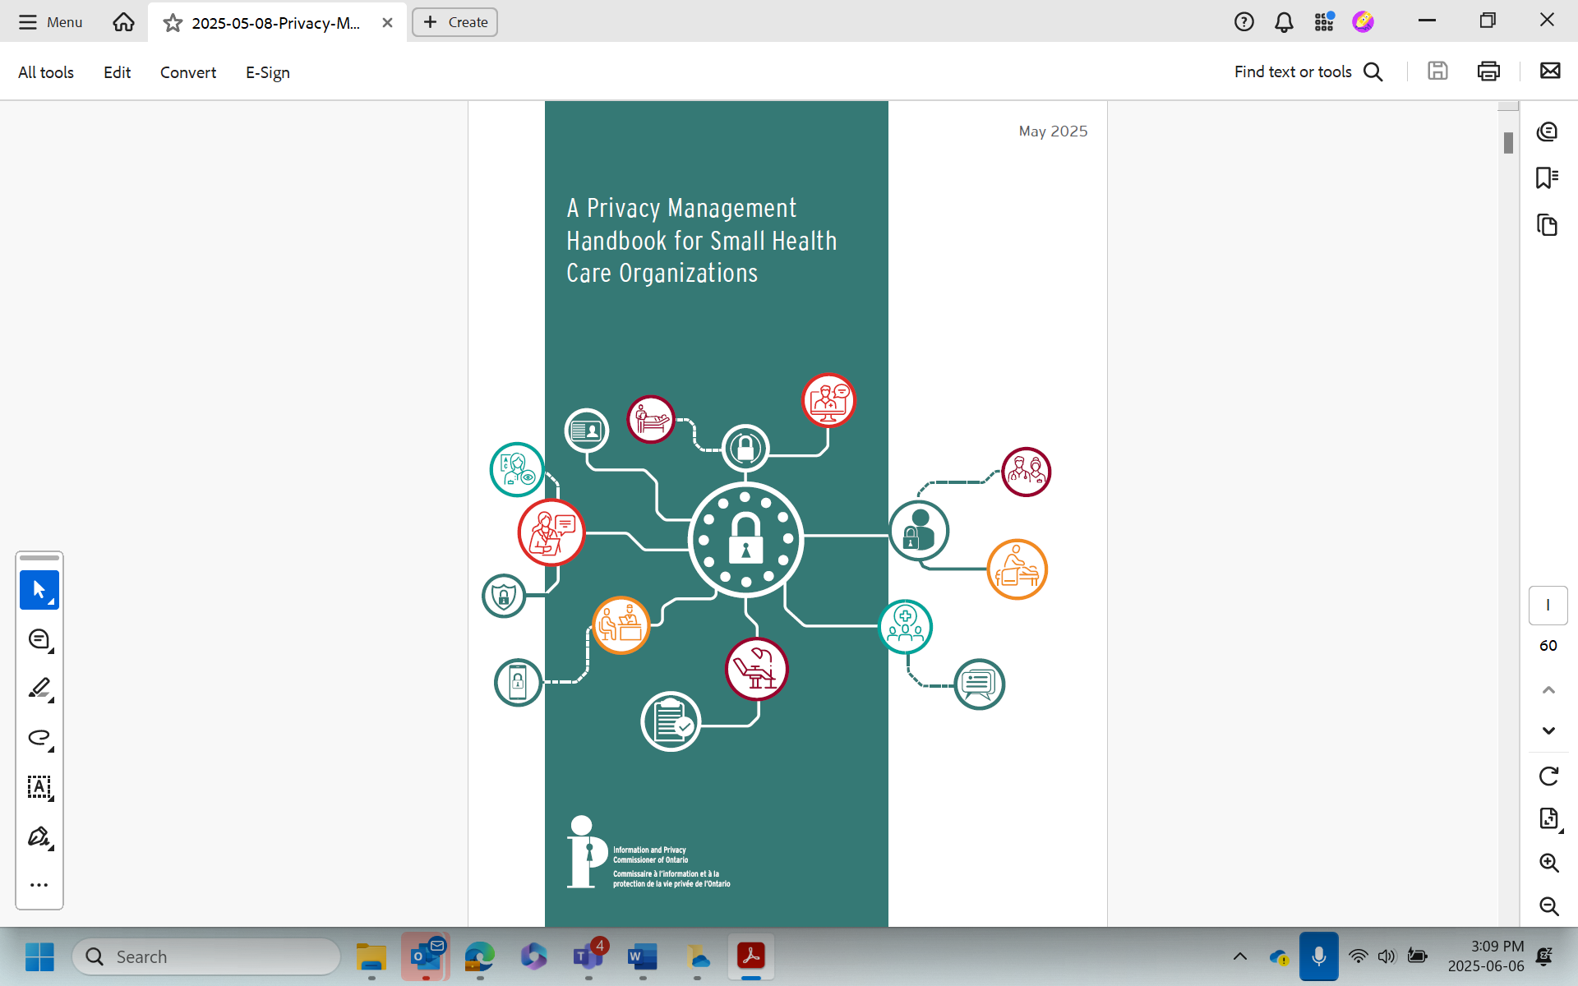

- Please provide the most relevant link on the authority’s website to the initiative, if applicable (The website content does not need to be in English)
https://www.ipc.on.ca/en/resources/privacy-management-handbook-for-small-health-care-organizations

- Please provide any other relevant links that help explain the initiative or its impact or success (e.g. links to news reports or articles):
Trust in Digital Health

GPA Rules and Procedures, Rule 6.2 ‘Assembly documents’: Without prejudice to section 4.2, Assembly documents, including accreditation and observer applications may be submitted in English or in another language. In the latter case, the documents shall be accompanied by an English version. Members with the ability and the resources to do so are encouraged to translate proposed resolutions and other Assembly documents such as the Assembly Rules and Procedures.

