GPA Global Privacy and Data Protection Awards 2025
Entry Form
To submit an entry to the GPA Global Privacy and Data Protection Awards, please complete and email this form to secretariat@globalprivacyassembly.org no later than 16 June 2025.
Note: GPA member authorities can submit as many entries as they wish, but a separate form should be used for each different entry, submitted by the deadline above.
Languages: The GPA documentation Rule 6.2 applies.
- CONTACT DETAILS FOR THIS ENTRY
Privacy/Data Protection Authority: | Office of the Privacy Commissioner for Personal Data, Hong Kong, China (PCPD)
Person completing this form: | Gwen-long | Chan
 | First name | Last name
Job title: | Personal Data Officer
Email address: | gl.chan@pcpd.org.hk

- ELIGIBILITY
By submitting this entry, I confirm that (please tick all boxes to confirm):
☒ | The Authority is a member of the Global Privacy Assembly
☒ | The initiative described in this entry was undertaken before 16 June 2025.
☒ | I am aware that the information in the entry (other than the contact details in 1(a) above) will be publicised by the GPA Secretariat.

- CATEGORIES
Please indicate which category you wish to enter.
Please tick one; please use a separate form for each category you wish to enter:
☐ | Education and Public Awareness
☒ | Accountability
☐ | Dispute Resolution and Enforcement
☐ | Innovation
☐ | People’s Choice
- DESCRIPTION OF THE INITIATIVE

- Please provide a brief summary of the initiative (no more than 75 words)
Since 2021, PCPD has published 4 guidance materials on AI. For organisations, it published “Guidance on the Ethical Development and Use of Artificial Intelligence”, “Artificial Intelligence: Model Personal Data Protection Framework”, and “Checklist on Guidelines for the Use of Generative AI by Employees” to facilitate compliance with the local data privacy law during AI use. For the public, it published “10 TIPS for Users of AI Chatbots” to help users protect their personal data privacy.
[75 words]

- Please provide a full description of the initiative (no more than 350 words)
Since 2021, the PCPD has been proactive in addressing the privacy risks arising from the development and use of AI by publishing a series of guidance materials aimed at both organisations and the public.

In 2021, the PCPD issued the "Guidance on the Ethical Development and Use of Artificial Intelligence" (“Guidance”) to help organisations understand and comply with the relevant requirements of the Personal Data (Privacy) Ordinance (“PDPO”). The Guidance recommends three Data Stewardship Values—being respectful, beneficial, and fair—and sets out seven Ethical Principles for AI, namely accountability, human oversight, transparency and interpretability, data privacy, fairness, beneficial AI as well as reliability, robustness and security.

In 2024, as the use of AI systems developed by third parties became common, the PCPD published the "Artificial Intelligence: Model Personal Data Protection Framework" (“Model Framework”) to assist organisations in complying with the relevant requirements of the PDPO when procuring, customising, implementing, and using AI systems. The Model Framework provides recommendations in four areas: establishing AI strategy and governance, conducting risk assessments and human oversight, customising AI models and implementing and managing AI systems, and communicating and engaging with stakeholders. The Model Framework won the “Hong Kong Public Sector Initiative of the Year – Regulatory” award in the Asia Pacific GovMedia Conference & Awards 2025.

In March 2025, the PCPD published the "Checklist on Guidelines for the Use of Generative AI by Employees" (“Guidelines”) to assist organisations in developing internal policies or guidelines on the use of generative AI by employees. The Guidelines cover areas such as scope of permissible use of generative AI, protection of personal data privacy, lawful and ethical use and prevention of bias, and data security.

Apart from organisations, the public has increasingly used AI in their daily lives. Thus, in 2023, the PCPD published the "10 TIPS for Users of AI Chatbots" leaflet to help the public use AI chatbots safely while protecting their personal data privacy. The leaflet covers important considerations for users during registration and communication with AI chatbots, as well as tips for safe and responsible use.

[342 words]

- Please explain why you think the initiative deserves to be recognised by an award (no more than 200 words)
As organisations are eager to unlock the potential of AI while navigating complex compliance landscapes, the PCPD recognised that many orgasniastions are not lacking in commitment to personal data privacy, but are often constrained by limited resources and technical know-how.

To bridge this gap, we have developed a suite of practical, accessible resources that show how innovation can thrive without compromising privacy.

Our publications offer clear, actionable guidance aligned with general business processes, ensuring seamless integration with the organisations’ business processes. Understanding the need for simplicity, we created concise pamphlets on the Guidance and Model Framework and designed the Guidelines in the form of a Checklist to distil key recommendations into digestible formats, making adoption feasible for organisations of all technical capacities.

We also acknowledged the importance of enhancing the privacy awareness of individual users, so we empower the users by issuing practical tips for safe AI chatbot use to help them safeguard their privacy in everyday interactions.

This initiative demonstrates that safe, secure and privacy-friendly AI adoption is not only possible but practical.

Recognition through this award would amplify this message globally: that responsible innovation is entirely possible as the path forward as we embrace the opportunities and challenges brought by AI.

[203 words]

- Please include a photograph or image, if you wish (This will be published with your entry on the GPA website. The image can be pasted into the box below, be sent as an attachment or a link may be provided)
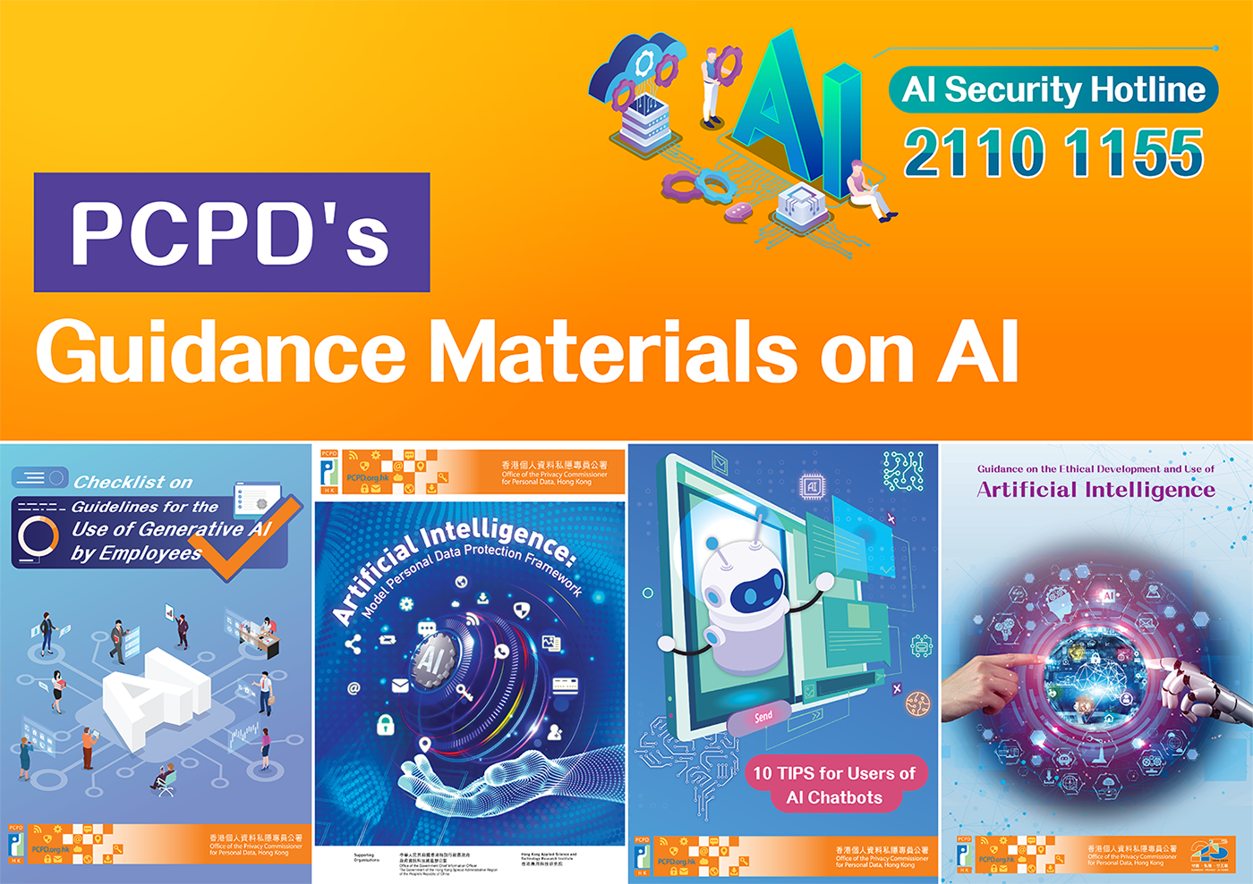

- Please provide the most relevant link on the authority’s website to the initiative, if applicable (The website content does not need to be in English)
PCPD’s AI Security Webpage:

https://www.pcpd.org.hk/english/artificial_intelligence/index.html

- Please provide any other relevant links that help explain the initiative or its impact or success (e.g. links to news reports or articles):
GovMedia Awards:
- Hong Kong Office of the Privacy Commissioner for Personal Data wins GovMedia Awards 2025 | GovMedia

Guidance Notes:
- Checklist on Guidelines for the Use of Generative AI by Employees (2025)
- Artificial Intelligence: Model Personal Data Protection Framework (2024)
- Guidance on the Ethical Development and Use of Artificial Intelligence (2021)

Leaflets:
- Leaflet on “Artificial Intelligence: Model Personal Data Protection Framework” (2024)
- 10 TIPS for Users of AI Chatbots (2023)
- Leaflet on “Guidance on the Ethical Development and Use of Artificial intelligence” (2021)

GPA Rules and Procedures, Rule 6.2 ‘Assembly documents’: Without prejudice to section 4.2, Assembly documents, including accreditation and observer applications may be submitted in English or in another language. In the latter case, the documents shall be accompanied by an English version. Members with the ability and the resources to do so are encouraged to translate proposed resolutions and other Assembly documents such as the Assembly Rules and Procedures.

